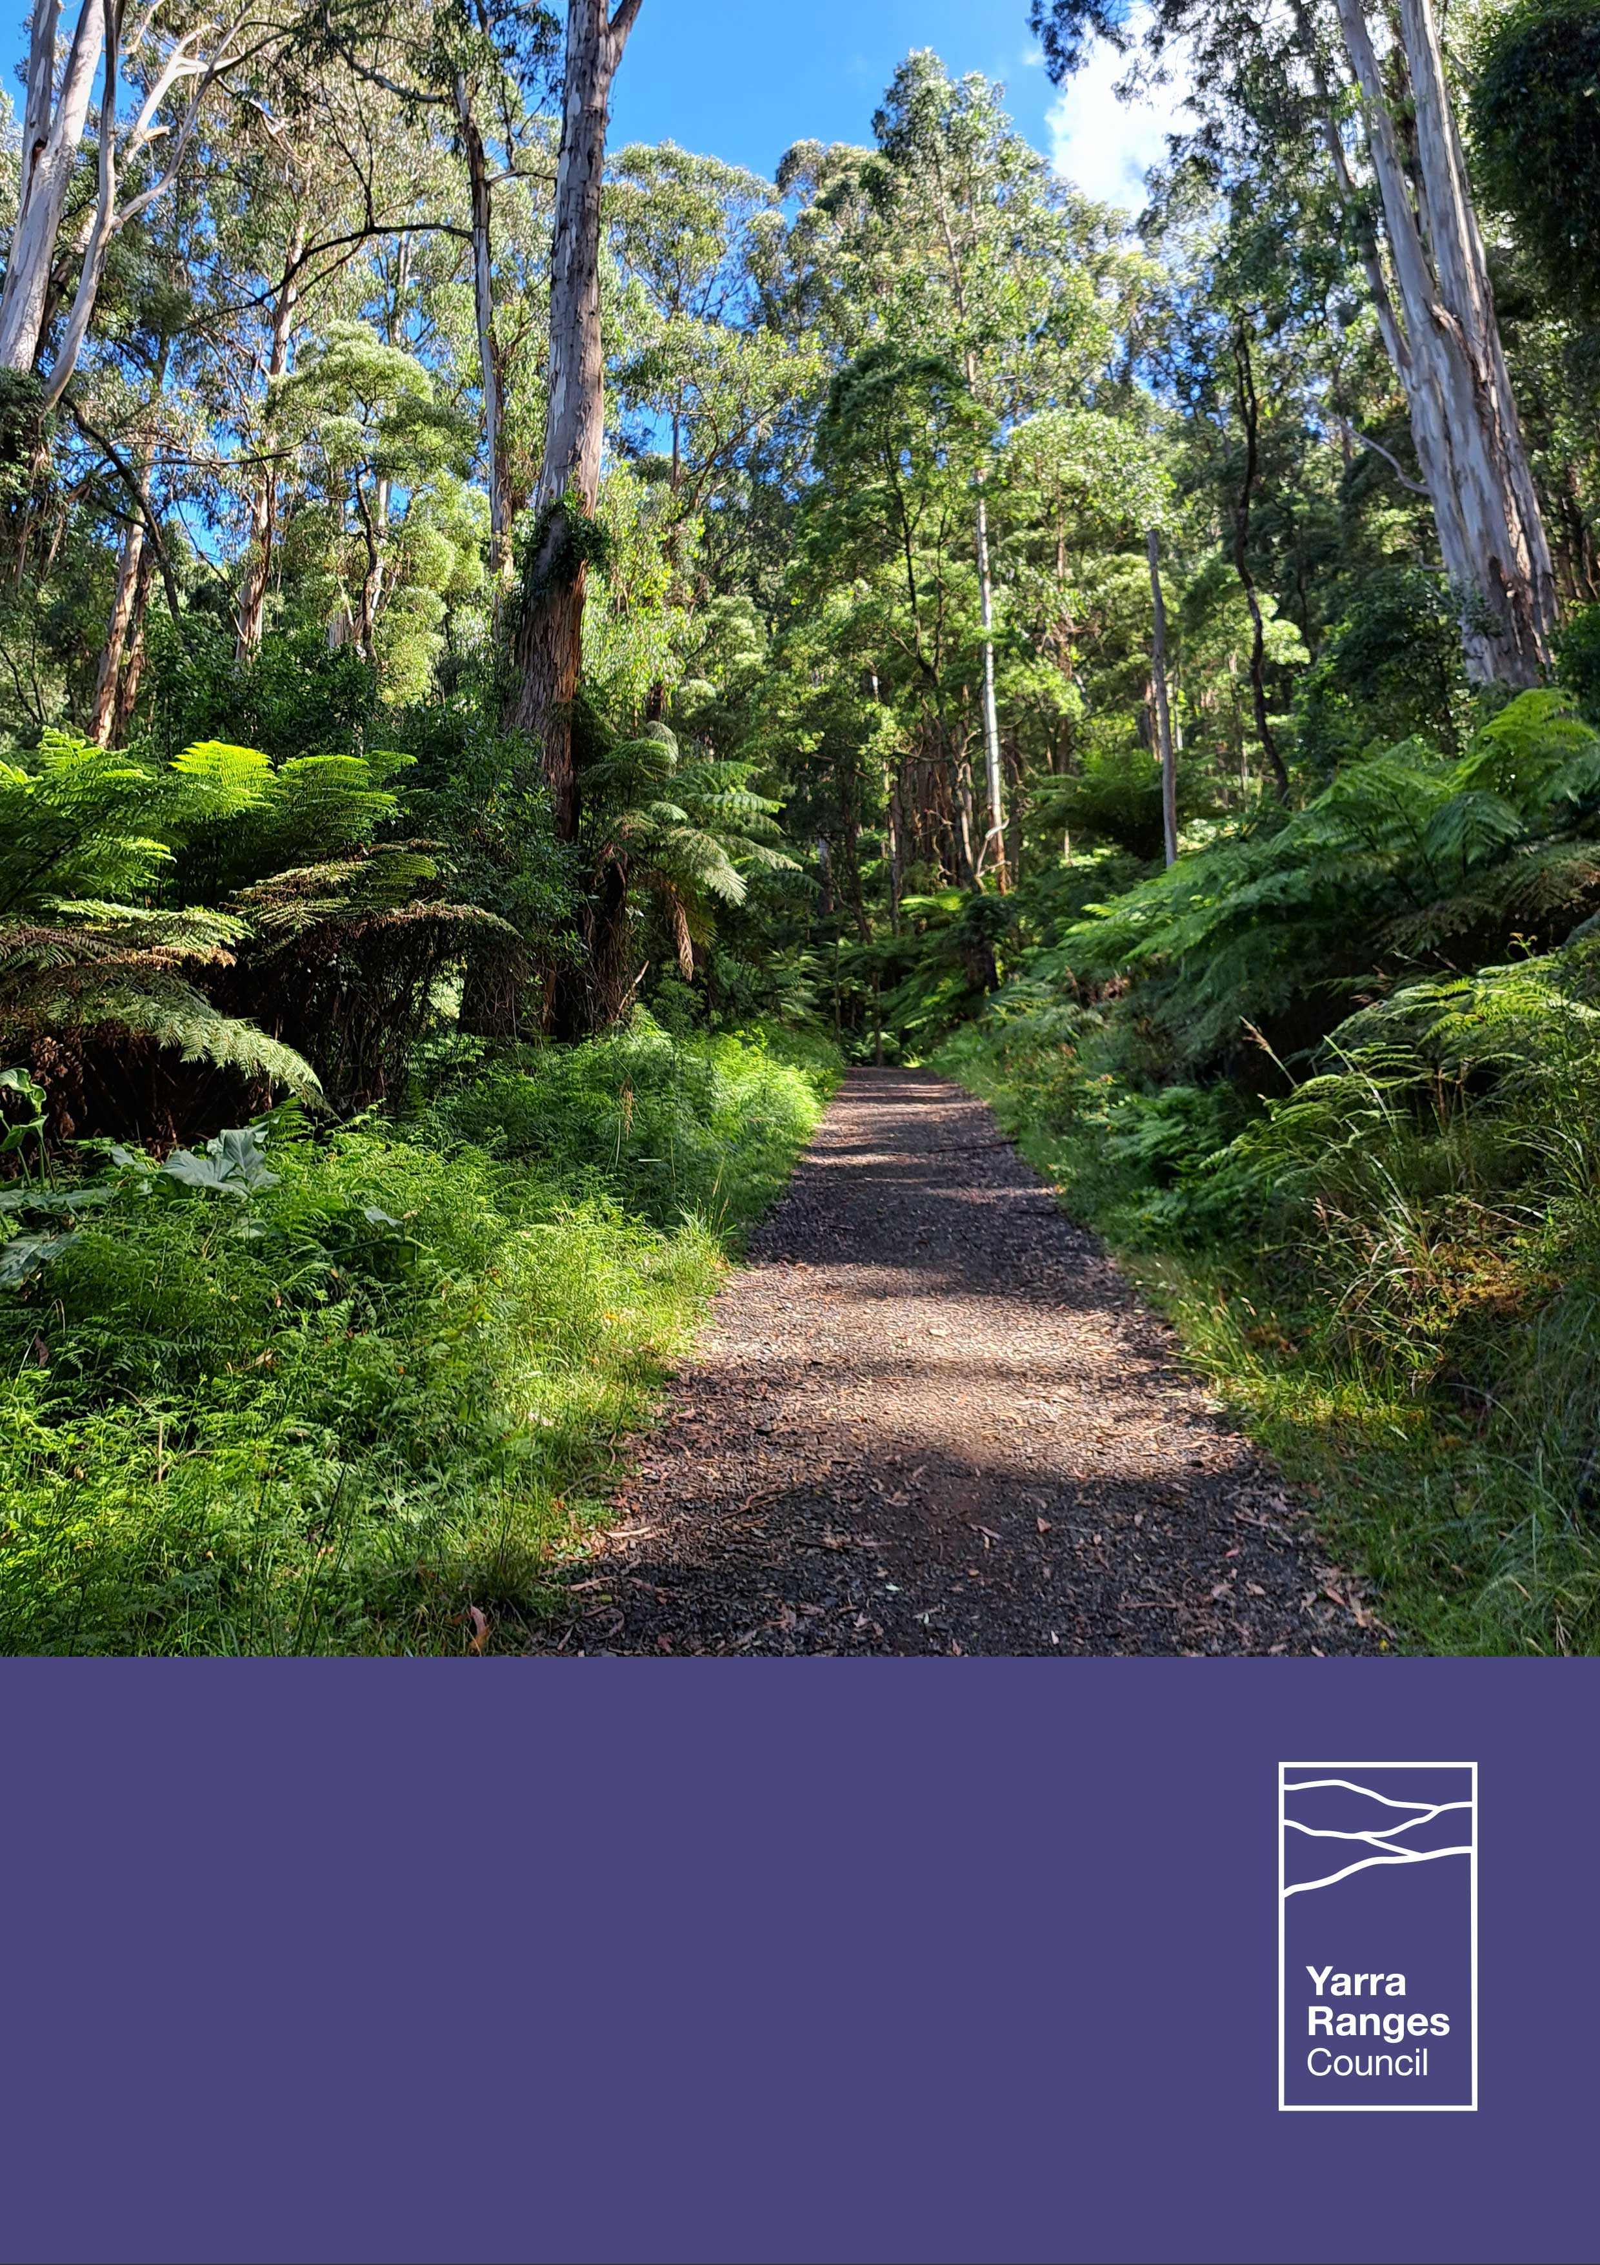
Yarra Ranges Council
Climate Resilience and Sustainability Report
2024-2025 Financial Year

Yarra Ranges Council acknowledges the Wurundjeri and other Kulin Nation people as the Traditional Owners and Custodians of these lands and waterways.
We pay our respects to all Elders, past, present, and emerging, who have been, and always will be, integral to the story of our region. We proudly share custodianship to care for Country together.


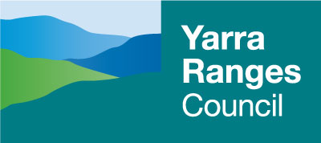

Yarra Ranges Council
15 Anderson Street, Lilydale
1300 368 333 | yarraranges.vic.gov.au

Contents

Contents 3
Introduction 4
Strategic Pillars 5
Headline Target Tracker 6
Year in Review 9
Biodiversity and Natural Environments 12
Catchments and Waterways 17
Climate Adaptation and Mitigation 19
Environmental Stewardship and Reconciliation 26
Sustainable Economy, Food and Housing 30
Resource Recovery 34

Introduction
The Climate Resilience and Sustainability Annual Report outlines Yarra Ranges Council’s progress in delivering key environmental initiatives, meeting strategic targets, and Caring for Country. It presents data-driven insights across areas such as emissions reduction, biodiversity protection, waste and resource recovery, and climate adaptation. The report tracks performance against Council’s Environment Strategy, Liveable Climate Plan, and Community Waste and Resource Recovery Plan. This year’s report also references the Nature Plan 2024-2034 and Tree Canopy Strategy 2024-2044. As these plans are in their first year, baseline data is being established, with comparative year-on-year reporting to begin in the 2025-2026 report.
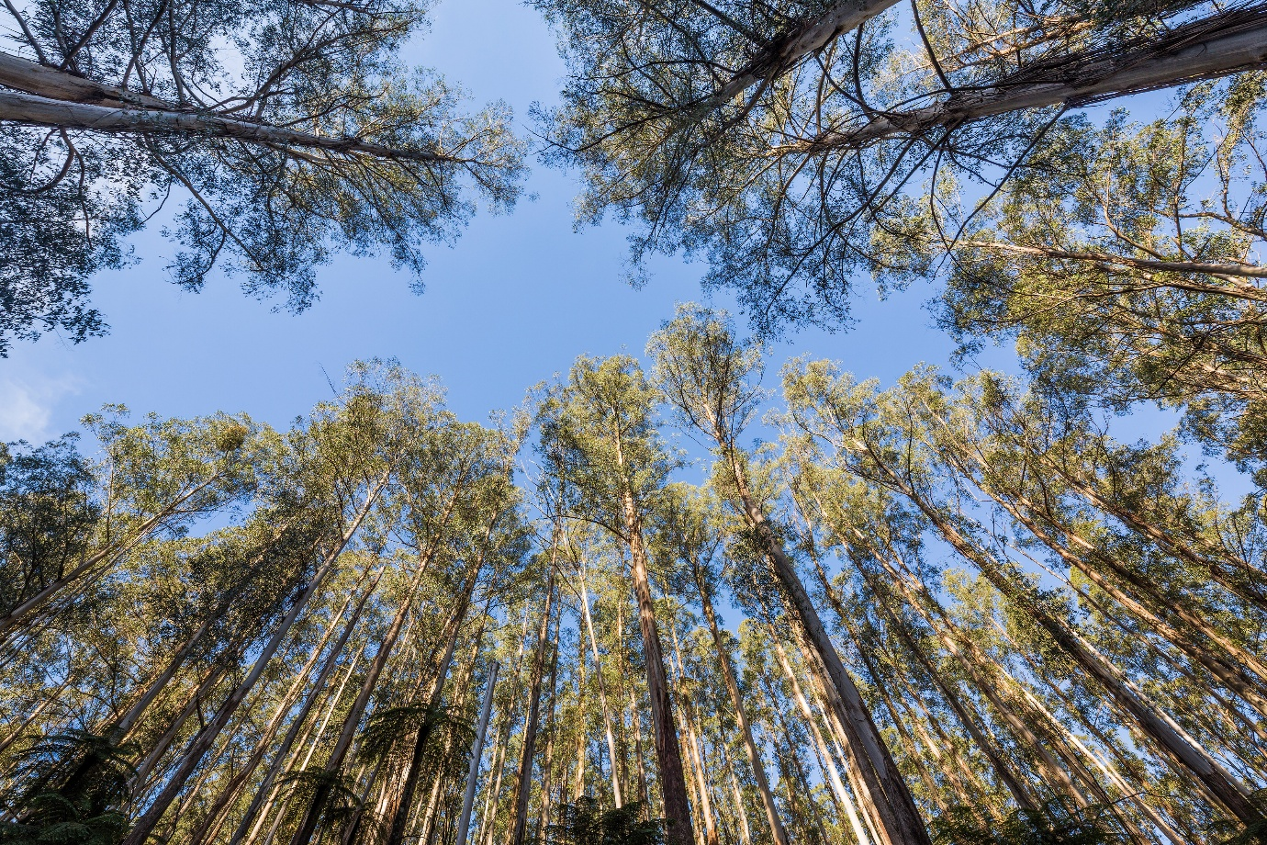

Strategic Pillars
Sustainability is a broad term, encompassing a wide range of initiatives across environmental, social, and economic areas. To reflect this breadth, the Climate Resilience and Sustainability Report is organised around six core pillars, each supported by relevant strategies and plans. A summary of these pillars is provided below.

Biodiversity and Natural Environments | Nature Plan  Tree Canopy Strategy | Environment Strategy | Open Space Strategy

Climate Adaptation and Mitigation | Liveable Climate Plan  Fire Management Plan | Aquatics and Leisure Strategy  Energy Transition Plan | Active Recreation Plan  Integrated Transport Strategy

Environmental Stewardship and Reconciliation | Reconciliation Action Plan | Municipal Recovery Plan | Draft Heritage Strategy

Catchments and Waterways | Integrated Water Management Plan | Stormwater Management Plan | Yarra Strategic Plan*
*External plan, YRC is a major contributor
Resource Recovery | Community Waste and Resource Recovery Plan

Sustainable Economy, Food and Housing | Housing Strategy  Health and Wellbeing Strategy | Regenerative Economic Development Strategy | Living Places Framework  Green Wedge Management Plan
Table 1: Summary of strategic context

Headline Target Tracker
Council’s progress to headline targets across three core sustainability plans are summarised below.
Liveable Climate Plan 2020-2030
Target | 2023-2024 Result | 2024-2025 Progress | Explanation
Reduce greenhouse gas emissions by 60% on 2005 levels by 2025 | 80% | 78% | Emissions have been reduced by 45% on 2005 levels.  A detailed explanation of emissions reduction progress is provided on page 22.
Transition all Council services and infrastructure to 100% renewable energy by 2030 | 25% | 29% | Non-renewable energy comprised 9.6% of total energy consumption in 2024-2025, a decrease of -4% compared to the previous year
Net Zero emissions by 2040 | 48% | 45% | Additional 214kW of solar (+12%) and 433kWh (+52%) of battery storage installed in 2024-2025.  A detailed explanation of emissions reduction progress is provided on page 22.
Net Zero Operational Energy Expenditure by 2040 | Comparison data is not available due to fluctuating energy prices.

Community Waste and Resource Recovery Plan 2023-2030
Target | 2023-2024 Result | 2024-2025 Progress | Explanation
20% reduction in total waste generation per capita by 2030 | Previous years not comparable due to service change.  Progress will be reported in future years.  23/24 baseline = 412kg per capita | 2% reduction in total waste generation achieved | Although the amount of rubbish and recycling collected has reduced, the amount of FOGO collected has doubled since October 2023, reducing achievement of this goal (but with positive impacts e.g. reduced need for burning off green waste).
Divert 90% of waste from landfill by 2030  - Interim target of 75% diversion by 2025 | 83% to  interim target | 88% to interim target | 63% of waste diverted from landfill in the 2024/25 financial year.
Cut the volume of organic material going to landfill by 60% by 2030  - Interim reduction target of 25% by 2025 | 100% complete  interim  target | 100% complete interim target | Volume of organic material sent to landfill cut by 33% since 2020.

Nature Plan 2024-2034
Target | 2023-2024 Result | 2024-2025 Progress | Explanation
Yarra Ranges achieves an overall ‘net gain’ in native vegetation cover by 2034 | Baseline values established in 2025/26
Triple restoration and revegetation works on private and Council-managed land per annum | Baseline values established in 2025/26
Increase the conservation value across our bushland reserve network over the next 10 years | Baseline values established in 2025/26
Enable at least 200 land stewards to improve the biodiversity on their land each year | Baseline values established in 2025/26
Table 2: Progress to headline targets across the three core plans.

Year in Review
Throughout 2024-25 Yarra Ranges Council continued its commitment to environmental stewardship and sustainability in service of the community. Through strong partnerships and delivery of innovative projects, Council improved the health of our natural environment and strengthened community resilience. This report outlines the year’s key milestones and achievements, reflecting Council's vision for a thriving, sustainable Yarra Ranges for generations to come.
Key
Liveable Climate Plan
Community Waste and Resource Recovery Plan
Nature Plan
Biodiversity and Natural Environments
 |  | 
Biggest planting year to date with over 175,000 plants in the ground. | Increased conservation value and reduced weed coverage in Bushland Reserves. | 210 people signed up to the Gardens for Wildlife program and 103 garden visits were conducted.

Climate Adaptation and Mitigation
 |  | 
Installation of energy resilience measures at 23 Council facilities. | Construction of the Resilient Energy Precinct (Monbulk Microgrid), with solar install of 100kW, with a battery storage capacity of 201kWh and a fixed 150kVa generator. | Three recreation sites upgrade to energy efficient LED lighting, halving energy use.

Catchments and Waterways
 |  |  | 
Stormwater discharge was reduced by 61ML/year, nitrogen by 373kg and gross pollutants by 24 tonnes. | The Tanks for Platypus Project received 236 expressions of interest in participation from local residents and businesses and completed 172 site assessments. | Stormwater Harvesting Systems at three existing locations supplied 5.7 million litres of treated stormwater for irrigating sports fields. | Installation of real-time water monitoring at aquatic facilities to detect leaks and conserve water.

Environmental Stewardship and Reconciliation
 |  |  | 
Cultural fire practices continued on Council land with a second Firesticks burn and planning for a further four sites underway. | Eastern Alliance for Sustainable Learning (EASL) held the biggest Learning for Sustainability Conference to date with 250 attendees.  EASL secured the contract to deliver the RSS program for the eastern region for the next two years in a highly competitive tender process. | The EASL ResourceSmart Schools (RSS) program supported 120 active schools, certified 30 modules and won 7 awards at the RSS awards. | 43 events focused on sustainable practices, resilience building, conservation and habitat restoration, citizen science, growing and preparing food, caring for wildlife and more.

Sustainable Economy, Food and Housing
 |  |  | 
Installation of two new cycling nodes, encouraging sustainable transport and eco-tourism. | Revitalisation and upgrade of five playspaces using sustainable materials, shade trees and nature-based play options. | Continuation of popular Gardens for Harvest program with well attended events. | Supported nine Community Gardens across the municipality.

Resource Recovery
 |  | 
Diversion of 63% of all waste from landfill. | Diversion of 33% of total organic waste sent to landfill into FOGO. | Salvage and reuse of rail infrastructure and timber along the Yarra Valley Trail.
Table 3: Key achievements in 2024-25 across the six Strategy Framework themes.

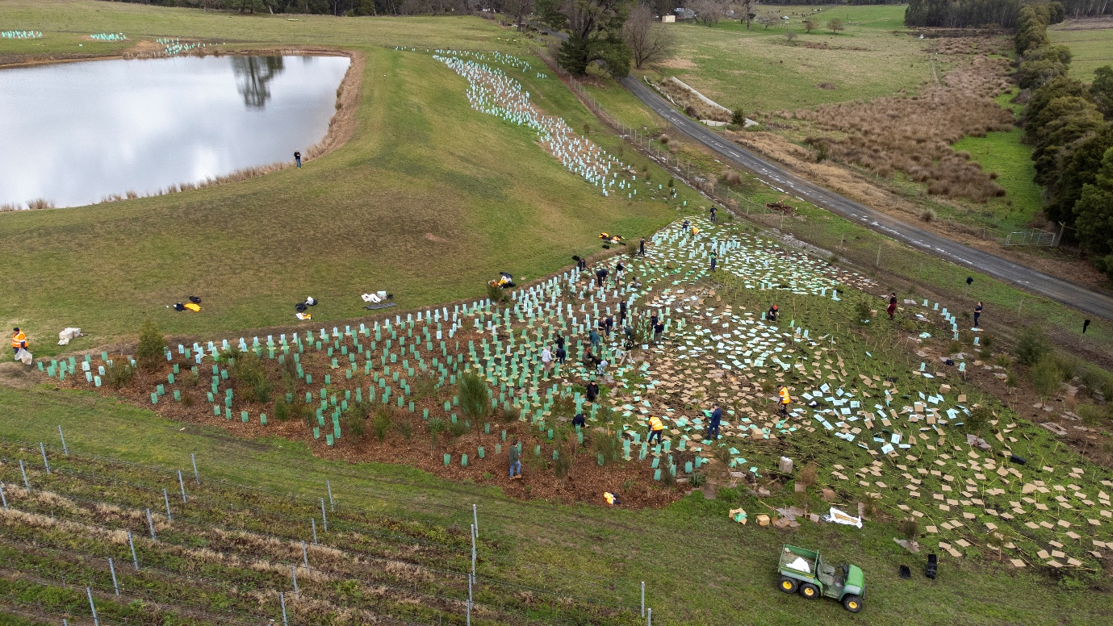
Biodiversity and Natural Environments
Ribbons of Green program planting taking place on a privately owned vineyard

Street Trees
1,700 mature trees were planted in townships across Yarra Ranges contributing to amenity and reducing urban heat island effect.

Ribbons of Green
The Ribbons of Green program offers free native plants for private properties (over one hectare), schools and community groups to restore habitats across the Yarra Ranges. This year 70,160 indigenous plants were planted across 61 private properties, covering approximately 11.7 hectares.

Bushland Revegetation Program
105,000 indigenous grasses, groundcovers, shrubs and trees were planted at 94 bushland reserves.

Bushland Conservation Values
Conservation value mapping revealed bushland reserve conservation values remained the same as 2023/24 whilst roadsides increased by one per cent. This included tree canopy cover, native vegetation, weeds, organic materials, patch size, vegetation links, and site disturbance.
In May 2025, an additional 36 nest boxes and hollows were installed as part of the Artificial Hollows and Nest Box Program, with several placed in Ken Leversha Reserve: a site impacted by bushfire in March 2025.
Monitoring, including spotlighting, pole camera, infrared camera and song meter use has confirmed use by a number of species including: Agile Antechinus, Feathertail Glider, Australian Owlet Nightjar, Greater Glider, Krefft's Glider, Common Ringtail Possum, Australian Wood Duck, Crimson Rosella and Bees.
Ongoing student placements from Deakin University are ensuring consistent monitoring and reporting.

Bushland Weed Cover
Weed cover has been reduced by two per cent on average across bushland reserves and one per cent in roadside sites. Blackberry remains the most threatening weed, with a 76 per cent presence in reserves and 68 per cent in roadsides. English Ivy and Sweet Pittosporum follow, with 67 per cent and 53 per cent presence in reserves, and 35 per cent and 33 per cent in roadsides respectively.
Overall, many weed species, especially woody weeds like Sallow Wattle, Pine, Cotoneaster, Sycamore Maple, and Japanese Honeysuckle have been reduced.

Biodiversity Offsets Program
The Yarra Ranges Biodiversity Offsets Program compensates for the permitted removal of native vegetation in the planning permit process by providing local native vegetation offsets. Currently, the program protects and enhances 70 hectares of native vegetation on Council-owned land. This program ensures that when native vegetation is legally removed, it is balanced by protecting and restoring other areas of native bushland, helping to preserve local biodiversity and habitats while meeting Council’s environmental obligations.
In 2024-2025, the program progressed the establishment of two new offset sites – Doongalla and Rosella Road – and offset almost 2.8 hectares of vegetation removal through 22 trades worth close to $121,000. This meets all Council's offset requirements and the cost recovery requirements of the program. This income is reinvested into conservation efforts at biodiversity offset sites, supporting biodiversity and habitat restoration.

Peri Urban Weed Partnership Program
Yarra Ranges Council has been actively working with agency partners and local environmental friends’ groups through the Victorian Government’s Peri Urban Weed Management Partnership Program - a collaborative initiative aimed at tackling invasive weeds in Melbourne’s fringe areas - to protect and restore natural landscapes in the Dandenong Ranges. Through this partnership, 956 hectares of weed control activities were undertaken on agency-managed land across the program area. In addition, targeted high-threat weed control was successfully completed on 21 private properties within Yarra Ranges (Sassafras and Ferny Creek) and Knox City (The Basin).

Deer Control Program
In 2024–2025, strong collaboration with Landcare Groups and active community participation enabled control across 29,050 hectares of cross-tenure land.
These efforts resulted in the removal of 293 deer—236 Sambar and 57 Fallow—with all carcasses processed locally at Coldstream for the pet food industry through the principle use of a local harvest contractor.

Yering Billabongs Project
The Yering Billabongs Project, led by Yarra Ranges Council in partnership with Melbourne Water and the Wurundjeri Woi-Wurrung Cultural Heritage Aboriginal Corporation (WWCHAC), is restoring 60 hectares of floodplain along the Yarra River (Birrarung) and Olinda Creek.
The project is improving stormwater management, enhancing biodiversity, and reestablishing natural flow patterns of the Birrarung. The project also supports cultural, recreational, and environmental outcomes for the community.
During 2024-2025:
- A second Cultural burn was conducted by Traditional Owners with support of Council’s Bushlands and Indigenous Development teams.
- Wurundjeri Narrap Rangers were engaged for:
  - On ground works including weed control, revegetation and other land management activities
  - Monitoring including vegetation and eDNA
- High threat weeds were treated across the site
- Local primary schools were engaged through the Planting the Seed program, where 3,000 indigenous tubestock were planted.
- There was an educational walk-and-talk focusing on billabongs.
- A water gate was installed enabling natural inundation during Olinda Creek high flows.
- Fencing to exclude cattle was completed.
- Valuable relationships formed between Council and Wurundjeri Woi Wurrung Cultural Heritage Aboriginal Corporation, Yarra Riverkeeper Association and Ecology and Restoration Australia.
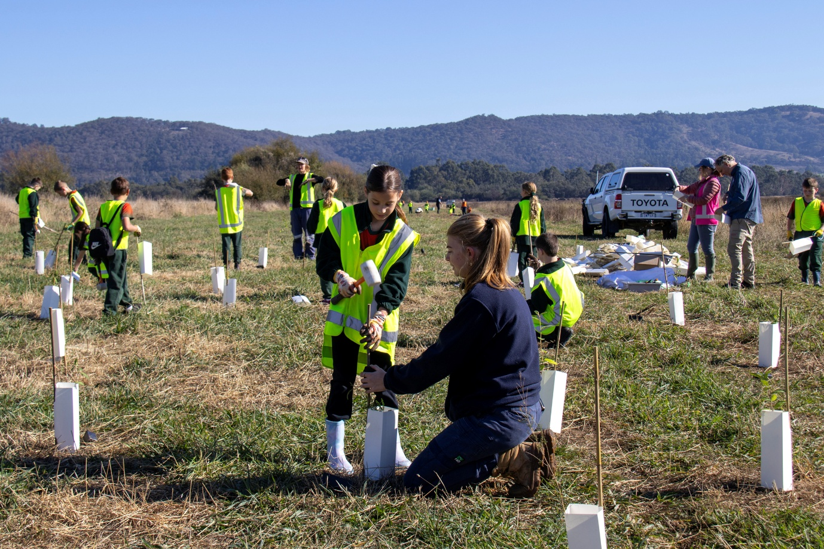
Children planting trees in Yering as part of the billabong restoration works.

Environmental Assessments
Council’s Environmental Assessment Team reviews planning applications for biodiversity impacts in Yarra Ranges, ensuring compliance with the 2025 State Guidelines on native vegetation removal.

Statutory Planning Referrals
In the 2024-2025 financial year:
- 198 Planning Referrals were completed.
- 37 permits were recommended for approval after assessment against the Guidelines and 70 Requests for Further Information were completed.
- 37 new Land Management Plans were requested to guide permitted development or reviewed.
- Total loss approved (by the assessment team) included:
  - 8.95 hectares of native vegetation and 73 large trees, to construct dwellings, outbuildings, driveways and to create defendable space.
  - Following the State Government’s Guidelines* these losses equate to offset requirements of 3.71 General Habitat Units, 0.774 Species Habitat Units for the White Star Bush Asterolasia asteriscophora subsp. Albiflora and 73 large trees.

Sustainability in Practice - Safeguarding Riparian Corridors
Environment Assessment Officers provided support to Statutory Planning Officers ensuring the consistent application of environmental legislation as outlined in the Planning and Environment Act 1987. A recurring focus has been the protection of waterways and their associated riparian vegetation, which plays a vital role in maintaining in-stream habitat and water quality.
To protect these natural assets, the strategy is to keep vegetated buffer zones at least 30 metres wide along each side of a waterway. Environment Officers have helped explain the ecological importance of these buffer zones and why new developments—and the defendable space needed to protect them from bushfires—can’t extend into these buffer zones.
Healthy riparian vegetation is characterised by a continuous corridor with a complex structure, including overlapping groundcovers, understorey, and canopy layers. However, this can sometimes conflict with bushfire safety rules, which require vegetation to be separated in all directions. This divergence has led to challenging planning outcomes, including the redesign of proposed developments, reduction in lot yield, and in one case, the determination that land is unsuitable for development.
These discussions can be complex and sensitive but are essential to uphold the environmental protections embedded within the planning scheme and to ensure long-term sustainability outcomes.

Gardens for Wildlife
The Gardens for Wildlife program promotes habitat creation and discusses weed impacts with urban and smaller homesteads.
In 2024-2025:
- 210 residents joined the Gardens for Wildlife Program, bringing total participation to 1007 since 2017
- 103 garden visits were conducted
- 20 volunteers visited properties and helped to promote the program.

Catchments and Waterways

Tanks for Platypus Project
The Tanks for Platypus project involves installing remote-controlled rainwater tanks on private and public properties to reduce flood risk, improve streamflow, and reduce potable water use. Yarra Ranges Council, University of Melbourne, Melbourne Water, South East Water Corporation, and the Department of Environment, Energy and Climate Change (DEECA) work together to deliver the project.
Progress this financial year included:
- Three real-time controlled rainwater tanks operating across residential and Council-owned properties.
- Belgrave Lake retrofitting design led by Melbourne Water and supported by Council to allow for additional environmental flows in Monbulk Creek nearing completion.
- 236 expressions of interest received from local residents and businesses.
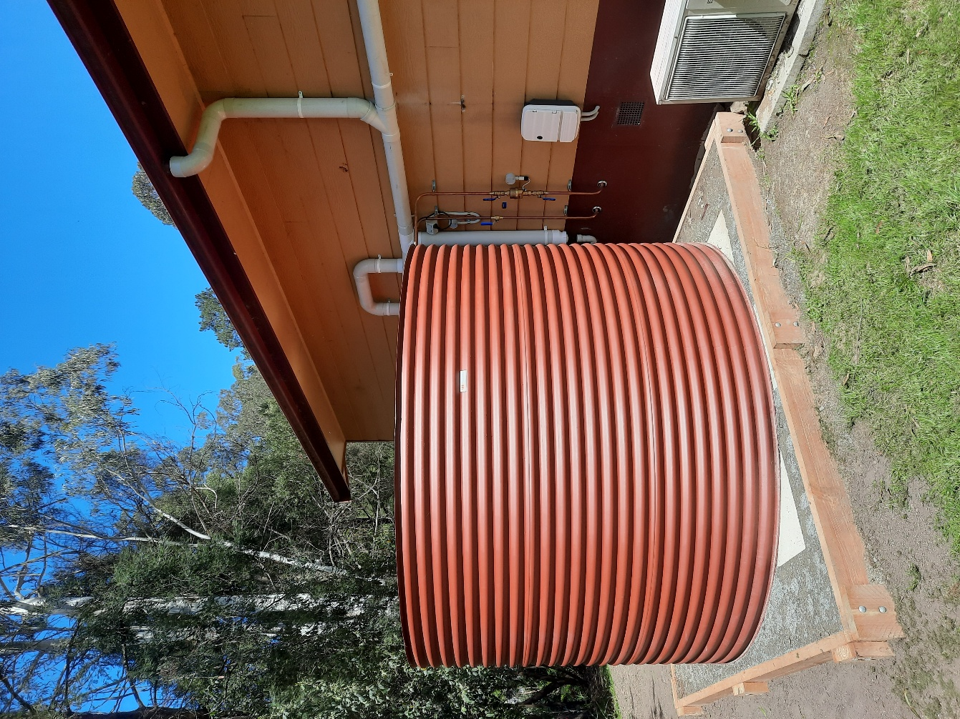
- 172 site assessments completed (93 residential and 4 non-residential suitable for further investigation).
Tank installed as part of the Tanks for Platypus program

Water Sensitive Urban Design
As of 2024-2025, Council manages 138 Water Sensitive Urban Design (WSUD) assets (swales, raingardens, wetlands and stormwater harvesting systems), reducing:
- stormwater discharging to waterways by 61 ML/year
- nitrogen by 373 kg/year
- gross pollutants by 24 tonnes/year.
Council operates stormwater harvesting systems at three sites – Pinks Reserve, Morrisons Reserve and Monbulk Recreation Reserve – supplying 5.7 million litres of treated stormwater for irrigating sports fields.
Council’s stormwater partnership with Melbourne Water continued through a range of initiatives that supported progress toward Healthy Waterways Strategy targets. This included investigations and feasibility studies in priority catchments, as well as detailed designs for ephemeral wetlands in Yarra Junction and Mt Evelyn.
This partnership, over the last three years, has also supported drainage projects as part of the Roads for Community Initiative (RCI). Overall, 60 per cent of roads sealed through RCI included lower impact drainage design to reduce the volume of additional stormwater discharging to waterways as a result of the road sealing program.

Climate Adaptation and Mitigation

Resilient Buildings and Energy
Working collaboratively across the organisation, Council’s Climate Team implemented a range of energy resilience measures in buildings throughout the Yarra Ranges, including solar power, battery storage, LED lighting, energy-efficient hot water systems, fixed and mobile generators and generator plug-in-points. These upgrades enhance power security by ensuring immediate back-up during grid failures.
Solar and battery systems provide reliable, on-site energy storage, while generator plug-in-points offer an alternative solution for sites where solar upgrades are not feasible. Additionally, the installation of LED lighting and energy-efficient hot water systems reduces overall electricity demand, extending the operational capacity of both battery storage and generator backup systems.
The following sites were upgraded using Preparing Australian Communities grant funding -
- Healesville Library/Link – battery optimisation.
- Dixons Creek Hall and Pavilion – generator plug-in point.
- Macclesfield Public Hall – hot water upgrade and generator plug-in point.
- Menzies Creek Recreation Reserve Pavilion C/B – LED lighting, hot water upgrade and generator plug-in point.
- Montrose Sports Pavilion – solar, battery, LED lighting, hot water upgrade and generator plug-in point.
- Lilydale Depot – LED lighting, hot water upgrade, generator plug-in point and shed to house the mobile generators.
- Steels Creek Community Centre – solar, battery and generator plug-in point.
- Wesburn Reserve Pavilion – LED lighting, hot water upgrade and generator plug-in point.
- Yarra Junction Shire Depot – LED lighting, hot water upgrade and generator plug-in point.
- Warburton Sporting Complex – LED lighting, hot water upgrade and generator plug-in point.
- Chirnside Park Community Hub – generator plug-in point.
- Esther Park Senior Soccer Pavilion – generator plug-in point.
- Japara Living and Learning Centre – generator plug-in point.
- Belgrave Community Hub – battery and generator plug-in point.
- Don Road Sporting Complex – Netball/Soccer Pavilion – generator plug-in point.
- Montrose Town Centre and Library – generator plug-in point.
- Morrison Reserve Sports Pavilion – generator plug-in point.
- Upwey Senior Citizens/meals on wheels (Blue Hills Centre) – generator plug-in point.
- Wandin North Community Sporting Pavilion – solar, battery and generator plug-in point.
- Monbulk Water Harvesting – generator plug-in point.
- Monbulk LINK and Sporting Pavilion (Microgrid) – solar, battery and fixed generator.
- Coldstream Community Centre – battery, solar and building fabrication improvements.
- Karwarra Gardens – battery.
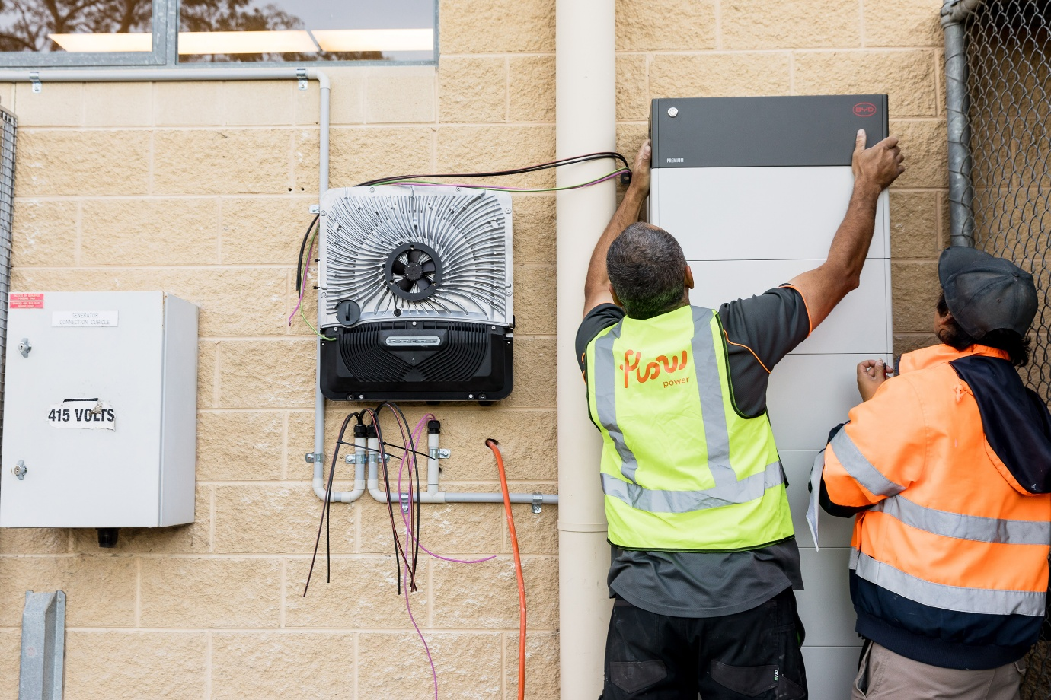
- Mobile Generators – three mobile generators (110kVA, 110kVA and 165kVA).
Men installing solar battery on Council-owned community building.

Sustainability in Practice - Steels Creek Community Centre
The Steels Creek Community Centre received a 7.36kW solar PV system, alongside a 22kwH battery and generator plug-in point to support its activation as an emergency hub during times of need.
For Maree Rothwell, vice president of Steels Creek Community Centre Committee, the upgrade holds significant value for local residents who have experienced power disruptions and bushfire events in the past.
“The initial benefit is reducing or eliminating electricity bills and thus improving the Community Centre’s financial position. In the longer term we are also hoping to make the Centre a hub during emergencies and situations such as prolonged power outages. Our community relies on tank water and thus electricity to have running water for toilets and food preparation.“
“Steels Creek Community Centre now has the ability to operate independently during power outages which means the community can act immediately in response to the local situation and can provide that timely support where other government assistance takes time to enable.” she said.

Sustainability in Practice – Resilient Energy Precinct, Monbulk Microgrid
In May 2024, Yarra Ranges Council, with support from Monash University and Birdwood Energy, published the ‘Resilient Energy Precinct’ feasibility study. The report proposed a staged approach to microgrid development in Monbulk, with the first stage involving the electrical connection of two buildings in Monbulk – the Sports Pavilion and the Living and Learning Centre – to form a small-scale microgrid. Deemed feasible, construction took place in late 2024 and early 2025. The project scope included redesign and alterations to the electrical connection between the two buildings, installation of a 201kWh battery storage unit and a fixed 150kVa generator, abolishment of a redundant electricity meter at the site and the installation of 100kW solar PV on the Sports Pavilion.
The Monbulk Microgrid enables the two key community buildings to operate independently of the grid during power outages, ensuring continuity of essential services and a safe community hub for relief during an emergency. This is critical in a region frequently impacted by storms, bushfires and other climate related events. The project was co-designed with local stakeholders which included emergency groups, sporting clubs and youth organisations, and the final design was informed by local needs and priorities.
More than 150 students contributed to a mural painted on the shipping container that houses the Microgrid’s infrastructure, turning it into a symbol of local pride and climate leadership, while fostering intergenerational engagement and ownership.

Emissions Profile
Greenhouse gas emissions are categorised into 3 scopes:
- Scope 1 emissions are direct emissions from activities such as Council fleet vehicles and on-site fuel combustion (gas boilers and other gas-powered equipment).
- Scope 2 emissions are indirect emissions from purchased electricity. Council’s Scope 2 emissions remain low due to participation in the Victorian Energy Collaboration (VECO), which sources 100% renewable electricity. A small increase this year reflects the inclusion of a previously unrecorded electricity account for unmetered uses such as traffic signals.
- Scope 3 emissions are indirect emissions from Council’s supply chain and supporting activities, such as contractor vehicle use and construction materials.
In 2024-25, Council’s emissions were calculated at 9,856.3tCO₂-e representing a 14.7 per cent increase from the previous year (2023-24: 8,592.6tCO₂-e).
This rise is primarily attributed to:
- Increased use of concrete and asphalt through the grant-funded Roads for Community Initiative;
- Inclusion of Melbourne Water wastewater and water data;
- Improved data availability and accuracy across all emission streams, including newly captured sources; and
- Evolving carbon accounting practices, with Council continuing to refine and strengthen its emissions reporting in line with industry best practice.
Scope 3 emissions remain the largest contributor, accounting for 85.8% of total emissions, reflecting the significant impact of Council’s supply chain and contracted services. Council has made significant progress in reducing Scope 1 emissions within its direct control, with a decrease of 4.6 per cent compared to last year.
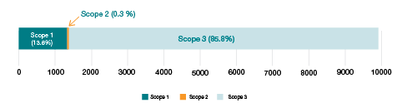
Breakdown of 2024-2025 emissions by Scope

 | 2023-2024 |  |  | 2024-2025
Emissions Source Category |  | Emissions (t CO₂-e) | Proportion of Total | Emissions (t CO₂-e) | Proportion of Total | Change | ▲▼ % Change
Scope 1 - Direct emissions
Natural Gas -  Scope 1 Sites |  | 70.0 | 0.8% | 60.0 | 0.6% | -10.1 | ▼14.38%
Stationary Energy (Fuel) |  | 9.1 | 0.1% | 7.5 | 0.1% | -1.6 | ▼17.82%
Transport Fuels (Fleet) |  | 1,262.4 | 14.3% | 1,222.5 | 12.4% | -39.9 | ▼3.16%
Refrigerants |  | 85.1 | 1.0% | 71.0 | 0.7% | -14.0 | ▼16.50%
Total Scope 1 |  | 1,426.6 | 16.1% | 1,360.9 | 13.8% | -65.6 | ▼4.60%
Scope 2 - Indirect emissions
Electricity - Scope 2 Non-VECO Sites |  | 0.0 | 0.0% | 34.0 | 0.3% | 34.0 | Newly Added
Electricity - Scope 2 VECO Sites |  | 0.0 | 0.0% | 0.0 | 0.0% | 0.0 | No Change
Total Scope 2 |  | 0.0 | 0.0 | 34.0 | 0.3% | 34.0 | Newly Added
Scope 3 - Indirect emission, voluntary, supply chain
Electricity- Non-VECO Scope 2 Sites |  | 0.0 | 0.0% | 4.6 | 0.05% | 4.6 | Newly added
Electricity- Non-VECO Scope 3 Site |  | 0.0 | 0.0% | 7.9 | 0.1% | 7.9 | Newly added
Electricity- VECO All Other Scope 3 Sites |  | 0.0 | 0.0% | 0.0 | 0.0% | 0.0 | No change
Natural Gas- Scope 3 Sites |  | 36.7 | 0.4% | 36.7 | 0.4% | 0.1 | ▲0.18%
Natural Gas- Scope 3 Aquatics |  | 846.7 | 9.6% | 819.0 | 8.3% | -27.7 | ▼3.27%
Scope 3 - Stationary Energy (Natural Gas) |  | 5.4 | 0.1% | 4.7 | 0.05% | -0.8 | ▼14.38%
Scope 3 - Stationary Energy (Fuel) |  | 2.2 | 0.03% | 1.8 | 0.02% | -0.4 | ▼17.82%
Scope 3 - Transport Fuels (Fleet) |  | 311.4 | 3.5% | 301.3 | 3.1% | -10.2 | ▼3.27%
Scope 3 - Transport Fuels (Contractors) |  | 4,192.9 | 47.4% | 4,198.8 | 42.6% | 5.9 | ▲0.14%
Scope 3 - Transport Fuels (Volunteers) |  | 153.6 | 1.7% | 0.0 | 0.0% | -153.6 | ▼100.00%
Business Travel  (Taxi and Hire Car) |  | 0.2 | 0.003% | 0.3 | 0.00% | 0.1 | ▲35.92%
Business Travel (Air and Space Transport) |  | 3.2 | 0.04% | 2.6 | 0.03% | -0.6 | ▼19.34%
Business Travel (Accommodation Hire) |  | 0.7 | 0.01% | 0.7 | 0.01% | 0.0 | ▲0.65%
Paper Use -  Carbon Neutral |  | 0.0 | 0.0% | 0.0 | 0.0% | 0.0 | No change
Water Supply |  | 21.0 | 0.2% | 460.9 | 4.7% | 439.9 | ▲2092.17%
Construction Materials (Asphalt & Concrete) |  | 1,710.1 | 19.3% | 2,481.1 | 25.2% | 771.0 | ▲45.09%
Food & Catering Services |  | 120.1 | 1.4% | 125.9 | 1.3% | 5.8 | ▲4.84%
Printing & Publications |  | 13.9 | 0.2% | 13.1 | 0.1% | -0.9 | ▼6.29%
Corporate Waste |  | 0.0 | 0.0% | 2.0 | 0.02% | 2.0 | Newly added
Total Scope 3 |  | 7,418.3 | 83.9% | 8,461.4 | 85.8% | 1043.1 | ▲14.06%
Total Scope 1,2 Emissions  (excluding Greenpower abatement) |  | 1,426.6 | 16.1% | 1,394.9 | 14.2% | -31.6 | ▼2.22%
Total Scope 1,2 and 3 Emissions  (excluding solar export abatement) |  | 8,844.9 | 100.0% | 9,856.3 | 100.0% | 1011.5 | ▲11.44%
Abatements
Emissions reduced through exported solar energy |  | 252.2 |  | 0.0
Total Abatements |  | 252.2 |  | 0.0
Total Net Emissions |  | 8,592.6 |  | 9,856.3 |  |  | ▲14.71%

Detailed emissions break down and year on year comparison

Zero Emissions Fleet
Council continues to transition its fleet towards zero emissions, with several key initiatives undertaken in 2024-25 to reduce operational emissions and support sustainable service delivery.

Electric Vehicles and Chargers
Ten 22kW AC chargers have been installed at the Civic Centre Lilydale, servicing ten carparking bays. This infrastructure, funded by Council and the Victorian Government’s Electric Vehicle Charging for Council Fleets Grant Program, will enable Council’s transition to electric vehicles (EVs).
Seven Council carpool vehicles have been replaced with electric vehicles.

Lillydale Lake Demonstrations
A demonstration day and on-site trial of an EcoTeq electric mower was held, with a 12-month trial now underway. Staff also participated in a test drive morning with a small electric truck manufacturer, informing a potential trial of the vehicle at Lilydale Lake in the second half of 2025.
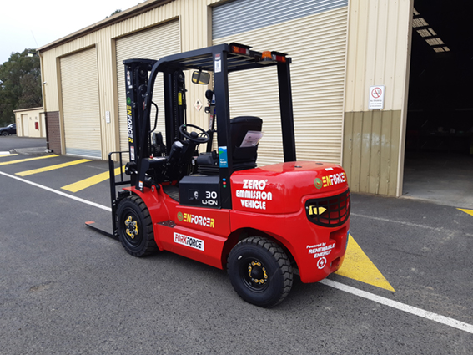

Environmental Stewardship and Reconciliation

Community Education and Events
Council’s Resilient Environment Department engaged with, and educated, community via 43 events in the last financial year. The events fostered community engagement and awareness in the areas of sustainable practices, resilience building, conservation and habitat restoration, citizen science, growing and preparing food, caring for wildlife and more.
Residents play a vital role in restoring habitats, creating wildlife-friendly gardens that help prevent weed spread, and reducing their carbon footprint—ensuring Yarra Ranges remains a thriving, sustainable community for generations to come.
Events included:
- Location walk and talks
- Mini-Beasts festival
- Platypus Festival and spotting events
- Environmental Volunteer Celebration event and expo
- Tree planting days with schools and community
- The Adaptation Game workshops
- Wildlife focussed walk and talks
- Food growing and preparation workshops
- Learning for Sustainability Conference for Educators
- City Nature Challenge at Lillydale Lake
- Habitat gardening.

Sustainability in Practice - Cultural Recovery and Resilience
Recent natural disasters have exposed gaps in emergency management, particularly in culturally appropriate support for trauma-affected communities and damaged landscapes. Aboriginal communities have faced barriers accessing effective relief and recovery services, compounding existing trauma and impacting the health of people, Country, and biodiversity.
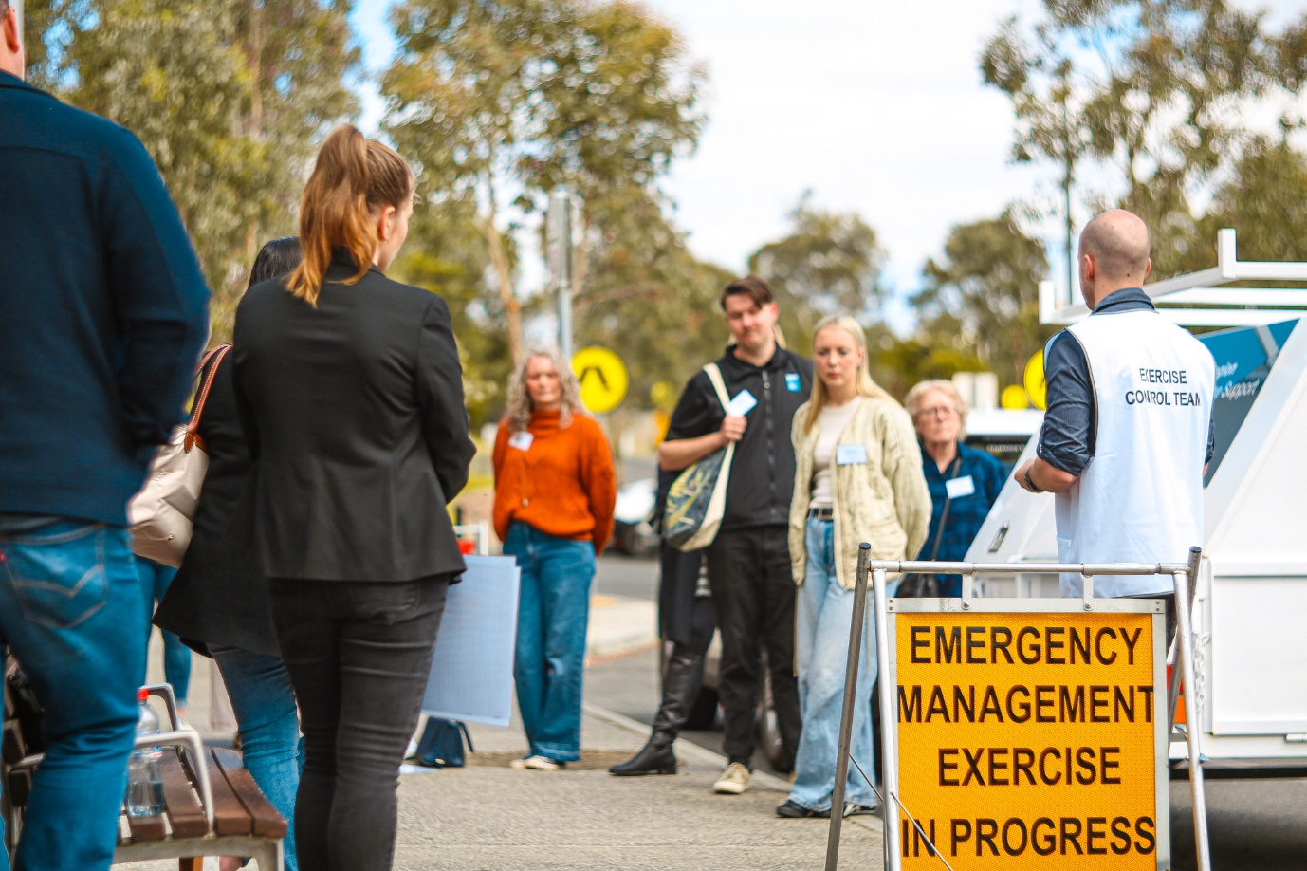
Yarra Ranges Council’s Pathway to Resilience initiative, developed by the Indigenous Development and Emergency Management teams, embeds Indigenous Ways of Knowing, Being and Doing into emergency response. Following the devastating June 2021 storms, Council delivered Cultural healing programs led by Taungurung and Larrakia community members, helping families reconnect with Country and begin their recovery journey. Participants described the workshops as transformative, affirming that “healthy Country means healthy people.” The initiative also supports cultural literacy among emergency practitioners and was nationally recognised in 2025, with Council invited to present at the Australian Disaster Resilience Conference.
People participating in an emergency management exercise.

Eastern Alliance for Sustainable Learning
The Eastern Alliance for Sustainable Learning (EASL) is a coalition of seven Councils dedicated to helping schools and early years services integrate sustainability into their curriculum, facilities, and policies. By fostering sustainable practices in education, EASL aims to embed sustainability within the broader community. EASL also serves as the delivery partner for the ResourceSmart Schools (RSS) program across eastern Melbourne.
In 2024-2025:
- The EASL member Councils include: Boroondara, Knox, Manningham, Maroondah, Monash, Whitehorse and Yarra Ranges.
- 250 people attended the annual Learning for Sustainability Conference, which included a welcome to country by Uncle Tony Garvey, a keynote speech by Millie Ross from Gardening Australia and an invigorating performance by the Junkyard Beats.
- Four online professional development/networking sessions delivered with registrations from 118 education providers.
- EASL facilitated numerous network meetings, including two for the Beyond Net Zero Network and two Teacher Environment Network meetings.

ResourceSmart Schools
The Sustainability Victoria ResourceSmart Schools (RSS) program supports schools to embed sustainability into curriculum, campus and community and make measurable reductions in waste, energy and water as well as improvements to biodiversity. The program is divided into eight regions across the State with each region supported by a local delivery partner. EASL is the delivery partner for the Eastern Metro Region which includes Boroondara, Knox, Manningham, Maroondah, Monash, Whitehorse and Yarra Ranges Councils.
In 2024-2025 Resource Smart Schools:
- Consisted of 120 active schools across the Eastern region (28 from Yarra Ranges)
- Awards had 10 EASL schools as finalists and won 7 of the 12 awards:
  - ResourceSmart School of the Year: Lilydale Heights College (Yarra Ranges Council)
  - School Volunteer of the Year: Bayswater South Primary School (Knox City Council)
  - Student Action Team of the Year (Primary): Heany Park Primary School (Knox City Council)
  - Student Action Team of the Year (Secondary): Kew High School (Boroondara City Council)
  - Curriculum Leadership of the Year (Primary) — Heany Park Primary School (Knox City Council)
  - RSS Teacher of the Year (Secondary) — Elise Dunstan, Kew High School (Boroondara City Council)
  - Container Deposit Scheme Victorian Excellence Award (Primary) – Wandin Yallock Primary School (Yarra Ranges Council)

Repower Festival
On 23 March 2025, Repower the Dandenongs hosted the first ‘Repower Festival’, a vibrant celebration centred on sustainability, electrification, and community resilience.
This family friendly event was a collaborative effort by community groups Repower the Dandenongs, Healesville CoRE and MADCOW, with support from Yarra Ranges Council, Community Bank Monbulk and District, and Monbulk Primary School. The festival addressed common misconceptions about electrification, renewable energy and home energy efficiency. Over 500 people attended to hear from renowned experts, explore a trade marketplace, and enjoy performances and fun activities such as face painting, electric go-karts and pedal-powered smoothies.

EASL’s Eastern region schools saved $1,321,434.00 through energy efficiencies including:
- 4,026,456 kWh energy
- 5,640 m³ waste diverted from landfill
- 61,103 KL water
- 3,100 tonnes greenhouse gas abated.

Volunteering
Council works with approximately 60 environmental volunteer groups/entities who operate within the Yarra Ranges. These include:
- Friends of and Landcare groups
- Gardens for Wildlife Garden Guides
- Community gardens
- Indigenous nurseries
- Renewable energy community groups
Council supports volunteer groups in a variety of ways including training, financial support, staff/contractor assistance and communications.

Sustainable Environment Advisory Committee
The Sustainable Environment Advisory Committee (SEAC), comprised of community representatives, continues to provide environmental and sustainability insights and advice on Council matters.
In 2024-2025, the committee provided valuable input across a range of strategic and place-based projects. Their contributions supported the integration of climate considerations into broader Council strategies and helped refine environmental data presentation and planning approaches.
SEAC members engaged in meaningful discussions on the following topics:
- Health and Wellbeing Strategy
- Green Wedge Management Plan
- Environment Strategy Review
- Upper Yarra Innovation Working Groups
- Yarra Glen Place Plan
- Integrated Water Management Plan
- Erosion Management Overlay.

Sustainable Economy, Food and Housing

Environmentally Sustainable Design and Planning Referrals
Environmentally Sustainable Design (ESD) aims to reduce environmental impact through thoughtful building and infrastructure design, to improve energy and efficiency and overall occupant comfort.
In 2024-2025:
- Yarra Ranges maintained its active membership with the Council Alliance for a Sustainable Built Environment (CASBE), continuing to benefit from shared knowledge and access to a wide range of learning opportunities and resources.
- A total of 83 statutory ESD referrals were completed in accordance with planning scheme requirements. These assessments supported high-quality development outcomes across the municipality, contributing to reduced community emissions and lower operating costs for building occupants.

Gardens for Harvest Program
The Gardens for Harvest program encourages residents to grow their own food or get involved in a local community garden as a way to eat healthy and affordable fresh food, helping to reduce supply chain emissions and improve their overall health and wellbeing.
The program has over 1,700 participants who receive a monthly newsletter and invitations to events and workshops.

Community Gardens Network
The Community Gardens Network brings together gardening enthusiasts who grow and share fresh vegetables and fruit.
During the last financial year:
- The network of nine gardens met monthly to share ideas and provide support to each other
- Council’s Community Gardens Facilitator collaborated with stakeholders to establish and implement a streamlined application process.
- Wheelchair accessible garden furniture was provided to multiple gardens by the Work for the Dole program.
- Sponsorship opportunities were made available to Community Gardens groups from building material suppliers.

Business Energy and Water Saving Kit Initiative
Local businesses continue to have access to Energy and Water Saver Kits. The kits contain a thermal imaging camera, power meter, thermometer and instructional guide which enables users to identify water leaks, high-energy consuming items and design inefficiencies.
Business Energy and Water Saving kits are available to borrow from Council Community Links.

Health and Wellbeing Projects
The Health and Wellbeing team enhances the health, safety and wellbeing of the Yarra Ranges community, supporting a more sustainable and resilient region by promoting healthy lifestyles, social connection, and access to nature. Highlights of their work are summarised below.
A new Changing Places facility opened at Pinks Reserve Sporting Stadium in Kilsyth making it the sixth fully accessible toilet and change room in the Yarra Ranges. The facility is designed to support people with disabilities along with their carers. Developed as part of the Resilient Yarra Ranges program, the project was funded by the Federal Government’s Preparing Australian Communities Program and was designed with input from the Yarra Ranges Council Disability Advisory Committee. It includes a height-adjustable adult-sized change table, shower, a constant-charging ceiling track hoist system, as well as a peninsula toilet with space for carers.
Council initiated a Yarra Ranges Homelessness committee that brings together critical stakeholders in homelessness to review complex cases and collaborate on sustainable solutions between partners.
Between 2021–2025, Council has distributed over $5.4 million in funding across 770 approved grants, supporting community-led initiatives that foster inclusion, resilience and wellbeing. The Community Grants Program is a key delivery mechanism for the Health and Wellbeing Plan 2021-2025 with criteria that prioritise accessibility, equity, and connection. Almost all funded projects help build a sense of belonging – one of the most powerful ways to improve community health outcomes. Council supports creative, strengths-based initiatives that tap into community knowledge and respond to local needs, helping to build more connected, inclusive and vibrant communities across Yarra Ranges.
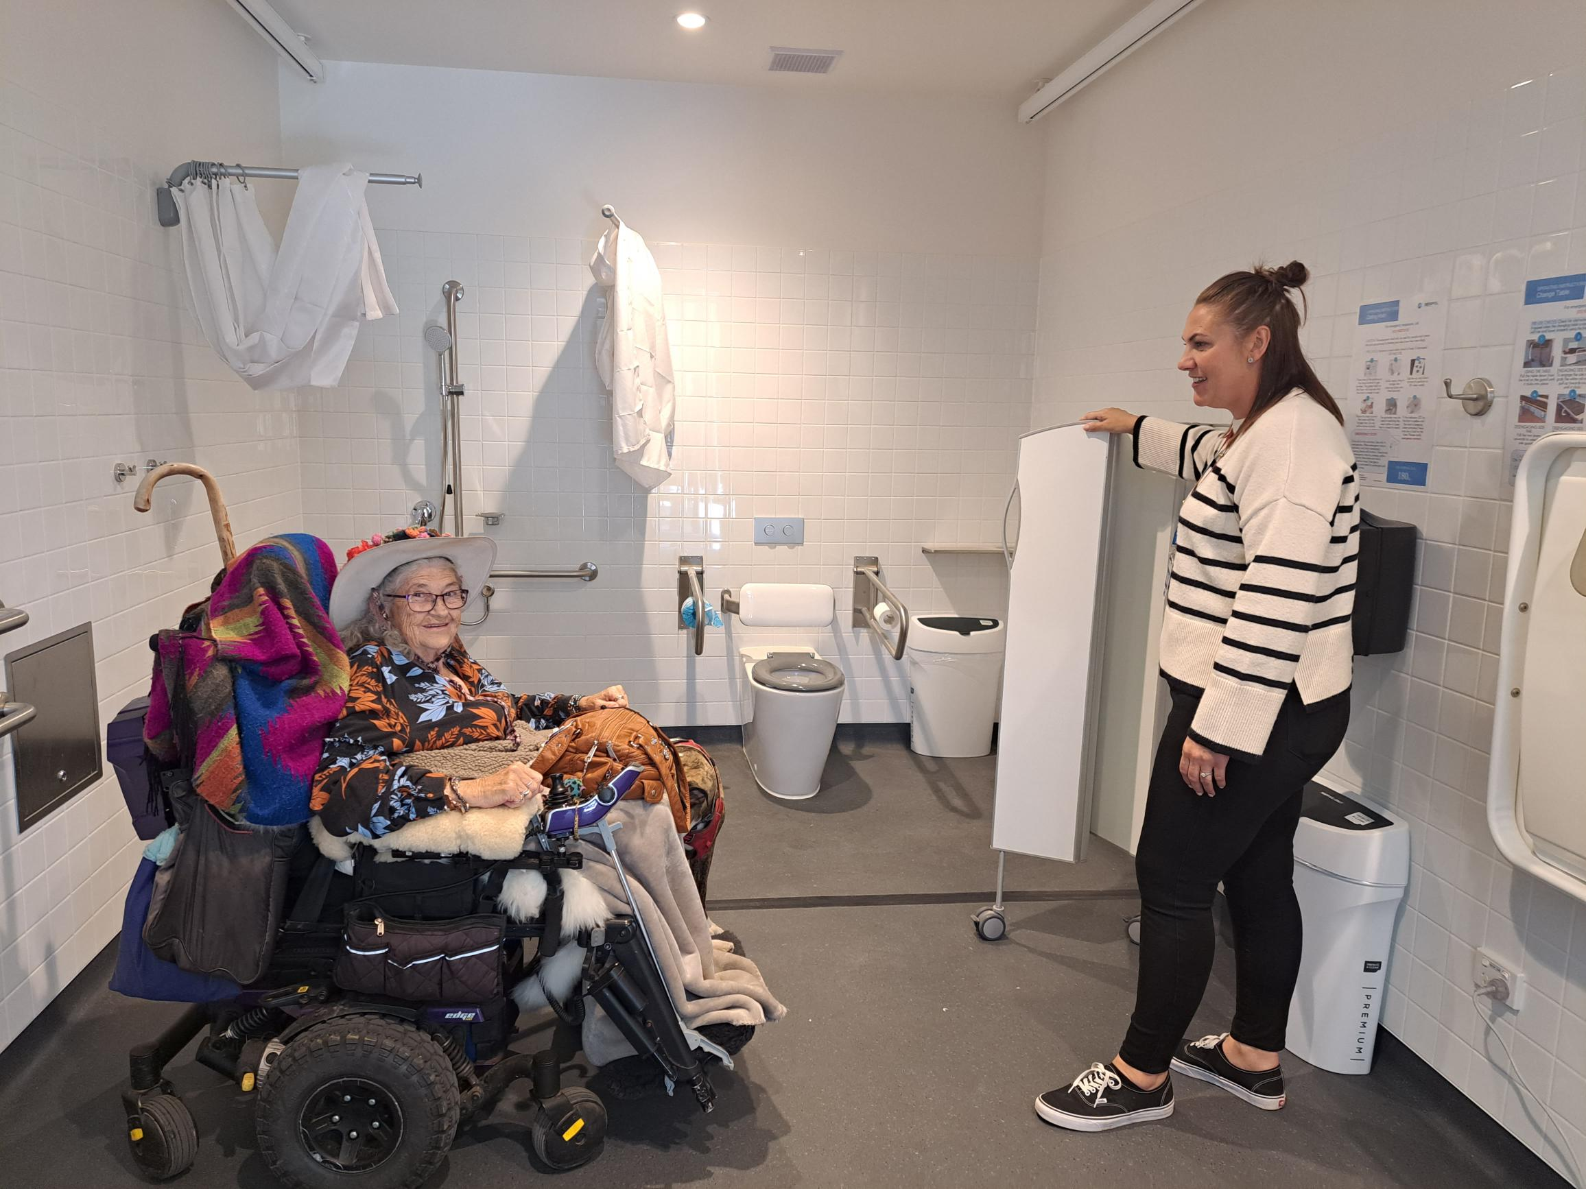
Changing Places facility at Pinks Reserve Sporting Stadium in Kilsyth

Enhancing Sustainable Transport and Places

Cycle Centre Nodes
Cycle Centre Nodes are purpose-built hubs along major cycling trails that support active transport and enhance rider experience. They offer essential amenities such as shelter, seating, electric bike charging, and repair stations to encourage sustainable travel and community connection.
Yarra Ranges Council has delivered two new nodes in Lilydale:
Beresford Road
Located at the junction of the Warburton Rail Trail and Yarra Valley Trail, transforming a previously underused site into a vibrant trailhead.
Main Street
Positioned along the Carrum to Warburton Trail, improving access from Lilydale’s town centre and boosting trail connectivity.
These upgrades promote sustainable travel, support eco-tourism, and strengthen the local economy by attracting more visitors. They also reflect Council’s commitment to sustainable infrastructure, low emissions transport and environmental stewardship.

Revitalised Playspaces
Five playspaces across the Yarra Ranges – Bluegum Reserve, Morrison Recreation Reserve, McKenzie King Reserve, Wright Avenue Reserve, and Queen Road – were upgraded and now feature nature-based play, inclusive equipment, sheltered seating, and native landscaping. Sustainable materials and shade trees were used to reduce environmental impact and urban heat.
These enhancements improve access to green spaces, support outdoor play and social connection, promote environmental awareness, and provide safe, welcoming areas for all ages and abilities.

Recreation and Sports
Enhanced remote online monitoring systems are now used across indoor and outdoor swimming pools after existing infrastructure was fitted with new pulse devices that record water usage every 30 seconds. This real-time data enables swift responses to abnormal consumption patterns through automated alerts, assisting in saving water.
Council continued its energy efficiency program by replacing metal halide lighting with high-efficiency LED technology across several sports fields and courts. LED fixtures consume significantly less energy (approximately 1,200 watts compared to 2,000 watts per metal halide fixture) and offer superior light output, often allowing for a reduction in the total number of light heads required. Sites upgraded this year include Lilydale BMX Club, Belgrave Tennis Club, and Mt Evelyn Pavilion.
Rail infrastructure and timber from Stage 1B.1 of the Yarra Valley Trail were salvaged and repurposed for use along the trail. These materials were utilised by other Council teams and heritage railways, supporting the circular economy principles through material reuse.
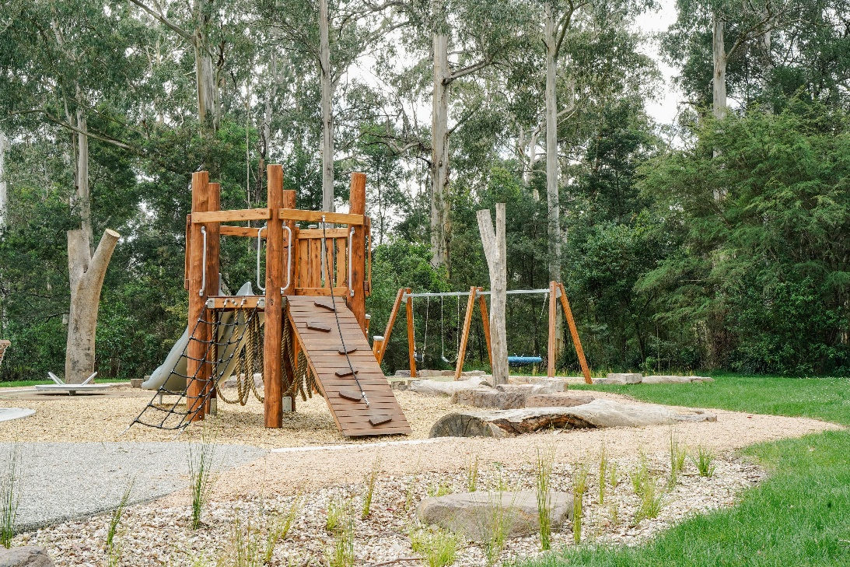
Bluegum Reserve playground in Badger Creek

Resource Recovery

Kerbside Collections
In the two years since changes to bin collections were introduced (weekly Food and Garden Organics (FOGO), fortnightly rubbish and recycling), there have been significant increases in the recovery of resources for recycling and reuse.
FOGO bins continue to be well utilised with the amount of organic waste (predominately food waste) recovered from landfill reaching 33 per cent, however, we are yet to achieve targets set for food waste in both Council and Victorian Government waste policies.
Whilst the amount of food waste sent to landfill needs to reduce, a large amount of green waste continues to be collected weekly. This reduces the amount of garden waste being burnt on bushfire-prone properties and results in cleaner air quality.
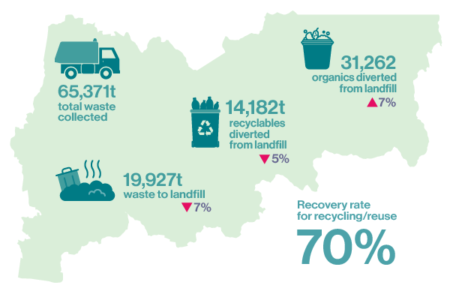
The total amount of each waste type collected in kerbside bins from households and small businesses (2024-2025) is detailed below (including a comparison with 2023/24 for collection types as a per centage).
Rubbish sent to landfill | 19,927 tonnes (-7%)
FOGO | 31,262 tonnes (+7%)
Recycling | 14,182 tonnes (-5%)
Total waste collected | 65,371 tonnes
Recovery rate for recycling/reuse  from bins | 70% in 2024/25

Overall Waste Collections
When all types of waste collected are included – park and street litter bins, annual hard rubbish and bundled branches collections – the rate of recovery of recyclables drops.
Total waste collected | 73,912 tonnes
Overall recovery rate for recycling/reuse | 63%

The decrease in the recovery rate is affected by two factors – street and park litter bin waste is sent to landfill due to the difficulty in recovering recyclables in these bins; and hard rubbish collections are largely made up of waste sent to landfill.

Detox Your Home
Detox Your Home is a hazardous waste drop-off program, organised by Sustainability Victoria with funding from the State government.
Residents were able to drop off materials for safe disposal in Lilydale in early 2025. A total of 248 people dropped off an average of 25kg each.
Council will continue to advocate for dedicated, ongoing funding from the State Government for this program

Recycling Education Project
Council delivered a comprehensive recycling education project supported by funding from Sustainability Victoria’s Circular Economy Household Education Fund.
The project aimed to improve correct use of recycling bins and build confidence in the recycling system. The campaign utilised social media, newsletters, newspaper advertising, public place advertising (posters, banners), and a mailout to reach residents across the municipality.
A 56 per cent reduction in recycling bins containing high levels of incorrect items was measured through Council’s bin education program following the campaign. We also saw a significant decrease in electronic waste placed in recycling bins, specifically, a 50 per cent reduction in items with power cords and a 70 per cent reduction in battery-powered items.

