2023

Yarra Ranges Human Services Needs Analysis, November 2023

YARRA RANGES COUNCIL



Access to human services in Yarra Ranges

Contents

Executive summary 1

Overview of findings 1

Project overview 5

Background 5

Project aims and objectives 5

Methodology 6

Notes on interpreting survey data 7

Survey response rate 7

Map of planning areas in Yarra Ranges 8

Key findings 9

Service characteristics 9

Service gaps 9

Gaps by service type 9

Gaps by local area 10

Gaps and issues by population group 12

Service barriers 15

Changes in demand since 2019 17

Inability to meet demand for services 20

What is driving changes in service demand? 20

Future service demand and challenges 21

Future service demand 21

Future challenges 22

Technology & innovation 22

Information from service data sets 22

Service needs and gaps 22

Changes in service use 23

Current service demand 23

Service barriers 23

Glossary 25

Human services survey data 26

Service characteristics 26

Age & disability services 31

Service types 31

Service gaps 31

Increases in demand since 2019 32

Community health services 34

Service types 34

Service gaps 35

Increases in demand since 2019 36

Emergency response and support services 38

Service types 38

Service gaps 39

Increases in demand since 2019 39

Mental health, drug and alcohol, and gambling services 41

Service types 41

Service gaps 41

Increases in demand since 2019 42

Other services 44

Service types 44

Service gaps 46

Increases in demand since 2019 48

Service gaps and challenges for different population groups 50

Women 52

Men 53

Children and families 53

Young people aged 12-24 54

Older people aged 65 years & over 55

Unpaid carers 56

Gender diverse residents 57

LGBTIQA+ residents 57

Persons with a disability 58

Low income residents and households 59

Culturally and linguistically diverse residents 59

Aboriginal and Torres Strait Islander residents 60

Barriers to meeting community needs 61

Lack of staff and volunteers 61

Service cost issues 61

Client cost issues 62

Physical service issues 62

Client health issues 62

Referrals and case management 63

Issues with service provision 63

Issues with restrictions on service access 64

Communication issues 64

Other issues 64

Impacts from the COVID-19 pandemic 65

Changing population health and demographics 65

Changing patterns of service use and demand 67

Changing patterns of service use 67

Factors affecting future service demand 67

Inability to service demand 68

Factors affecting services’ ability to meet community demand 68

Future challenges 69

Reduced demand after COVID-19 69

Programs which have ceased in the past 12 months 69

Technology 70

Innovation 70

Other comments 70

Demographics 71

2021 Census highlights 71

Key population characteristics 73

Service datasets 78

Health services 78

General factors affecting health workforce shortages 78

Shortages of medical practitioners 79

Distribution Priority Areas for GPs services 79

Districts of Workforce Shortage 79

GP costs and numbers 79

Service issues for GPs 80

Primary health needs in the community 82

NEPHU population health planning 82

Changes in use of GP, allied health and specialist health care 84

Allied health 84

Chronic disease, preventative care and service provision 84

GPs 84

Physical care 85

Mental health 85

Indigenous health care 85

Other 85

Specialist health care 86

Preventative care 86

GPs and nurses 86

Mental health 86

Other 86

Community health services 92

Community dental services 92

Mental health services 96

Availability of psychiatrists and GPs 96

Unpublished GP and hospital data 96

Medicare-subsidised mental health-specific services 97

Ambulance services 100

Specialist Homelessness Services 102

Clients by local area 102

Client characteristics 104

Unmet needs for services and assistance 108

Alcohol services 111

Ambulance attendances 111

DirectLine phone counselling 113

Counselling online 114

Treatment episodes 116

Other service types 117

Legal services 117

Eating disorder services 118

Problem gambling support services 119

Social support services 119

Emergency support services 119

Family violence support services 120

Aged care services 120

Conclusion 123

Appendix 1: Additional demographics 124

People and population 124

Cultural diversity 125

Income 126

Unpaid work and care 126

Health 127

Long-term health conditions 127

Mental health conditions 128

Disability 129

Housing 129

Transport 129

Appendix 2: Strategic alignment 130

Council Plan 130

Municipal Recovery Plan 131

Appendix 3: Survey respondents 132

Appendix 4: Selected survey tables 133

# Executive summary

Throughout 2023, Yarra Ranges Council has been conducting an analysis of the need for human services in Yarra Ranges. The Human Services Needs Analysis (HSNA) provides insight into the main issues affecting services. These includethe challenges for services in meeting community needs, andwhether these challenges are expected to continue; increases and shifts in service demand since the onset of the pandemic;the main localities and service types which have gaps in their capacity to meet community needs; and the extent of unmet community need.The HSNA also provides insight into community service needs and issues, including difficulties in obtaining necessary services; barriers obstructing access to services; and the ongoing physical, mental and social impacts of the pandemic.

## Overview of findings

The ability to access services where and when they are needed is crucial to community health and wellbeing. However, Yarra Ranges residents experience significant challenges when trying to access local human services. An analysis of service data and the survey this report represents provides evidence that most services have experienced rising demand over the past four years and have often been unable to meet community demand. Community service needs and service access have been affected by rising living costs, lack of affordable accommodation, transport access, worsening mental health, lack of social connections, and increasing levels of chronic health issues. Services have also been affected by rising costs, along with a multitude of difficulties in providing services, including staff and volunteer shortages, reductions to funding, and a lack of appropriate infrastructure.

The pandemic has created ongoing mental health, social and financial impacts. Issues such as cost of living and the level of chronic health issues are expected to continue to affect services over the next five years,along with the health and wellbeing impacts of an increasing number of climate-related disasters and extreme weather events. At the same time, the community is becoming more aware of service options and associating less stigma with using services. The pandemic has led to increased online service options; and services are using technology, collaboration and outreach services to try to fill service gaps.

**Community needs**

Community needs have shifted substantially. Worsening mental and physical health, and rising living costs, were the main factors driving changing service demand. The services with the most increases in demand since 2019 were emergency and food relief; housing and homelessness support; social connection and support; mental health; and financial counselling. People now need more services per person, have more complex health issues, and are deeply affected by issues such as housing and family violence. There is now less stigma about using services, better awareness of services and new online service options; but one-quarter of consumers are still concerned about the risk of infection from COVID-19 when using services.

**Challenges for service provision**

Human services are currently facing a range of barriers to providing services, relating to staffing, difficulties in providing services, cost issues, transport and worsening community health.Clients are presenting with more numerous and complex conditions, more advanced health problems (e.g., advanced skin cancer), worse mental and physical health, and higher service needs per person.

The key barriers for services include lack of staff and volunteers; long waiting lists and waiting times; lack of sufficient services, combined with a reduction in the number of services and programs; lack of suitable space; lack of GPs, who are often the first step in referring patients to a specialist service; rising costs of service provision; and difficulties with referring clients to other services– again, due to issues such as waiting lists, services not accepting new clients,lack of available services or no local services.Service data also showed major shortages for all types of medical specialists, and that workers are not available in the areas that need them the most, contributing to the workforce shortages identified in the survey. Shortages of staff who live locally, and difficulties in attracting (and retaining) staff to work in Yarra Ranges, are exacerbated by lack of affordable accommodation to rent or purchase, and the distance of many service locations from population centres and public transport.

Most services have experienced rising demand over the past four years; nearly two-thirds of services had experienced demand which they had been unable to meet, and one-third had had to decline requests for service.This has mostly been caused by insufficient funding combined with cuts to funding for some programs (such as preventative community health services, telehealth, cuts to the number of visits under a mental health plan); lack of staff and volunteers; lack of resources; and lack of infrastructure.

Over the next five years, services expect the continuing challenge of rising demand, worsening community health, lack of service funding, rising living costs, and shortages of staff and volunteers. One in five GPs plan to retire over the next three years, which will exacerbate shortages of health workers. Many services were also expecting climate change to have major impacts on community wellbeing, service access and infrastructure.

Council plays an important role in providing infrastructure for services, providing premises to 43% of the human services surveyed. This is in the context of 28% of services saying that lack of suitable infrastructure is likely to be a future service challenge.

Services are adapting by using online service provision and other forms of technology, more collaboration with other services, and more outreach and co-location. Services are re-training staff, but staff shortages are likely to remain a key issue, and reducing levels of volunteering are an issue nation-wide. Whilst online service provision may work in some contexts, service data from GPS and patients indicates an ongoing lack of support for patients using online services, and experiencing issues with internet connections and technology, which limits the effectiveness of telehealth services unless more support becomes available.

**Issues for specific service types**

Council has used a range of information to identify service needs and issues, including a survey of local service providers and information from a wide range of data sets. The main service gaps, across all service types and areas, include:

* Housing and homelessness support. This includes a high level of unmet service need amongst clients of homelessness services, for both accommodation and a range of other services.
* Transport services and access to transport; lack of transport access to physical services was also identified in service datasets.
* Youth services.
* Mental health services. Service data also highlight shortages of GPs, mental health specialists and other specialists, potentially linked to a higher use of hospitals for mental health care.
* Advocacy. Council advocates for community needs to all levels of government. Council advocacy aims to gain support for key projects and policies, to deliver the social, health, cultural, infrastructure, education and transport outcomes necessary to community wellbeing.
* Social connection and support.
* Acute health care services.
* Services for culturally diverse groups and for indigenous residents.
* Family violence and sexual assault.

The Hills and the Valley reported the highest number of service gaps.

**Community access to services**

Residents are facing a range of barriers in accessing services, including the cost of using services, lack of health insurance, transport access, difficulties in getting a referral promptly, waiting times, and lack of availability of local services. Factors such as insecure housing and family violence also make it harder to access services. Nearly all services report ongoing pandemic impacts within the community, particularly mental health impacts, social impacts and financial impacts.

Services identified a range of issues for specific community sectors. These included the need for more carer support and respite care; culturally safe services; and social groups for different segments in the community, especially LGBTIQA+ residents. One unexpected issue was an identified need for safe spaces for people to socialise in. The feedback also highlighted the need for services to be affordable, and a need for financial planning and education for low income residents and households.

Use of early intervention services for children has jumped over the past few years; lockdowns have had a range of developmental impacts for children which would contribute to increase service use. The need for early intervention services was not identified in the survey, and increased targeting of children’s services would be recommended for future iterations of the survey.

Service data shows that people were using less preventative care for chronic diseases during lockdowns (e.g., diabetes care) and were also using less allied health services, which would be contributing to the increased chronic health issues that services are now witnessing amongst their clients. There was reduced use of indigenous health care services, a lockdown issue not identified in the survey data.

**Next steps**

Council’s next step is to share these insights more broadly, to use this work to inform upcoming strategic and advocacy work, and to work with service providers to develop appropriate responses.

## Project overview

### Background

Yarra Ranges Council is strongly committed to supporting services which meet community needs, and to understanding the needs of both community members and local services. To this end, Council has undertaken a comprehensive analysis of human services needs across Yarra Ranges. The project is the first of its kind for Yarra Ranges – previous service planning work has tended to focus on a specific service type, or be driven by factors such as legislative change or funding availability. The project concept was modelled on the approach taken by the City of Whittlesea in its analysis of human service needs.

The Yarra Ranges Human Services Needs Analysis (HSNA) provides an evidence-based assessment of human services in Yarra Ranges, in order to identify service needs, gaps and barriers. The information gathered will be used to inform Council’s service and infrastructure planning, provision and advocacy – both internally and externally - and to assist with identifying service priorities. It will support needs-based allocation of resources in service provision; and will help to inform the development of Council’s Social Planning Framework. The HSNA will also assist in exploring opportunities for partnership and advocacy work between Council, service providers, community members and other stakeholders.

### Project aims and objectives

The main aims of the HSNA were to obtain and collate evidence and information (both qualitative and quantitative) regarding human services[1] supply, demand and needswithin Yarra Ranges; and to identify service gaps and issues across different local areas, demographic groups and service types. The HSNA also sought feedback from services on predicted future levels of service provision and demand.

Key project aims:

* To understand supply and demand for various types of human services (including those with a primary prevention role), service gaps and challenges, unmet community needs, barriers to service usage, emerging issues, and potential future trends and innovations.
* To enhance Council capacity to undertake advocacy, support local services, and plan for future service demand.

The information from the HSNA will be used by Council, its partners and service providers for the following purposes:

**Inform**

* Gain increased awareness of current and emerging service demand, service gaps, service issues and service priorities.
* Inform program development and evaluation.
* Provide background information for potential new service providers.
* Form part of a framework to inform broad discourse.
* Inform key council strategies and documents, including the health and wellbeing plan, the disability access and inclusion plan, and the social planning framework.
* Strengthen and inform work with external partners.

**Advocate**

* Support general Council advocacy work.
* Provide a basis for ministerial briefings.
* Be used in briefing other bodies.
* Contribute evidence for grant applications, for both service- and infrastructure-focused grants.

**Plan**

* Support strategic and action planning.
* Support service and infrastructure planning and provision.
* Provide a benchmark and basis for reviewing existing human services delivery models.

**Partner**

* Support partnership work and development.

### Methodology

The HSNA has been developed using data from the online survey of service providers; information from publicly-available health, service and workforce data sets; demographic data from the 2021 Census and from customised population forecasts; and qualitative information from stakeholder discussions. A detailed survey was developed in consultation with internal and external stakeholders. This was trialed and adjusted, then sent out to external services, and to Council teams providing human services in Yarra Ranges.

The methodology incorporated the following stages:

1. Consultation with key stakeholders regarding project scope, data needs and survey content; identifying existing data sets; and finalising stakeholder lists for survey distribution.
2. Drafting the survey and developing distribution methods.
3. Testing the survey with internal and external stakeholders.
4. Finalising and distributing the survey.
5. Analysing existing health, service and workforce data sets; and analysing key demographic indicators for the community.
6. Survey table production and data analysis.
7. Development of draft report with preliminary findings.
8. Additional consultation with stakeholders and the community.
9. Development of final Human Services Needs Analysis report.

### Notes on interpreting survey data

Note that the survey findings generally relate to all services, except where questions were targeted to a particular service type. This may skew the results somewhat. For example, housing and homelessness was one of the main service types answering the survey, so housing-related issues could be expected to feature strongly in results and comments.

The percentages used for survey results refer to all survey respondents, unless a specific group or survey type is referenced (e.g., percentage of age and disability services). Percentage results refer only to the percentage of survey respondents, and are not meant to be taken as representative of all services in Yarra Ranges; rather, the survey data provides a snapshot of the views of those who answered the survey.

### Survey response rate

The survey was sent to 192 organisations which provide health and human services in Yarra Ranges; it was also sent to outwards-facing Council teams which provide services to the community. The survey received 125 responses, including:

* 67 fully complete responses; one was anonymous, so data from that response has been excluded, leaving 66 responses used in the survey data analysis. These included responses by eleven Council staff across various Council services. A total of 55 responses were provided by 47 external organisations, giving an approximate response rate of 24.5%. Many organisations have separate areas providing different services, which would lead to multiple responses for one organisation.
* 29 incomplete responses, where respondents started to complete the survey but did not finish it. The available data indicates that reasons for this would include deciding that the survey was more relevant to someone else in the organisation (for many of these incomplete surveys, Council also received a completed survey from that organisation); or deciding that the survey content was not relevant to their organisation or program.
* 29 blank responses. These would include situations where people were interested in looking at the survey design (e.g., other Councils), but they were not a Yarra Ranges service so they did not start filling out the survey.

## Map of planning areas in Yarra Ranges

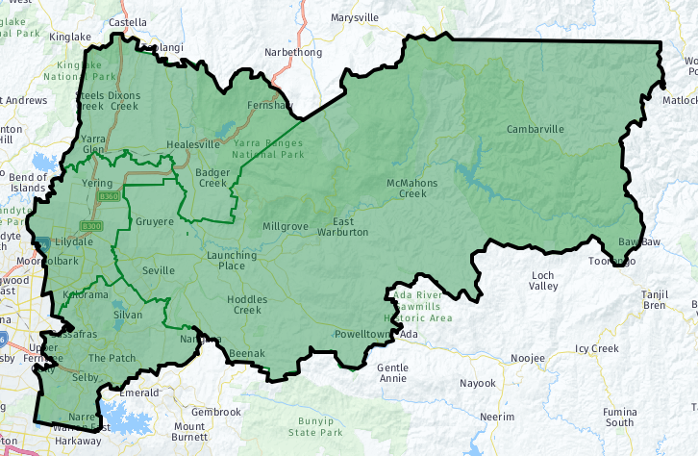

**Healesville-Yarra Glen**

**Hills**

**Urban Area**

**Valley**

Source ID Consulting (2023). *Profile areas, Yarra Ranges Council.* <https://profile.id.com.au/yarra-ranges/about>

## Key findings

### Service characteristics

More than half of the services surveyed had all of Yarra Ranges as their main catchment area; the rest covered local areas within Yarra Ranges, or Yarra Ranges plus a broader catchment area. Survey respondents were predominantly Yarra Ranges-focused - for most services, at least 80% of their users were Yarra Ranges residents. The main user groups were women (68%), children and families (62%), men (57%), older people (51%), low income households (49%), and young people aged 12-24; services also covered a diverse range of users going far beyond these groups. Key service types included social connection, housing, emergency relief, support for specific population groups, mental health services, and information and advice. Half of the services offered preventative health programs. Council played an important infrastructure role, as the sole or part provider of premises for 43% of services.

The main types of services were social connection and support; housing and homelessness support; emergency relief and response; health and other services for specific population groups; mental health services; and information, advice and referrals.

### Service gaps

#### Gaps by service type

For age and disability services, the most frequent gap identified was support for unpaid carers, which was a gap across the whole of Yarra Ranges. Service data show that Yarra Ranges also has large gaps in residential aged care services, with no services at all in the Hills and a large shortfall in the Urban Area. This benchmark will reduce from 2024/25, due to an increasing preference amongst older residents to age at home rather than going into residential care. However, Yarra Ranges has an ageing population, so the shortfall in availability of residential care is likely to grow unless new services are built.

Community health services cover a wide range of health services with services focusing on health promotion, women’s health, chronic disease management, allied health, family violence and sexual health. Their main service gaps were in women’s health, including family violence and sexual assault, sexual health, and women’s health; allied health; and health promotion. Perceptions of gaps in emergency response and support services were high across all service types. Mental health was a major gap - all mental health service providers saw this as a service gap across Yarra Ranges. Gaps affecting all of Yarra Ranges were also seen as an issue for most other service types: housing and homelessness, transport, youth services, advocacy, social connection and support, services for CALD and ATSI communities, and acute health care.

#### Gaps by local area

The Hills and the Valley were the areas most likely to be affected by service gaps, with less gaps being identified for the Urban Area and Healesville-Yarra Glen. Gaps in emergency response and support services were the most likely to be seen as specific to local areas, particularly in terms of gaps in disaster preparation and recovery services in the Hills. The Hills also had the highest number of age and disability service gaps, particularly for services for older people; and it was the only area identified as having a gap in disability services. For community health, the largest number of service gaps was identified in the Valley, with gaps identified for all community health service types apart from dental health.

Mental health service gaps were fairly evenly spread across the four planning areas. There was also a high level of gaps for information, advice and referrals; youth services; and advocacy. These were issues across Yarra Ranges, but also particularly in the Hills and the Valley. Transport in the Valley had the highest level of area-specific gaps of any service type.

Key service gaps - Are there any service gaps affecting all or part of Yarra Ranges?

|  |  |
| --- | --- |
| Type of service gap | Number of services |
| Housing and homelessness support | 28 |
| Transport services | 26 |
| Mental health services, including counselling | 23 |
| Family violence and sexual assault | 18 |
| Youth services (12-25 year olds) | 16 |
| Support for unpaid carers | 16 |
| Advocacy | 15 |
| Social connection and support | 15 |
| Services specifically for refugees and culturally and linguistically diverse groups | 15 |
| Acute health care services | 14 |
| Women’s health | 14 |
| Aboriginal and Torres Strait Islander - specific health services | 13 |
| Sexual health | 13 |
| Financial counselling and support | 13 |
| Allied health (e.g. physiotherapy) | 13 |
| Disaster preparation and recovery | 13 |
| Legal services | 12 |
| Emergency and food relief services | 12 |
| Services for older people | 12 |
| Residential care | 12 |
| Respite care | 12 |
| Men’s health | 12 |
| Disability support | 11 |
| Gender equity programs | 11 |
| Parent, child and family services | 11 |
| Gambling support | 11 |
| Health promotion (including nutrition and physical activity) | 9 |
| Drug and alcohol | 9 |
| Information, advice and referrals | 9 |
| Community safety | 9 |
| Employment, education and training | 8 |
| Chronic disease management | 8 |
| Dental health | 6 |
| General practitioners/Medical clinic | 6 |
| Sport and leisure | 4 |
| Volunteer training and referrals | 4 |

#### Gaps and issues by population group

There were several service gaps and issues which affected specific population groups. Survey responses indicated a need for the following additional services:

* Mental health services, particularly for children and families, young people, women and people on low incomes. Service issues for young people included waiting lists, affordability, lack of counselling services, and the impact of closing the Lilydale Youth Hub.
* Respite care and support for unpaid carers. Support needs included navigating the NDIS system, accessing services with long wait lists, and doing paperwork to access services.
* Services which feel culturally safe to all user groups, particularly to LGBTQIA+ and gender diverse residents, persons with disability, and indigenous residents.
* Affordable and accessible services, including GPs. This affected a range of groups, including children and families, persons with disability, older people, young people, women, and people on low incomes. Lack of services was particularly an issue outside of the Urban Area. It was also a key issue for persons with a disability, who needed services which felt accepting of persons with disability, were physical accessible and were awareness of barriers to access.
* Transport options, particularly for older residents, young people, indigenous residents and people living in the Valley.
* Family and children's services, including parenting and support groups for men.
* Financial planning and education programs, primarily for low income residents and households.
* Social groups – these are needed across population groups, but particularly for LGBTQIA+ and gender diverse residents, and for men.
* Aged care and home care for older residents.
* Safe after-school and social activities for young people.
* Pharmacy and allied health services for older persons, carers and persons with a disability; and specialist allied health services for children.
* Domestic violence services for women.
* Employment and education options for young people and indigenous residents.

Housing was a major infrastructure issue. The survey data reiterated the need for affordable appropriate housing for all population groups, especially low income households, women and persons with disability. Service accessibility was also an infrastructure issue, with facilities needing to be physically accessible for persons with a disability or a mobility issue. One unexpected issue was an identified need for safe spaces for people to socialise in.

Cost of living was an issue for all service user groups, but particularly for low income residents and households, women, and families with children. Isolation and loneliness were also an issue across the community, particularly for men.

Key issues across the community - Issues affecting multiple population groups

|  |  |
| --- | --- |
| Key issues across different population groups | Number of services reporting it as an issue for multiple groups |
| Mental health & services | 23 |
| Carer support/respite care | 16 |
| Culturally safe services | 15 |
| Service access and demand | 14 |
| Transport access | 12 |
| Affordable appropriate housing | 10 |
| Cost of living | 10 |
| Isolation/loneliness | 7 |
| LGBTIQA+ social groups | 7 |
| Access to family and children's services | 5 |
| Domestic violence & services | 5 |
| Social groups | 4 |
| Financial planning and counselling/education | 4 |
| GP access | 4 |
| Pharmacy and allied health  service access | 4 |
| Physically accessible facilities | 4 |
| After school activities | 3 |
| Aged care access/home care | 3 |
| Employment | 3 |
| Safe spaces | 3 |
| NDIS issues | 3 |
| Education and training | 2 |
| Family law services | 2 |
| Access to affordable food | 2 |
| Lack of childcare | 2 |

### 

### Service barriers

Human services are currently facing a range of barriers to providing services. Their main issues include:

* Lack of staff and volunteers (75%) – particularly staff shortages and absences, lack of volunteers, and staff leaving the sector. Services also had difficulties in recruiting and retaining specialists to work in Yarra Ranges.
* Issues with service provision (63%), including long waiting lists and waiting times, closed waiting lists, lack of local and outreach services, and lack of capacity to take new clients. Lack of allied health services also an issue - e.g., lack of local radiology services.
* Lack of other services to refer people to (61%).
* The cost of service provision (52%), mostly due to rising staff and venue costs, and to insufficient government funding.
* Loss of existing services in the region (42%).
* Lack of available and suitable space (39%).
* Costs affecting clients (38%) – particularly out-of-pocket costs, changes to funding, and lack of private insurance. General cost of living issues were also affecting people’s capacity to pay.
* Physical service access (38%), primarily client transport issues and the physical accessibility of buildings.
* Lack of case management services and issues with client referrals, along with a lack of GPs (35%).
* Client health issues (32%), especially mental health issues and increasingly complex health/service needs.
* Difficulties in bringing in extra services during an emergency (28%).
* Restrictions on who can access services (27%).
* Communication issues such as limited proficiency in English, or issues with accessing and using digital technology (18%).

### Changes in demand since 2019

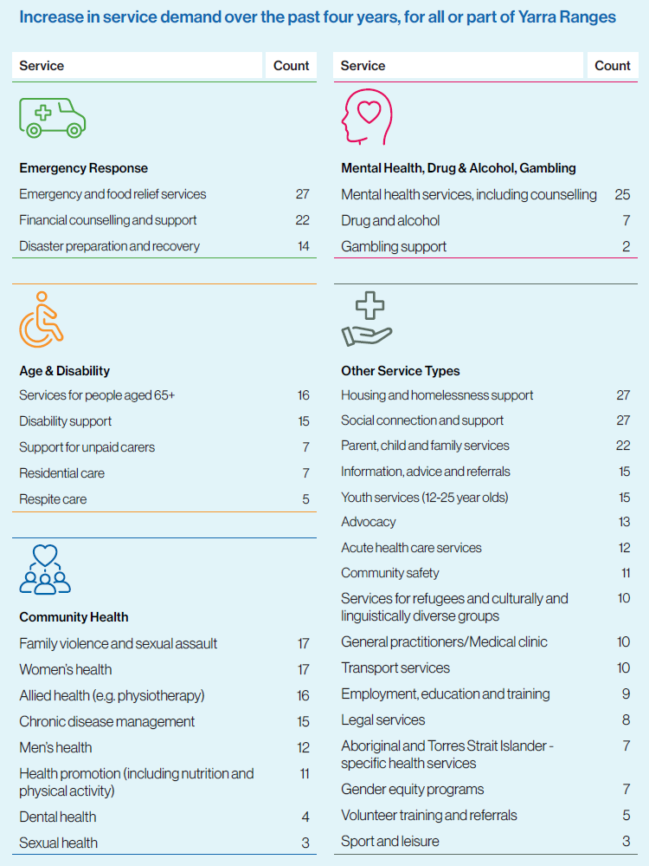

With an ageing population and ongoing impacts from the COVID-19 pandemic and lockdowns, service demand is rising across many services. Multiple services have been impacted by increased demand over the past four years:

* Demand has increased for non-residential age and disability services, across Yarra Ranges.
* The community health services with the most increases in demand were: allied health, chronic disease management, family violence and women’s health. The main increases in community health demand in the Hills were for women’s health services; and the main increase in demand in the Valley was for chronic disease management. With limited access to allied health services and preventative health care during lockdowns, and a spike in family violence incidents, these changes are likely to be directly linked to the impacts of the pandemic.
* Emergency/food relief and financial counselling have had the largest increases in demand, amongst emergency response and support services. Despite major storms in the area, disaster preparation and recovery had experienced comparatively less increase in demand.
* All mental health services surveyed had seen increased demand across Yarra Ranges, particularly in the Urban Area.
* Other services with substantial increases in demand included social connection and support across Yarra Ranges, but also particularly in the Hills and the Valley; housing and homelessness support; and parent, child and family services.

Services with increases in demand over the past four years groups

|  |  |
| --- | --- |
| Service type | Count of services |
| Emergency and food relief services | 27 |
| Housing and homelessness support | 27 |
| Social connection and support | 27 |
| Mental health services, including counselling | 25 |
| Financial counselling and support | 22 |
| Parent, child and family services | 22 |
| Family violence and sexual assault | 17 |
| Women’s health | 17 |
| Services for people aged 65+ | 16 |
| Allied health (e.g. physiotherapy) | 16 |
| Disability support | 15 |
| Chronic disease management | 15 |
| Information, advice and referrals | 15 |
| Youth services (12-25 year olds) | 15 |
| Disaster preparation and recovery | 14 |
| Advocacy | 13 |
| Men’s health | 12 |
| Acute health care services | 12 |
| Health promotion (including nutrition and physical activity) | 11 |
| Community safety | 11 |
| Services for refugees and culturally and linguistically diverse groups | 10 |
| General practitioners/Medical clinic | 10 |
| Transport services | 10 |
| Employment, education and training | 9 |
| Legal services | 8 |
| Support for unpaid carers | 7 |
| Residential care | 7 |
| Drug and alcohol | 7 |
| Aboriginal and Torres Strait Islander - specific health services | 7 |
| Gender equity programs | 7 |
| Respite care | 5 |
| Volunteer training and referrals | 5 |
| Dental health | 4 |
| Sexual health | 3 |
| Sport and leisure | 3 |
| Gambling support | 2 |

#### Inability to meet demand for services

Overall, nearly two-thirds of services had experienced demand which they had been unable to meet, and one-third had had to decline requests for service. Whilst some service gaps were localised, most affected the entire municipality. Unmet demand was mainly dealt with through referring to other services (69%), prioritising service access for those most in need (55%), keeping a waiting list (45%), and/or referring to services in neighbouring Council areas (43%).

#### What is driving changes in service demand?

Factors affecting services’ ability to meet community demand

Lack of funding was by far the main factor affecting services’ ability to meet demand (60% of services). Lack of staff and volunteers was also a major issue, including lack of staff time (42%), lack of skilled staff (36%), challenges in retaining staff (29%) and not enough volunteers (27%).General resourcing was also a major issue (40%) along with lack of infrastructure (36%). One service highlighted as an issue the complexity of presenting conditions, combined with no suitable place to refer clients to other than acute outpatients at hospitals.

Impacts from the COVID-19 pandemic

Nearly all of the organisations surveyed identified ongoing impacts from the pandemic, primarily mental health and social impacts (83%), and financial impacts (62%). Ongoing physical health issues had much less of an impact (40%). One in four services thought that user concern about exposure to infection by COVID-19 was still affecting service usage.

Changing population health and demographics

Services were asked about their experiences of changing population needs, issues and demographics amongst their service users. These were also major contributors to demand. Consumer health and household cost issues were the key community factors driving changing demand for services, whilst population growth is having less impact on demand – local population growth has been minimal over the past few years. The main issue driving service demand was the rising level of mental health concerns (89% of services). Cost of living was also having a major impact (71%), along with rising levels of service need per person and increasing complexity of consumer need (56% each). Housing issues were also having a major impact, as were increased rates of family violence and worsening population health.

Changes affecting community service need

|  |  |  |
| --- | --- | --- |
| What changes are services seeing in the community? | % | Count |
| Increased mental health concerns | 89% | 56 |
| Increasing costs of living | 71% | 45 |
| Increasing complexity of consumer need | 56% | 35 |
| Increasing level of service demand per individual | 56% | 35 |
| Lack of affordable housing | 54% | 34 |
| Homelessness or insecure housing | 46% | 29 |
| Increased rates of domestic and family violence | 44% | 28 |
| Lack of crisis accommodation | 41% | 26 |
| Lack of appropriate housing choices | 35% | 22 |
| Population ageing | 35% | 22 |
| Worse overall population health | 25% | 16 |
| Unemployment | 17% | 11 |
| Population growth | 13% | 8 |
| Total | 100% | 63 |

Changing patterns of service use

Other factors affecting current patterns of service use and provision included improved knowledge of services, and increased availability of online and telehealth services. One positive is that nearly 30% of services felt that there is now reduced stigma in accessing services. One-quarter of services felt that user concern about being exposed to infection was still affecting service use.

### Future service demand and challenges

#### Future service demand

Past issues - such as rises in living costs, chronic health problems and mental health issues - were expected to continue to affect service demand. The most pressing expected issues were continuing increases in cost of living (79%) and the level of chronic health issues (60%). Climate change was seen as a major factor in future demand for services, with 51% of services expecting an increasing number of disasters, which would affect community need for services and support; and 51% expecting worsening health impacts from extreme weather events.

#### Future challenges

Lack of funding (75%), increased service demand (66%) and staff shortages (57%) were expected to be the main service challenges for the next five years. Climate change was also expected to have major impacts, including its impacts on community wellbeing (38%), service access (28%) and infrastructure (22%). Volunteer shortages (32%) and lack of appropriate infrastructure to house services (28%) were also expected to be a challenge.

### Technology & innovation

Services were using a range of innovations to cope with current and expected changes to service demands, particularly: collaborating with other services (75%), seeking alternative funding (47%), re-training staff (39%), using technology (38%) and using outreach services (36%). Other innovations included telehealth (27%), scenario planning for future changes (22%), working to establish service hubs (19%) and pop-up services (17%). Most services were using technology to fully or partly deliver their services – the main form was online service provision such as Zoom.

### Information from service data sets

A range of service data and consultation findings is publicly available, although very focused on health services. These datasets support the findings from the human services survey. However, they are more focused on issues than need – what is happening in terms of service usage, rather than perceptions of services.

#### Service needs and gaps

Various service datasets specified a lack of access to mental health services, especially in the Hills and Valley. The data indicate that GP use for mental health issues is not as high as it should be relative to hospital use, and that people may be using hospitals instead of GPs for mental health care. This appears to be particularly an issue for residents of the Urban Area and the Hills. It is unclear whether lower hospital use in the Valley is due to the geographic difficulties in accessing hospitals for Valley residents. Better access to adolescent mental health services is also needed, particularly for CALD teenagers.

Clients of specialist homelessness services (SHS) in Yarra Ranges were much more likely to have unmet needs for services and assistance met than clients across Greater Melbourne. The gap in wholly unmet needs – services neither provided nor referred - between Yarra Ranges and Greater Melbourne was highest for accommodation provision, family services, disability services, immigration/cultural services and other specialist services. This aligns with gaps identified in the survey. It also aligns with housing issues identified in demographic data. In 2021, Yarra Ranges had an above average level of renting households which are spending a high proportion of income on rent; a very high level of households with a mortgage, many of whom would be impacted by rising interest rates; and an extremely low level of public housing.

Other service gaps included a need for more services targeting women’s health; and additional services to fill the gap in residential care in the Yarra Valley.

#### Changes in service use

The service data aligns with the survey data, by showing increasing need per person. People who were existing mental health patients had a higher number of visits per patient during the pandemic. There was also a rise in the number of people seeing psychiatrists; but there was a drop in use of psychologists, GP mental health appointments and allied mental health care – possibly due to lockdowns affecting access to less acutely needed services. However, existing psychology patients used more services per person than they did prior to the pandemic.

People were also using less preventative care appointments for chronic diseases, such as asthma care, diabetes care, GP chronic disease management, general GP care, and GP care for patients in imminent danger of death. These shifts in use of preventative care are likely to be contributing to the increased chronic health issues that services are now witnessing amongst their clients. There was reduced use of indigenous health care services, a lockdown issue not identified in the survey data. There was also a drop in the number of patients for allied health services such as chiropractic services, exercise physiology and GP acupuncture.

Service usage related to alcohol varied a lot by service type during the pandemic. Data on treatment is one of the better indicators of the level of alcohol issues in the community. These data show that after years of going down, the rate of treatment for alcohol issues more than doubled in 2020/21, then rose by a further 23% in 2021/22. Hospital admissions related to alcohol spiked up in 2020/21, then dropped in 2021/22 - but have not returned to pre-pandemic levels.

#### Current service demand

SHS data also show that current demand is highest in Kilsyth, Lilydale-Coldstream, Upper Yarra Valley and Yarra Valley, with these areas having the highest rates of service use.

Use of early intervention services for children have jumped over the past few years, with a 16% increase in patients and services, and 33% rise in the service rate. This may be due to the developmental impacts of COVID lockdowns. The need for early intervention services was not identified in the survey.

#### Service barriers

Workforce shortages

The service data show a lack of access to both GPs and local mental health specialists, which would be a major barrier for seeking mental health care outside of the hospital system – GPs are essential in referring patients to mental health specialists. Most Yarra Ranges GPs are willing to take on new patients, thus it is likely that GP shortages are localised; available data show that all areas in the Yarra Valley have a low level of GPs.

Also, all areas within Yarra Ranges have a workforce shortage for every type of non-GP medical specialist, in terms of the number of specialists relative to the number of residents. This includes mental health services such as psychologists and psychiatrists; and a wide range of other services such as radiology. This supports the survey feedback about the need for more mental health services and allied health services.

The survey data reiterated that workers are not available in the areas that need them the most, contributing to the shortages identified in both the survey and the service datasets. GP consultation has reported low GP work satisfaction. And nearly one in five intend to retire within three years, which will exacerbate the worker shortages identified in the survey.

Other barriers

GPs have highlighted issues such as it being hard to deliver health care to patients in aged care facilities; and delays in discharging people from hospital, which impacts the availability of hospital care.

The Outer East was affected by lack of transport access to physical services, linking into the transport issues identified in the survey results. Services also reported a lack of support for patients accessing online services. And both GPs and patients have issues with internet connections and technology, which can cause further issues for video telehealth services.

# Glossary

ABS Australian Bureau of Statistics

ATSI Aboriginal and Torres Strait Islander

CALD Culturally and linguistically diverse

DWS District of Workforce Shortage

EMR Eastern Metropolitan Region

GP General Practitioner

HSNA Human Services Needs Analysis

LGA Local government area

SHS Specialist homelessness services

# Human services survey data

## Service characteristics

Map of planning areas in Yarra Ranges



**Valley**

**Urban Area**

**Healesville-Yarra Glen**

**Hills**

Source ID Consulting (2023). *Profile areas, Yarra Ranges Council.* <https://profile.id.com.au/yarra-ranges/about>

Services had a mix of catchment areas, but all were Yarra Ranges-focused. More than half of those surveyed had all of Yarra Ranges as their main catchment area (52%), followed by the Valley (24%), Urban Area (17%), Hills (15%) and Healesville-Yarra Glen (9%). The other catchment areas (15%) were:

* wider Melbourne;
* Eastern Metropolitan Region (EMR);
* Coldstream;
* the lower part of the Valley;
* Chirnside Park;
* primarily mainly Yarra Ranges, plus some other areas;
* inner and outer eastern suburbs of Melbourne;
* Knox and Casey (Casey electorate boundaries closely align with those of Yarra Ranges); and
* outer eastern Melbourne.

Services are focused on the key population segments, and also disadvantaged households. The main user groups were women (68%), children and families (62%), men (57%), older persons aged 65 plus (51%), low income residents/households (49%) and young people aged 12-24. However, the full range of user groups was very diverse, including persons with disability, carers, people affected by homelessness and housing issues, culturally and linguistically diverse residents, indigenous residents, and LGBTIQA+ and gender diverse residents. Additional user groups included people with hearing issues, those using drugs, and people living with dementia.

Who are your main user groups? Select all that apply

|  |  |  |
| --- | --- | --- |
| Main user groups | Share of total (%) | Count |
| Women | 68% | 44 |
| Children and families | 62% | 40 |
| Men | 57% | 37 |
| Older persons aged 65+ | 51% | 33 |
| Low income residents/households | 49% | 32 |
| Young people aged 12-24 | 45% | 29 |
| Persons with disability | 43% | 28 |
| Carers | 35% | 23 |
| People experiencing housing and homelessness issues | 32% | 21 |
| Culturally and linguistically diverse residents | 32% | 21 |
| Aboriginal and Torres Strait Islander residents | 26% | 17 |
| LGBTIQA+ | 25% | 16 |
| Gender diverse | 25% | 16 |
| Other | 8% | 5 |

*Note: Multiple responses were possible, so percentages will not add up to 100%.*

Most services were run out of buildings which were not owned by Council (57%). Twenty-nine percent were run out of a Council building, and 14% were run out of both Council and non-Council buildings. For most services (68%), at least 80% of their users were Yarra Ranges residents; for a further 20% of services, 5%-29% of their service users were Yarra Ranges residents. Services were highly health prevention-orientated, with 50% of services providing preventative health programs. The main types of services were:

* Social connection and support (39%).
* Housing and homelessness support (38%).
* Emergency relief and response, including emergency and food relief services (32%), financial counselling and support (27%), and disaster preparation and recovery (21%).
* Services for specific population groups – parent/child/family (27%), older persons (21%) and youth (21%).
* Mental health services (24%).
* Information, advice and referrals (23%).

Service types represented in survey

|  |  |  |
| --- | --- | --- |
| Service type | Number of services  providing | Share of total |
| Social connection and support | 26 | 39% |
| Housing and homelessness support | 25 | 38% |
| Emergency and food relief services | 21 | 32% |
| Financial counselling and support | 18 | 27% |
| Parent, child and family services | 18 | 27% |
| Mental health services, including counselling | 16 | 24% |
| Information, advice and referrals | 15 | 23% |
| Services for people aged 65+ | 14 | 21% |
| Disaster preparation and recovery | 14 | 21% |
| Youth services (12-25 year olds) | 14 | 21% |
| Disability support | 13 | 20% |
| Advocacy | 13 | 20% |
| Allied health (e.g. physiotherapy) | 12 | 18% |
| Chronic disease management | 11 | 17% |
| Family violence and sexual assault | 11 | 17% |
| Women’s health | 11 | 17% |
| Acute health care services | 11 | 17% |
| Community safety | 11 | 17% |
| Health promotion (including nutrition & physical activity) | 10 | 15% |
| Services for refugees, culturally & linguistically diverse | 10 | 15% |
| Transport services | 10 | 15% |
| Employment, education and training | 9 | 14% |
| General practitioners/Medical clinic | 9 | 14% |
| Men’s health | 8 | 12% |
| Legal services | 8 | 12% |
| Support for unpaid carers | 7 | 11% |
| Drug and alcohol | 7 | 11% |
| Aboriginal & Torres Strait Islander-specific health services | 7 | 11% |
| Gender equity programs | 7 | 11% |
| Respite care | 5 | 8% |
| Volunteer training and referrals | 5 | 8% |
| Dental health | 4 | 6% |
| Residential care | 3 | 5% |
| Sexual health | 3 | 5% |
| Sport and leisure | 3 | 5% |
| Gambling support | 2 | 3% |

## Age & disability services

### Service types

Thirty-nine percent of the services surveyed (26 services) provided age and disability services. Most provided multiple service types, including:

* Services for older people (19 services).
* Disability support (14 services).
* Support for unpaid carers (7 services).
* Respite care (3 services).
* Residential care (2 services).
* Other services (3 services).

Other age and disability services included:

* Support for any one of any age living with dementia.
* Day programs.
* A7S program for older people and younger people with disabilities.
* Allied health and nursing support.

There were no services which organisations planned to stop providing in the next five years. Three services planned to add services supporting unpaid carers, and two planned to add new residential care services. There were no plans amongst existing services to add additional services for older people, disability support services or respite care services.

Age and disability services: Of the services listed below, please tell us which services you currently provide, plan to add or plan to stop providing?

|  |  |  |  |  |  |  |  |
| --- | --- | --- | --- | --- | --- | --- | --- |
| Service | Currently provide | | Plan to add new service in the next 5 years | | Plan to stop providing within the next 5 years | | Total |
| Services for people aged 65+ | 100% | 19 | 0% | 0 | 0% | 0 | 19 |
| Support for unpaid carers | 70% | 7 | 30% | 3 | 0% | 0 | 10 |
| Residential care | 50% | 2 | 50% | 2 | 0% | 0 | 4 |
| Disability support | 100% | 14 | 0% | 0 | 0% | 0 | 14 |
| Respite care | 100% | 3 | 0% | 0 | 0% | 0 | 3 |
| Other | 100% | 3 | 0% | 0 | 0% | 0 | 3 |

### Service gaps

The main service gaps were for:

* Support for unpaid carers (identified as a gap by 12 services).
* Disability support (11 services).
* Services for older people (10 services).
* Respite care (8 services).
* Residential care (8 services).

These gaps typically affected the whole of Yarra Ranges (70%-92%, depending on service type).For specific geographic areas, one or two services tended to identify gaps for each service type and local area, indicating a fairly even spread of gaps across Yarra Ranges. Disability support was only identified as a specific gap for the Hills - as well as for the whole of Yarra Ranges - and by only one service. The highest number of overall age and disability service gaps was in the Hills (8 services identified gaps). Fewer gaps were identified in the Valley (5 services), Healesville-Yarra Glen (5 services) and the Urban Area (3 services).

Residential care data shows that Yarra Ranges has large gaps in residential aged care services, with no services at all in the Hills and a large shortfall in the Urban Area; the Valley is closest to the benchmark for service provision. This benchmark will reduce from 2024/25, due to an increasing preference amongst older residents to age at home rather than going into residential care.

Age and disability services: Are there any service gaps affecting the following areas of Yarra Ranges?

|  |  |  |  |  |  |  |  |  |  |  |  |
| --- | --- | --- | --- | --- | --- | --- | --- | --- | --- | --- | --- |
| Question | Whole of Yarra Ranges | | Hills | | Valley | | Urban | | Healesville/ Yarra Glen | | Total |
| Services for older people | 70% | 7 | 20% | 2 | 10% | 1 | 0% | 0 | 20% | 2 | 10 |
| Support for unpaid carers | 92% | 11 | 8% | 1 | 17% | 2 | 8% | 1 | 8% | 1 | 12 |
| Residential care | 88% | 7 | 25% | 2 | 13% | 1 | 13% | 1 | 13% | 1 | 8 |
| Disability support | 91% | 10 | 9% | 1 | 0% | 0 | 0% | 0 | 0% | 0 | 11 |
| Respite care | 88% | 7 | 25% | 2 | 13% | 1 | 13% | 1 | 13% | 1 | 8 |

### Increases in demand since 2019

Over the past four years, increased demand had the most impact for:

* Services for older people – 14 services identified this as an issue, both for the whole of Yarra Ranges (11) and also in the Hills (3), Valley (1) and Urban Area (1).
* Disability support services – 13 services identified this as an issue, primarily as a Yarra Ranges-wide issue (12).

Seven services identified support for unpaid carers as a growing area of demand, five identified respite care and three identified residential care – primarily as a Yarra Ranges-wide issue.

The main increase in demand identified for the Hills was services for older people. Shifts indemand were more evenly spread across service types for the Urban Area and the Valley, and minimal increases in demand were specifically identified for Healesville-Yarra Glen.

Age and disability services: Has your service noticed an increase in demand over the past four years? If yes, for which services and areas?

|  |  |  |  |  |  |  |  |  |  |  |  |
| --- | --- | --- | --- | --- | --- | --- | --- | --- | --- | --- | --- |
| Question | Whole of Yarra Ranges | | Hills | | Valley | | Urban | | Healesville/ Yarra Glen | | Total |
| Services for older people | 79% | 11 | 21% | 3 | 7% | 1 | 7% | 1 | 0% | 0 | 14 |
| Support for unpaid carers | 86% | 6 | 14% | 1 | 0% | 0 | 0% | 0 | 0% | 0 | 7 |
| Residential care | 100% | 3 | 33% | 1 | 33% | 1 | 33% | 1 | 33% | 1 | 3 |
| Disability support | 92% | 12 | 8% | 1 | 8% | 1 | 8% | 1 | 0% | 0 | 13 |
| Respite care | 100% | 5 | 0% | 0 | 0% | 0 | 0% | 0 | 0% | 0 | 5 |

Age and disability services with increased demand over the past 4 years, by service type and area

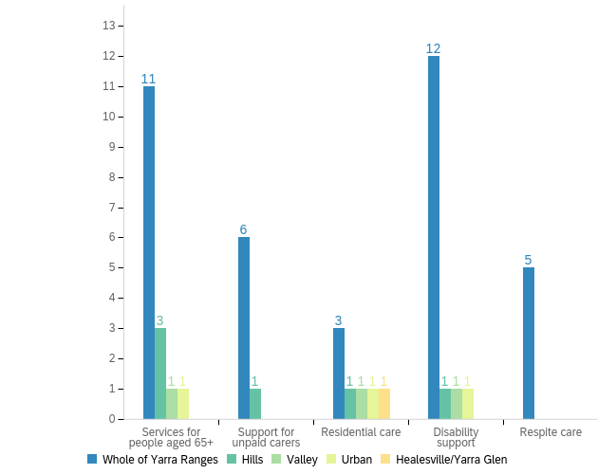

## Community health services

### Service types

Forty percent of services (26 services) provided community health services. Most provided multiple service types, including:

* Health promotion (16 services).
* Women’s health (15 services).
* Chronic disease management (12 services).
* Allied health (10 services).
* Family violence and sexual assault (10 services).
* Sexual health (9 services).
* Men’s health (6 services).
* Dental health (4 services).
* Other services (4 services).

Other community health services included:

* Oncology and infusion service.
* Free exercise classes.
* Children's developmental therapies.
* Routine GP Services.
* District nursing, day surgery and GP practice, and an Aboriginal health team.

There were no services which organisations planned to stop providing in the next five years. Two services planned to add a new allied health service, one service planned to add a family violence and sexual assault service, and one planned to add a men’s health service.There were no plans amongst existing services to add additional services for health promotion, women’s health, chronic disease management, sexual health or dental health.

Community health services: Of the services listed below, please tell us which services you currently provide, plan to add or plan to stop providing?

|  |  |  |  |  |  |  |  |
| --- | --- | --- | --- | --- | --- | --- | --- |
| Service | Currently provide | | Plan to add new service in the next 5 years | | Plan to stop providing within the next 5 years | | Total |
| Allied health (e.g. physiotherapy) | 91% | 10 | 18% | 2 | 0% | 0 | 11 |
| Chronic disease management | 100% | 12 | 0% | 0 | 0% | 0 | 12 |
| Dental health | 100% | 4 | 0% | 0 | 0% | 0 | 4 |
| Family violence and sexual assault | 100% | 10 | 10% | 1 | 0% | 0 | 10 |
| Health promotion (including nutrition and physical activity) | 100% | 16 | 0% | 0 | 0% | 0 | 16 |
| Sexual health | 100% | 9 | 0% | 0 | 0% | 0 | 9 |
| Women’s health | 100% | 15 | 0% | 0 | 0% | 0 | 15 |
| Men’s health | 86% | 6 | 14% | 1 | 0% | 0 | 7 |
| Other | 100% | 4 | 0% | 0 | 0% | 0 | 4 |

### Service gaps

The main service gaps identified by services were for:

* Family violence and sexual assault (identified by 13 services).
* Sexual health (12 services).
* Allied health (11 services).
* Women’s health (9 services).
* Health promotion (9 services).
* Men’s health (8 services).
* Dental health (6 services).
* Chronic disease management (6 services).

For specific geographic areas, the most service gaps were identified in the Valley - 14 services identified gaps across all service types apart from dental health. Fewer gaps were identified in the Hills (7 services), Healesville-Yarra Glen (7 services) and the Urban area (5 services).

Community health services: Are there any service gaps affecting the following areas of Yarra Ranges?

|  |  |  |  |  |  |  |  |  |  |  |  |
| --- | --- | --- | --- | --- | --- | --- | --- | --- | --- | --- | --- |
| Question | Whole of Yarra Ranges | | Hills | | Valley | | Urban | | Healesville/ Yarra Glen | | Total |
| Allied health | 82% | 9 | 9% | 1 | 18% | 2 | 9% | 1 | 0% | 0 | 11 |
| Chronic disease management | 67% | 4 | 17% | 1 | 33% | 2 | 17% | 1 | 0% | 0 | 6 |
| Dental health | 100% | 6 | 0% | 0 | 0% | 0 | 0% | 0 | 0% | 0 | 6 |
| Family violence & sexual assault | 85% | 11 | 8% | 1 | 15% | 2 | 8% | 1 | 23% | 3 | 13 |
| Health promotion | 89% | 8 | 0% | 0 | 11% | 1 | 0% | 0 | 0% | 0 | 9 |
| Sexual health | 83% | 10 | 0% | 0 | 17% | 2 | 0% | 0 | 8% | 1 | 12 |
| Women’s health | 67% | 6 | 22% | 2 | 33% | 3 | 11% | 1 | 22% | 2 | 9 |
| Men’s health | 75% | 6 | 25% | 2 | 25% | 2 | 13% | 1 | 13% | 1 | 8 |

### Increases in demand since 2019

Over the past four years, increased demand had the most impact for:

* Allied health - 12 services identified this as an issue, for the whole of Yarra Ranges (9) and across each area (1-2).
* Chronic disease management - 11 services identified this as an issue, for the whole of Yarra Ranges (8) and across each area (1-3).
* Family violence and sexual assault - 11 services identified this as an issue, for the whole of Yarra Ranges (9) and across each area (2 per area).
* Women’s health - 11 services identified this as an issue, for the whole of Yarra Ranges (8) and across each area (2-3).
* Health promotion - 10 services identified this as an issue, for the whole of Yarra Ranges (8) and across each area (1 in the Hills, Valley and Healesville-Yarra Glen).

Eight services identified men’s health as having growing demand (mostly across the whole of Yarra Ranges), four identified dental health across the whole of Yarra Ranges, and three identified sexual health (across the whole of Yarra Ranges).

The main increase in demand identified for the Hills was women’s health and the main increase in demand for the Valley was chronic disease management. Shifts in demand were more evenly spread across service types for the Urban Area and Healesville-Yarra Glen.

Community health services: Has your service noticed an increase in demand over the past four years? If yes, for which services and areas?

|  |  |  |  |  |  |  |  |  |  |  |  |
| --- | --- | --- | --- | --- | --- | --- | --- | --- | --- | --- | --- |
| Question | Whole of Yarra Ranges | | Hills | | Valley | | Urban | | Healesville/ Yarra Glen | | Total |
| Allied health | 75% | 9 | 17% | 2 | 17% | 2 | 17% | 2 | 8% | 1 | 12 |
| Chronic disease management | 73% | 8 | 9% | 1 | 27% | 3 | 9% | 1 | 18% | 2 | 11 |
| Dental health | 100% | 4 | 0% | 0 | 0% | 0 | 0% | 0 | 0% | 0 | 4 |
| Family violence & sexual assault | 82% | 9 | 18% | 2 | 18% | 2 | 18% | 2 | 18% | 2 | 11 |
| Health promotion | 80% | 8 | 10% | 1 | 10% | 1 | 0% | 0 | 10% | 1 | 10 |
| Sexual health | 100% | 3 | 0% | 0 | 0% | 0 | 0% | 0 | 0% | 0 | 3 |
| Women’s health | 73% | 8 | 27% | 3 | 18% | 2 | 18% | 2 | 18% | 2 | 11 |
| Men’s health | 88% | 7 | 25% | 2 | 13% | 1 | 13% | 1 | 13% | 1 | 8 |

Community health services with increased demand over the past 4 years, by service type and area

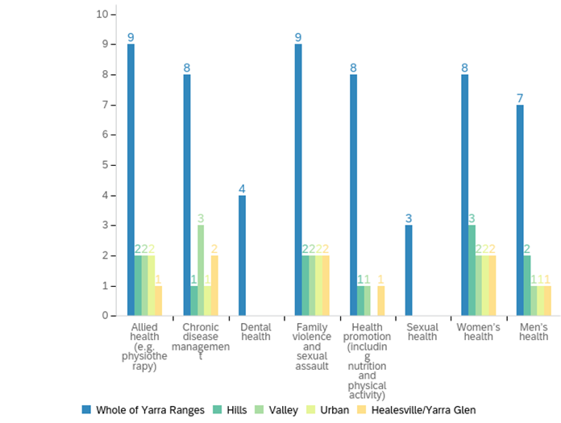

## Emergency response and support services

### Service types

Twenty-four services (36%) provided emergency response and support services, including:

* Emergency and food relief services (19 services).
* Disaster response and recovery (12 services).
* Financial counselling and support (6 services).
* Other services (5 services).

Other emergency response and recovery services included:

* Casework for people in need of urgent support.
* Emergency housing referrals, clothing and anything else that community members require.
* Community asset building activities – one service planned to add this in the next 5 years.
* Social inclusion.
* Access to legal help for immediate aftermath and recovery.
* Emergency shelter in managed facilities – e.g., storm event.

One service planned to stop providing emergency and food relief services within the next five years. Five services planned to add new disaster response and recovery services, the highest number of planned new services of any service type. Two services planned to add new emergency and food relief services, two planned to add new financial counselling and support services, and one planned to add a different type of service in this field.

Emergency response and support services: Of the services listed below, please tell us which services you currently provide, plan to add or plan to stop providing?

|  |  |  |  |  |  |  |  |
| --- | --- | --- | --- | --- | --- | --- | --- |
| Service | Currently provide | | Plan to add new service in the next 5 years | | Plan to stop providing within the next 5 years | | Total |
| Disaster response and recovery | 80% | 12 | 33% | 5 | 0% | 0 | 15 |
| Emergency and food relief services | 100% | 19 | 11% | 2 | 5% | 1 | 19 |
| Financial counselling and support | 75% | 6 | 25% | 2 | 0% | 0 | 8 |
| Other | 83% | 5 | 17% | 1 | 0% | 0 | 6 |

### Service gaps

For most services, gaps were seen as affecting the whole of Yarra Ranges. But for emergency response, gaps were more likely to be seen as specific to local areas. The main service gaps which were identified were:

* Financial counselling and support (identified by 12 services in total). Eight services saw it as a gap for the whole of Yarra Ranges, two as a gap for the Hills, two as a gap for the Urban Areas, one as a gap for the Valley and none as a gap for Healesville-Yarra Glen.
* Emergency and food relief services (identified by 11 services). Seven services saw it as a gap for the whole of Yarra Ranges, two as a gap for the Valley, and one service saw it as a gap for each of the other areas.
* Disaster preparation and recovery was identified as a gap by 10 services. Five saw it as a gap across Yarra Ranges and four saw it as a particular gap for the Hills. Two services saw it as a gap for the Urban Area, one as a gap for the Valley, and one as a gap for Healesville-Yarra Glen.

Overall, the Hills were most likely to be seen as having gaps in emergency response services, particularly for disaster preparation and recovery.

Emergency response and support services: Are there any service gaps affecting the following areas of Yarra Ranges?

|  |  |  |  |  |  |  |  |  |  |  |  |
| --- | --- | --- | --- | --- | --- | --- | --- | --- | --- | --- | --- |
| Question | Whole of Yarra Ranges | | Hills | | Valley | | Urban | | Healesville/ Yarra Glen | | Total |
| Disaster preparation and recovery | 50% | 5 | 40% | 4 | 10% | 1 | 20% | 2 | 10% | 1 | 10 |
| Emergency and food relief services | 64% | 7 | 9% | 1 | 18% | 2 | 9% | 1 | 9% | 1 | 11 |
| Financial counselling and support | 67% | 8 | 17% | 2 | 8% | 1 | 17% | 2 | 0% | 0 | 12 |

### Increases in demand since 2019

Over the past four years, increased demand had the most impact for:

* Emergency and food relief services (identified by 21 services). Twelve services had seen increased demand across Yarra Ranges, six in the Hills, four in the Valley, three in the Urban Area and two in Healesville-Yarra Glen.
* Financial counselling and support (identified by 18 services). Twelve services had seen increased demand across Yarra Ranges, six in the Hills, two in the Urban Area, one in the Valley and one in Healesville-Yarra Glen.

Disaster preparation and recovery services had seen less increase in demand, being identified by 14 services. The increases were seen across Yarra Ranges (8 services) and particularly in the Hills (5 services). One service had experienced increased demand in the Valley; no services identified increased demand specifically in the Urban Area or Healesville-Yarra Glen. Overall, the Hills were most likely to be seen as having rising demand for emergency response.

Emergency response and support services: Has your service noticed an increase in demand over the past four years? If yes, for which services and areas?

|  |  |  |  |  |  |  |  |  |  |  |  |
| --- | --- | --- | --- | --- | --- | --- | --- | --- | --- | --- | --- |
| Question | Whole of Yarra Ranges | | Hills | | Valley | | Urban | | Healesville/ Yarra Glen | | Total |
| Disaster preparation and recovery | 57% | 8 | 36% | 5 | 7% | 1 | 0% | 0 | 0% | 0 | 14 |
| Emergency and food relief services | 57% | 12 | 29% | 6 | 19% | 4 | 14% | 3 | 10% | 2 | 21 |
| Financial counselling and support | 67% | 12 | 33% | 6 | 6% | 1 | 11% | 2 | 6% | 1 | 18 |

Emergency response services with increased demand over the past 4 years, by service type and area

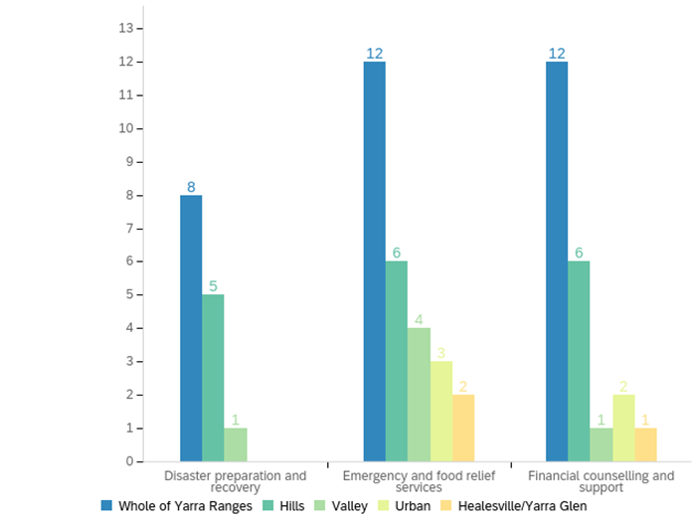

## Mental health, drug and alcohol, and gambling services

### Service types

Twenty services (30% of services surveyed) provided mental health, drug and alcohol, and/or gambling services. These included:

* Mental health (15 services).
* Drug and alcohol (5 services).
* Gambling support (no services at present, one planning to add).
* Other services (4 services).

Other mental health, drug and alcohol, and gambling support services included:

* Peer support for carers.
* Related legal services.
* Mental health training for staff.
* Mental health-trained support workers.
* Referrals and support.

There were no plans to stop providing any of these services within the next five years. Two services planned to add new drug and alcohol services, one to add a new mental health service, and one to add a new gambling support service.

Mental health, drug and alcohol, and gambling services: Of the services listed below, please tell us which services you currently provide, plan to add or plan to stop providing?

|  |  |  |  |  |  |  |  |
| --- | --- | --- | --- | --- | --- | --- | --- |
| Service | Currently provide | | Plan to add new service in the next 5 years | | Plan to stop providing within the next 5 years | | Total |
| Mental health services, including counselling | 94% | 15 | 6% | 1 | 0% | 0 | 16 |
| Drug and alcohol | 71% | 5 | 29% | 2 | 0% | 0 | 7 |
| Gambling support | 0% | 0 | 100% | 1 | 0% | 0 | 1 |
| Other | 100% | 4 | 0% | 0 | 0% | 0 | 4 |

### Service gaps

The main service gaps which were identified were:

* Mental health services, including counselling (identified by 15 services in total). All fifteen services saw it as a gap for the whole of Yarra Ranges, and two services also saw it as a gap in each of the four planning areas.
* Drug and alcohol services (identified by 9 services). All of these services perceived this as a gap for the whole of Yarra Ranges, but not for specific areas within Yarra Ranges.
* Similarly, gambling support was identified as a gap by 9 services. All nine perceived this as a gap for the whole of Yarra Ranges, one as a gap for the Valley and one as a gap for Healesville-Yarra Glen.

Gaps were fairly evenly spread across the four planning areas.

Mental health, drug and alcohol, and gambling services: Are there any service gaps affecting the following areas of Yarra Ranges?

|  |  |  |  |  |  |  |  |  |  |  |  |
| --- | --- | --- | --- | --- | --- | --- | --- | --- | --- | --- | --- |
| Question | Whole of Yarra Ranges | | Hills | | Valley | | Urban | | Healesville/ Yarra Glen | | Total |
| Mental health services | 100% | 15 | 13% | 2 | 13% | 2 | 13% | 2 | 13% | 2 | 15 |
| Drug and alcohol | 100% | 9 | 0% | 0 | 0% | 0 | 0% | 0 | 0% | 0 | 9 |
| Gambling support | 90% | 9 | 0% | 0 | 10% | 1 | 0% | 0 | 10% | 1 | 10 |

### Increases in demand since 2019

Over the past four years, increased demand had the most impact for mental health (identified by all 16 mental health services surveyed**).**  Fourteen services had seen increased demand across Yarra Ranges, four in the Urban Area, three in the Hills, two in the Valley and two in Healesville-Yarra Glen. Overall, the Urban Area was most likely to be seen as having rising demand for mental health services.

Drug and alcohol, and gambling support, had seen less increase in demand, with six services experiencing increases in drug and alcohol service demand (primarily across the whole of Yarra Ranges); and only two services seeing increases in demand for gambling support services (also across Yarra Ranges).

Mental health, drug and alcohol, and gambling services: Has your service noticed an increase in demand over the past four years? If yes, for which services and areas?

|  |  |  |  |  |  |  |  |  |  |  |  |
| --- | --- | --- | --- | --- | --- | --- | --- | --- | --- | --- | --- |
| Question | Whole of Yarra Ranges | | Hills | | Valley | | Urban | | Healesville/ Yarra Glen | | Total |
| Mental health services | 88% | 14 | 19% | 3 | 13% | 2 | 25% | 4 | 13% | 2 | 16 |
| Drug and alcohol | 86% | 6 | 0% | 0 | 14% | 1 | 0% | 0 | 0% | 0 | 7 |
| Gambling support | 100% | 2 | 0% | 0 | 0% | 0 | 0% | 0 | 0% | 0 | 2 |

Mental health, drug and alcohol, and gambling support services with increased demand over the past 4 years, by service type and area

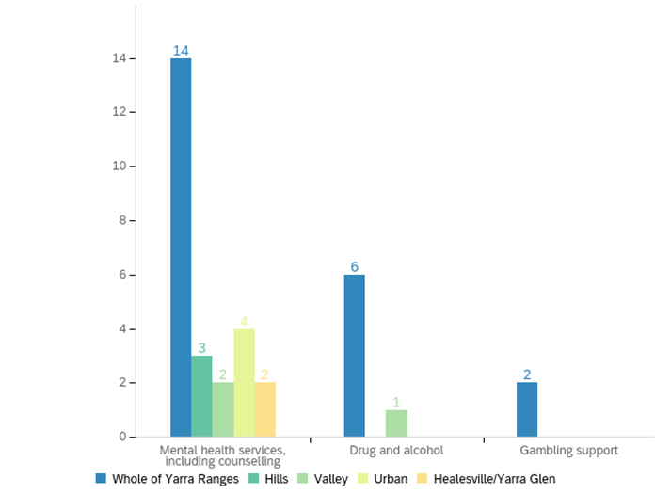

## Other services

### Service types

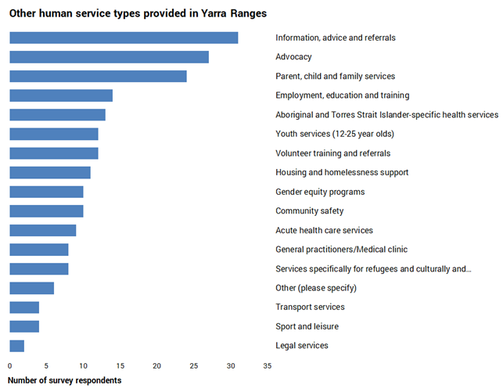

Survey respondents were asked about a range of other service types. The main additional services that they provided were:

* social connection and support (32 services);
* information, advice and referrals (31);
* advocacy (27);
* parent, child and family services (24);
* employment, education and training (14);
* Aboriginal and Torres Strait Islander-specific health services (13);
* volunteer training and referrals (12);
* youth services (12); and
* housing and homelessness services (11).

Other services included community safety (10 services), gender equity programs (10), acute health care services (9), GP/medical clinic (8), services for refugees and culturally and linguistically diverse groups (8), other services (6), sport and leisure (4), transport services (4), and legal services (2).

Other services not identified in the survey list but mentioned by survey respondents included:

* Services and support for people living with dementia and their carers.
* Casework.
* Psychology/counselling (service currently provided, and plans to add additional services in the next five years).
* A Tuesday drop-in centre.
* LGBTIQA+ advocacy.
* Hearing services for all ages.
* Youth homelessness services for 16-25 year olds.
* Kindergartens.
* Disability programs.

There were no plans to stop providing any of these services within the next five years. Three services planned to add new indigenous health services; employment, education and training; gender equity programs; GP/medical clinics; and parent, child and family programs. Two planned to add services for refugees and culturally and linguistically diverse groups; information, advice and referral services; transport services; and youth services. For the other service types, there was one organisation planning to add a new service for each of them within the next five years, with the exception of housing and homelessness support (no additional services planned).

Other types of human service: Of the services listed below, please tell us which services you currently provide, plan to add or plan to stop providing?

|  |  |  |  |  |  |  |  |
| --- | --- | --- | --- | --- | --- | --- | --- |
| Service | Currently provide | | Plan to add new service in the next 5 years | | Plan to stop providing within the next 5 years | | Total |
| Aboriginal and Torres Strait Islander-specific health services | 93% | 13 | 21% | 3 | 0% | 0 | 14 |
| Acute health care services | 90% | 9 | 10% | **1** | 0% | 0 | 10 |
| Advocacy | 100% | 27 | 4% | **1** | 0% | 0 | 27 |
| Community safety | 91% | 10 | 9% | **1** | 0% | 0 | 11 |
| Services specifically for refugees and culturally and linguistically diverse groups | 80% | 8 | 20% | 2 | 0% | 0 | 10 |
| Employment, education and training | 88% | 14 | 19% | 3 | 0% | 0 | 16 |
| Gender equity programs | 77% | 10 | 23% | 3 | 0% | 0 | 13 |
| General practitioners/Medical clinic | 80% | 8 | 30% | 3 | 0% | 0 | 10 |
| Housing and homelessness support | 100% | 11 | 0% | 0 | 0% | 0 | 11 |
| Information, advice and referrals | 97% | 31 | 6% | 2 | 0% | 0 | 32 |
| Legal services | 67% | 2 | 33% | 1 | 0% | 0 | 3 |
| Parent, child and family services | 92% | 24 | 12% | 3 | 0% | 0 | 26 |
| Social connection and support | 100% | 32 | 3% | 1 | 0% | 0 | 32 |
| Sport and leisure | 80% | 4 | 20% | 1 | 0% | 0 | 5 |
| Transport services | 67% | 4 | 33% | 2 | 0% | 0 | 6 |
| Volunteer training and referrals | 92% | 12 | 8% | 1 | 0% | 0 | 13 |
| Youth services (12-25 year olds) | 86% | 12 | 14% | 2 | 0% | 0 | 14 |
| Other (please specify) | 100% | 6 | 17% | 1 | 0% | 0 | 6 |

### 

### Service gaps

The main service gaps which were identified were:

* Housing and homelessness (identified by 24 services), with this mostly seen as an issue across Yarra Ranges.
* Transport services (22). This was seen as an issue across Yarra Ranges and also in the Valley. It was raised as a gap for the Valley by five services, by far the highest level of area-specific gap identification.
* Youth services (16), primarily across Yarra Ranges.
* Advocacy (15), primarily across Yarra Ranges.
* Social connection and support (15). Services saw this as an issue for the whole of Yarra Ranges; no service highlighted it just for a specific area.
* Services specifically for refugees and culturally and linguistically diverse groups (14), across Yarra Ranges.
* Acute health care services (14), primarily across Yarra Ranges.
* Aboriginal and Torres Strait Islander-specific health services (13) – across Yarra Ranges and in the Hills.

Gaps were also identified by each of the other service types. The main gaps identified were in the Valley (service-specific gaps identified by 17 services) and the Hills (12).

Other human services: Are there any service gaps affecting the following areas of Yarra Ranges?

|  |  |  |  |  |  |  |  |  |  |  |  |
| --- | --- | --- | --- | --- | --- | --- | --- | --- | --- | --- | --- |
| Question | Whole of Yarra Ranges | | Hills | | Valley | | Urban | | Healesville/ Yarra Glen | | Total |
| Aboriginal and Torres Strait Islander - specific health services | 85% | 11 | 15% | 2 | 0% | 0 | 0% | 0 | 0% | 0 | 13 |
| Acute health care services | 86% | 12 | 7% | 1 | 7% | 1 | 0% | 0 | 0% | 0 | 14 |
| Advocacy | 87% | 13 | 0% | 0 | 13% | 2 | 0% | 0 | 0% | 0 | 15 |
| Community safety | 75% | 6 | 13% | 1 | 13% | 1 | 13% | 1 | 0% | 0 | 8 |
| Services specifically for refugees and culturally and linguistically diverse groups | 93% | 13 | 0% | 0 | 7% | 1 | 0% | 0 | 7% | 1 | 14 |
| Employment, education and training | 88% | 7 | 0% | 0 | 13% | 1 | 0% | 0 | 0% | 0 | 8 |
| Gender equity programs | 100% | 11 | 0% | 0 | 0% | 0 | 0% | 0 | 0% | 0 | 11 |
| General practitioners/Medical clinic | 83% | 5 | 0% | 0 | 17% | 1 | 0% | 0 | 0% | 0 | 6 |
| Housing and homelessness support | 79% | 19 | 13% | 3 | 13% | 3 | 8% | 2 | 4% | 1 | 24 |
| Information, advice and referrals | 100% | 9 | 0% | 0 | 0% | 0 | 0% | 0 | 0% | 0 | 9 |
| Legal services | 75% | 9 | 8% | 1 | 8% | 1 | 8% | 1 | 0% | 0 | 12 |
| Parent, child and family services | 91% | 10 | 0% | 0 | 9% | 1 | 0% | 0 | 0% | 0 | 11 |
| Social connection and support | 100% | 15 | 0% | 0 | 0% | 0 | 0% | 0 | 0% | 0 | 15 |
| Sport and leisure | 100% | 4 | 0% | 0 | 0% | 0 | 0% | 0 | 0% | 0 | 4 |
| Transport services | 73% | 16 | 9% | 2 | 23% | 5 | 5% | 1 | 9% | 2 | 22 |
| Volunteer training and referrals | 100% | 4 | 0% | 0 | 0% | 0 | 0% | 0 | 0% | 0 | 4 |
| Youth services (12-25 year olds) | 81% | 13 | 13% | 2 | 0% | 0 | 0% | 0 | 6% | 1 | 16 |

### Increases in demand since 2019

Over the past four years, increased demand had the most impact for the following services.Increases in demand generally affected the whole of Yarra Ranges, unless stated otherwise:

* Social connection and support (identified by 26 services). This was an issue across Yarra Ranges, but also particularly in the Hills and the Valley.
* Housing and homelessness support (25). This was an issue across Yarra Ranges, but also particularly in the Hills and the Valley.
* Parent, child and family services (18). This was an issue across Yarra Ranges, but also particularly in the Hills and the Valley.
* Information, advice and referrals (15), with demand increasing across Yarra Ranges.
* Youth services (12-25 year olds) (14), with demand increasing across Yarra Ranges.
* Advocacy (13), with demand increasing across Yarra Ranges.

Overall, the Hills and the Valley were most likely to be seen as having rising demand for this group of services.

Other human services: Has your service noticed an increase in demand over the past four years? If yes, for which services and areas?

|  |  |  |  |  |  |  |  |  |  |  |  |
| --- | --- | --- | --- | --- | --- | --- | --- | --- | --- | --- | --- |
| Question | Whole of Yarra Ranges | | Hills | | Valley | | Urban | | Healesville/ Yarra Glen | | Total |
| Aboriginal and Torres Strait Islander - specific health services | 85% | 11 | 15% | 2 | 0% | 0 | 0% | 0 | 0% | 0 | 13 |
| Acute health care services | 86% | 12 | 7% | 1 | 7% | 1 | 0% | 0 | 0% | 0 | 14 |
| Advocacy | 87% | 13 | 0% | 0 | 13% | 2 | 0% | 0 | 0% | 0 | 15 |
| Community safety | 75% | 6 | 13% | 1 | 13% | 1 | 13% | 1 | 0% | 0 | 8 |
| Services specifically for refugees and culturally and linguistically diverse groups | 93% | 13 | 0% | 0 | 7% | 1 | 0% | 0 | 7% | 1 | 14 |
| Employment, education and training | 88% | 7 | 0% | 0 | 13% | 1 | 0% | 0 | 0% | 0 | 8 |
| Gender equity programs | 100% | 11 | 0% | 0 | 0% | 0 | 0% | 0 | 0% | 0 | 11 |
| General practitioners/Medical clinic | 83% | 5 | 0% | 0 | 17% | 1 | 0% | 0 | 0% | 0 | 6 |
| Housing and homelessness support | 79% | 19 | 13% | 3 | 13% | 3 | 8% | 2 | 4% | 1 | 24 |
| Information, advice and referrals | 100% | 9 | 0% | 0 | 0% | 0 | 0% | 0 | 0% | 0 | 9 |
| Legal services | 75% | 9 | 8% | 1 | 8% | 1 | 8% | 1 | 0% | 0 | 12 |
| Parent, child and family services | 91% | 10 | 0% | 0 | 9% | 1 | 0% | 0 | 0% | 0 | 11 |
| Social connection and support | 100% | 15 | 0% | 0 | 0% | 0 | 0% | 0 | 0% | 0 | 15 |
| Sport and leisure | 100% | 4 | 0% | 0 | 0% | 0 | 0% | 0 | 0% | 0 | 4 |
| Transport services | 73% | 16 | 9% | 2 | 23% | 5 | 5% | 1 | 9% | 2 | 22 |
| Volunteer training and referrals | 100% | 4 | 0% | 0 | 0% | 0 | 0% | 0 | 0% | 0 | 4 |
| Youth services (12-25 year olds) | 81% | 13 | 13% | 2 | 0% | 0 | 0% | 0 | 6% | 1 | 16 |

## Service gaps and challenges for different population groups

Services were asked an open ended question about the service gaps and challenges for different groups in the community. Whilst some responses were specific to particular groups (e.g., physical access to facilities for persons with disability), there were several themes which recurred across different groups. The main recurring themes were:

* Mental health issues and service access (23 mentions).
* Carer support and respite care (16).
* Culturally safe services (15).
* Access to services and unmet demand for services (14), and GP access (4).
* Transport access (12).
* Affordable appropriate housing (10).
* Cost of living (10).
* The need for more social groups and activities (4), particularly for LGBTIQA+ and gender diverse residents (8).
* Isolation and loneliness (7).
* Access to family and children's services (5).
* Domestic violence & services (5).
* Financial planning and counselling/education (4).
* Pharmacy and allied health service access (4).
* Physically accessible facilities (4).

There were also recurring themes within each client group, as follows.

* The main themes for service gaps and challenges for women were mental health, family violence, GP and health service access, cost of living, and affordable housing.
* The main service gaps and challenges for men related to social groups and isolation/loneliness; and support and parenting services.
* For children and families, service access was by far the main service gap, in terms of lack of specialist allied health and mental health services, and lack of affordable services.
* For young people, mental health issues and lack of mental health services was the main theme identified. Service issues included waiting lists, affordability, counselling for vulnerable young people, impacts of closing Lilydale Youth Hub. Another issue was lack of safe out-of-school-hours activities and places to meet. Transport issues and limited employment opportunities were also issues for young people, and lack of services outside of the Urban Area.
* Service access and transport were also key issues for older people.
* Unpaid carers faced different issues, primarily the need for more respite care, and for support groups and other forms of support. Support needs included navigating the NDIS system, accessing services with long wait lists, and doing paperwork to access services.
* Very little is known about service provision and needs for gender diverse residents. Services supporting gender diverse and LGBTIQA+ residents identified the main gaps and challenges to be service access, especially to culturally safe and accepting services; and social supports.
* Service access was also a key issue for persons with a disability, including services which felt accepting of persons with a disability, physical accessibility, suitable housing, and awareness of barriers to access.
* For low income residents and households, the main service gaps and challenges related to cost of living; affordable and appropriate housing; affordable health services – especially mental health care; and the need for financial support, including financial counselling and financial planning.
* The main service gaps for culturally and linguistically diverse (CALD) residents was lack of access to culturally appropriate mainstream services, and lack of awareness of other languages. The main issue for Aboriginal and Torres Strait Islander residents was the need for culturally safe services – a recurring theme across several user groups. Both of these groups had a very low level of issues identified by services. Note that Yarra Ranges has a low level of CALD, and a small number of indigenous residents concentrated in the Healesville area.

The main service needs indicated by this information are:

* Mental health services, particularly for young people, women and people on low incomes.
* We need more respite care and carer support for unpaid carers.
* We need services which feel culturally safe to all user groups, particularly to LGBTQIA+ and gender diverse residents.
* We need better access to services, with this particularly an issue for young people and people on low incomes.
* Transport access is a major issue, particularly for older residents, young people and indigenous residents.
* Access to family and children's services.
* Financial planning and education, primarily for low income residents and households.
* We need more social groups for LGBTQIA+ and gender diverse residents.
* Better access to aged care and home care for older residents.
* After school and social activities for young people.
* Pharmacy and allied health service access for older persons, carers and persons with a disability.
* Domestic violence services for women.
* Employment and education for young people and indigenous residents.

The main infrastructure issues raised are:

* The need for affordable appropriate housing affects all groups, especially low income households.
* Facilities need to be physically accessible for persons with a disability, or mobility issues.
* Safe spaces for all groups.

Key issues affecting individuals and households included:

* Cost of living is an issue for all user groups, but particularly for low income residents and households, and for families with children.
* Isolation and loneliness is mentioned as an issue for all groups.

### Women

The main themes for service gaps and challenges for women were:

* Mental health (5).
* Family violence (3).
* GP and health service access (3).
* Cost of living (2).
* Homelessness risk for older women, affordable housing (2).

Other issues raised included:

* Access to free or low cost family law services.
* Respite for parents of children with special needs.
* No access to full range of pregnancy options.
* Isolation/Access to community transport.
* Safe spaces for unstructured physical activity; lighting, paths, greenery, open spaces.
* Women who are older struggle to re-enter the workforce, and are often primary carers.

Comments on service gaps and challenges for women

|  |
| --- |
| Women |
| Access to GPs, mental health services, food relief |
| Domestic Violence services, young mums services |
| Access to affordable housing, access to good mental health support/counselling |
| more mental health services |
| Specific women’s mental heath and health services |
| Safe spaces for unstructured physical activity; lighting, paths, greenery, open spaces. Women who are older struggle to re-enter the workforce and are often primary carers. |
| Accessing timely affordable health services |
| Lack of female GP |
| Access to free or low cost family law services |
| Respite for parents of children with special needs |
| no access to full range of pregnancy options |
| Isolation/Access to community transport |
| support for domestic violence |
| Family violence |
| Mental Health, Managing cost of living, Loneliness |
| Cost of living pressures, risk of homelessness for older women |

### Men

The main themes for service gaps and challenges for men were:

* Social groups, isolation/loneliness (4)
* Support and parenting services (2)

Other issues raised included:

* Better men's health services - prostate and aged care.
* Drinking culture, lack of want to engage, input or seek help.
* Access to free or low cost family law services.
* Respite for parents of children with special needs.
* Access to community transport.
* Men who use violence.
* Mental health.
* Managing cost of living.

Comments on service gaps and challenges for men

|  |
| --- |
| Men |
| Support Services |
| Better men's health services - prostate and age care |
| Drinking culture, lack of want to engage, input or seek help. |
| Support and social groups/education relating to parenting |
| Access to free or low cost family law services |
| Respite for parents of children with special needs |
| Isolation/Access to community transport |
| social groups for younger men feeling isolated |
| Men who use violence |
| Mental Health, Managing cost of living, Loneliness |

### Children and families

The main themes for service gaps and challenges for children and families were:

* Service access (6 services) – referral pathways, waiting lists, getting an appointment, increased demand, affordability. E.g., paediatricians and other allied health services in the Valley, affordable mental health services, lack of allied health providers such as speech therapy and occupational therapy, lack of affordable mental health services.
* Need for additional services in terms of family support, trauma support and family therapy (2).
* Lack of childcare (2).
* Cost of living (2).

A diverse range of issues were raised for children and families. Other issues which were identified included:

* Housing access.
* Lack of social options for diverse families (including parents of neuro-diverse children).
* Need for safe after-school/weekend activities.
* Engaging kids at school post-COVID.
* Mental health.
* Family violence and family breakdown.
* Need for financial counselling.
* Support for carers of children with disability; potential NDIS changes.

Comments on service gaps and challenges for children and families

|  |
| --- |
| Children and families |
| Access to appropriate/safe housing options, including transitional housing. |
| Waiting list and access to professional care |
| Better family support and services to keep families together |
| Diverse families are often excluded and find it hard to connect; same sex parents or parents of neurodiverse children. Lack of activities and places for families to meet. |
| Timely access to referral pathways/GP/MCH appointments |
| Cost of living issues, relationship breakdown, domestic violence |
| Waiting lists, potential changes to the NDIS, increased demand |
| Trauma support and family therapy |
| lack of available childcare, many services are full. Shortage of allied health providers such as speech therapy and OT |
| After school and weekend safe activities |
| Lack of Childcare places, cost of living pressures, financial counselling |
| parent/carer Disability support |
| No affordable mental health services |
| trying to engage at school again after COVID. Mental Health issues. |
| Access to paediatricians and other allied health professionals that families in the Valley can afford. |

### Young people aged 12-24

The main service gaps and challenges for young people were:

* Mental health issues, including eating disorders; lack of mental health services - including waiting lists, affordability, counselling for vulnerable young people, impact of closing Lilydale Youth Hub (9).
* Lack of safe out-of-school-hours activities and places to meet. (4)
* Transport issues, including limited public transport and lack of transport outside the Urban Area (2).
* Limited employment opportunities (2). Lack of volunteering options and life skills training were also mentioned.
* Lack of services in the Hills and Upper Yarra (2).

Other issues raised included limited social activities, the need for better access to homeschooling support, and the need for information and support to reduce vaping harm. One service stated that young people should be the top priority for all services, including mental/physical health, peer support and social activities.

Comments on service gaps and challenges for young people

|  |
| --- |
| Young people aged 12-24 |
| Programs and mental health support |
| Eating disorder management and mental health |
| Lack of youth mental health services |
| No out of school hours activities that provide a safe and welcoming space. No volunteering options targeted at young people. Limited employment opportunity. Lack of transport options beyond urban living. |
| Significant gap left by the closure of the Lilydale Youth Hub. Employment opportunities, access to life skills training |
| Mental health issues, long wait lists for support/treatment |
| public transport is limited, limited social activity, Information and support to reduce vaping harm |
| Lack of services - closure of the Youth Hub left a huge hole |
| This urgently needs addressing - no mental health supports available |
| After school and weekend safe activities |
| Lack of activities, access to homeschooling support, counselling services for vulnerable youth |
| No affordable mental health services |
| Not as many services available to them in the Upper Yarra. |
| Not enough services in the Hills area |
| Lack of safe spaces |

### Older people aged 65 years & over

The main service gaps and challenges for older people were:

* Service access, including home care in the Valley and the Hills, aged care, GPs, allied health (e.g., radiology, pathology), lack of services on the southern edge of the shire, personal and respite care, MACH (maternal and child health) had delays with service access (7).
* Transport – low cost, transport to and from hospital (4).
* Social inclusion, loneliness and isolation (2).
* Lack of affordable small housing to downsize into and stay in the same community (1).
* Cost of living (1).

One service indicated a need for free or low-cost future planning/succession planning, e.g., wills and powers of attorney.

Comments on service gaps and challenges for older residents

|  |
| --- |
| Older persons aged 65+ |
| Personal and Respite Care |
| MACH delays to service access. Significantly low CHSP and Home Care Package providers in the valley and hills. |
| Better aged care support |
| Access to GP, pharmacy and services such as radiology/scanning/pathology etc. |
| Social inclusion and cost of living issues |
| low cost transport |
| The Aged Care reforms have decreased service availability across all types of services for older people. Demand is much higher than availability and many services are closed or severely limited. Compliance and reporting requirements are increasing and taking time away from service provision. The collaborative relationships between service that support so-ordinated care are no longer funded and are decreasing, also impacting care. |
| transport to/from hospital appointments |
| Not enough access/resources for allied health needs |
| Transport |
| Isolation, Loneliness |
| Lack of affordable small housing to downsize and stay in the community |
| Transport |
| Very few services provided on the Southern edge of the Shire. |

### 

### Unpaid carers

The main service gaps and challenges for unpaid carers were:

* Respite care (7)
* Support groups and other forms of support (5) – including navigating the NDIS system, accessing services with long wait lists, and doing paperwork to access services.
* Lack of counselling resources and family therapy options (1).
* Education (1).

Comments on service gaps and challenges for unpaid carers

|  |
| --- |
| Unpaid carers |
| Carers support groups |
| Respite, Education |
| Respite |
| Support network and access |
| Support navigating NDIS. Support accessing allied health services with long waitlists. Lack of support for carers of young children who are isolated. |
| Respite services |
| Respite |
| Difficult to access support for respite- difficult paperwork for everything |
| Social groups/support |
| Not enough counselling resources and family therapy options |
| Respite care |
| Respite Care, respite services at home |
| Parent/carer disability support |

### Gender diverse residents

The main service gaps and challenges for gender diverse residents were:

* Access to culturally safe and accepting services (4).
* Access to services in general (2).
* Social and peer support groups (2).

Comments on service gaps and challenges for gender diverse residents

|  |
| --- |
| Gender diverse |
| Access to safe and appropriate services |
| More of anything needed for this and LGBT, throughout Yarra Ranges |
| Education, health services |
| Access to non-judgmental and accepting services and support |
| Lack of acceptance within community and safety. Very few services that identify as safe. |
| Access to culturally safe services |
| inclusive social groups |
| Need peer support available within Yarra Ranges |

### LGBTIQA+ residents

The main service gaps and challenges for LGBTIQA+ residents were:

* Access to culturally safe and accepting services (5).
* Inclusive social and peer support groups and events (4).
* Access for young people to be supported locally in gender transitions.

Comments on service gaps and challenges for LGBTIQA+ residents

|  |
| --- |
| LGBTIQA+ |
| Access to safe and appropriate services |
| Social events for the LGBTQI community |
| Safe spaces, health services |
| Access to non-judgmental and accepting services and support |
| Lack of acceptance within community and safety. Very few services that identify as safe. |
| Access to culturally safe services |
| inclusive social groups |
| Need peer support available within the Yarra ranges |
| All identifying community members |
| Need more inclusive groups and activities available to them locally. |
| Access for young people to be supported locally in transitions, etc. |

### 

### Persons with a disability

The main service gaps and challenges for persons with a disability were:

* Accessibility - accepting services, physical accessibility of local amenities, suitable housing, and awareness of barriers to access (5). Yarra Junction pool was given as an example of a service lacking support for disabled children/adults.
* Better awareness of different services for cross referral (2).

Other issues include housing, respite care, potential NDIS changes, staff shortages, social isolation, sexual assault risks/service gaps, transport, and support from allied health services.

Comments on service gaps and challenges for persons with a disability

|  |
| --- |
| Persons with a disability |
| More accessible |
| Respite, Knowledge of support services, |
| Access to non-judgmental and accepting services and support |
| Suitable housing. Access to local amenities eg; chairs with arms or buildings with wide door ways and without stairs. |
| Lack of awareness of wide range of accessibility barriers. Increased risk of abuse and sexual assault and lack of access to appropriate assistance. Tailored education. |
| Social isolation |
| transport |
| Allied Health Support |
| Potential changes to the NDIS, bureaucratic justifications severely limit the types of service available to people with a disability and add considerably to the cost of care. It is also hard to attract quality staff to work in the NDIS, particularly OT and Speech. |
| Yarra Junction pools is severely outdated and offers no support for disabled children/adults. E.g., hoist, classes for people with disabilities, heated pool for elderly physio treatment. |
| Accessibility |
| Connection of different Disability Services for the purpose of cross referral. |

### Low income residents and households

The main service gaps and challenges for low income residents/households were:

* Cost of living (4).
* Affordable and appropriate housing (4). This included access to “safe, suitable, climate resilient, affordable housing”.
* Affordable health services, particularly mental health care (4).
* Financial and education supports (4), and financial counselling/planning (2).

Other issues include general service access and transport.

Comments on service gaps and challenges for low income residents and households

|  |
| --- |
| Low income residents/households |
| Access to Centrelink and education supports |
| Access to support and dignified services |
| Financial planning support and information on local relief agencies needed. |
| Access to safe, suitable, climate resilient, affordable housing |
| Financial support/education |
| Very restricted housing options |
| Transport |
| No financial counselling available, more resources for affordable health care, especially mental health |
| Families struggling to afford basics, now struggling to access bulk billing GP's and other services requiring part payment |
| Cost of living. Affordable accommodation |
| Cost of living pressures, access to low cost services - dental, medical care |
| No affordable mental health services |
| current income or benefits don't cover all necessary expenses, so often lack nutritious food |
| Affordable housing |
| Affordable mental health care |

### Culturally and linguistically diverse residents

The main service gaps and challenges for culturally and linguistically diverse residents were:

* Lack of access to culturally appropriate mainstream services, and lack of awareness of other languages (3). Also a lack of access to interpreters was mentioned by one service.
* Lack of service information (1).
* Lack of language schools (1).
* Lack of support/social groups (1).

This group of residents had the least issues identified by services, with only six services identifying issues or challenges.

Comments on service gaps and challenges for culturally and linguistically diverse residents

|  |
| --- |
| Culturally and linguistically diverse residents |
| Accessing culturally appropriate mainstream services generally |
| Language schools and social integrations |
| Lack of awareness of the 29 languages other than English spoken at home. Real lack of service information and help navigating. |
| Access to appropriate interpreters, culturally safe services |
| Inclusive support and social groups |
| Services are not available in the Yarra Ranges |

### Aboriginal and Torres Strait Islander residents

The main service gaps and challenges for Aboriginal and Torres Strait Islander residents were:

* Need for culturally safe services (3)
* Need for more services in general (2).
* Need for dedicated infrastructure, and a more centrally-based space (2).

Other issues raised include inclusion, and recognition of self-determination and tradition celebrations.

This group of residents had a very low level of issues identified by services, with only seven services identifying issues or challenges.

Comments on service gaps and challenges for Aboriginal and Torres Strait Islander residents

|  |
| --- |
| Aboriginal and Torres Strait Islander residents |
| Culturally safe chronic disease care management |
| Greater services |
| Culturally safe services. Transport/access to services. |
| Health, transport, education, employment, cultural development, housing |
| Need for dedicated infrastructure, recognition of importance of self-determination and Community Control, improved cultural safety across the board at mainstream services |
| Inclusive support, social groups, traditional recognition and celebrations |
| Need a more centralised space, Oonah is too far away for all clients to access |

### 

### Barriers to meeting community needs

#### Lack of staff and volunteers

Human services are currently facing a range of barriers. Lack of staff and volunteers was an issue for 75% of services surveyed. Their main issues were:

* staff shortages and absences (57% of services);
* lack of volunteers (41%);
* staff leaving the sector (31%);
* other issues (24%).

The other issues identified included lack of funding for staff; distance for travel to work and issues recruiting specialists to work in Yarra Ranges; and lasting impacts of COVID-19. Lack of local accommodation for staff was only identified as an issue by two services.

Please select the main barriers relating to lack of staff/volunteers:

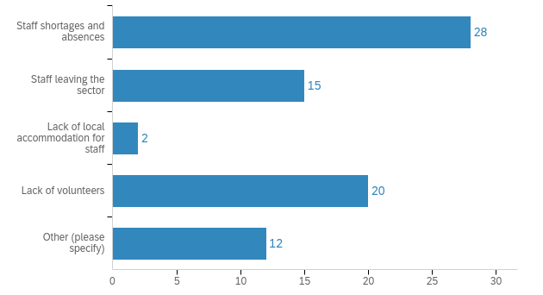

#### Service cost issues

Roughly half of the services surveyed (52%) had had trouble providing sufficient services to clients, due to their service’s cost of providing services. The main barriers were:

* rising service costs for providers, in terms of staff and venues (65%);
* changes to government funding (50%);
* other issues (26%).

Other issues included:

* rising costs of utilities and materials;
* increased cost of living meaning that clients can no longer afford services;
* services not being funded, or funding not increasing in line with rising service provision costs;
* rising staff costs;
* no longer being able to waive fees;
* increased cost of food impacting food relief services.

#### Client cost issues

Thirty-eight percent of the services surveyed had had trouble providing sufficient services to clients, due to cost issues for clients. Thus service cost issues were having more of an impact than client financial hardship. The main cost issues for clients were out-of-pocket costs for services users (88%), funding changes (32%) and lack of private insurance (20%).

Other issues included:

* Cost of living.
* Requirement to cover minimum costs.
* Families who do not qualify for Centrelink (just above the threshold) are really struggling to make ends meet due to the increasing cost of living.
* The service not being funded.
* Families cannot afford to see paediatricians and without assessments and reports from them students are missing out on possible support funding for disabilities such as ASD, etc.
* Increase in living expenses.

#### Physical service issues

Thirty-eight percent of the services surveyed had had trouble providing sufficient services to clients, due to physical service access issues. The main issues were transport (80%), physical access issues for persons with mobility issues (48%), and other issues (36%).

Other issues included:

* size of facility not meeting service needs;
* lack of building access in the Valley;
* building needing to look like an accessible and safe space;
* the high cost of building rental;
* people sleeping rough in bush areas where it may be unsafe for staff to attend;
* lack of social support networks;
* lack of parking;
* venue costs and availability; and
* transport in the rural areas of the Shire is a barrier.

#### Client health issues

Thirty-two percent of the services surveyed had had trouble providing sufficient services to clients, due to client health issues. The main issues were mental health issues amongst clients (81%); increasing complexity of health/service needs and co-morbidities (76%); and clients having to cancel due to COVID-19 and other illnesses (48%). The only other issue identified was transport and ongoing fear of catching COVID-19.

#### Referrals and case management

Thirty-five percent of the services surveyed had had trouble providing sufficient services to clients, due to issues with client referrals and case management. The main issues were lack of case management services (70%), issues with client referrals (61%) and lack of GPs (22%). Other issues included:

* My Aged Care delays. Competing community health services and lack of communication and cross referral to ensure fastest access to service.
* Increased administrative requirements.
* No LGBTIQ specific services.
* Identifying people in need.
* Homelessness - however services are under-resourced.
* Lack of bulk billing services.
* Inappropriate NDIS care plans that disregard actual client needs.
* Referrer's knowledge of services.
* Lack of access to paediatricians and other relevant services for young people, and long waiting lists (up to 14 months).

#### Issues with service provision

Most services surveyed (63%) had had trouble providing sufficient services to clients, due to issues with service provision. The main barriers were:

* Difficulty getting an appointment due to waiting lists or waiting times, or waiting lists being closed (71%).
* Lack of local or outreach services (62%).
* No additional capacity to take new clients (62%).
* Other issues (19%).

Other issues included:

* Limited capacity.
* Demand continually fluctuates and is a complex issue. Wait times for some services are incredibly long, e.g., paediatric speech pathology and dietetics. The risks of not seeing these clients urgently could be quite high so significant risks associated with these services and waiting lists.
* Lack of government funding for outreach.
* Capacity to run programs.
* No radiology within 40km.
* Childcare - limited capacity, yet high demand.
* Lack of carer funded supports and not being able to access NDIS support.
* Waiting lists.

#### Issues with restrictions on service access

Twenty-seven percent of services surveyed had had trouble providing sufficient services to clients, due to restrictions on who can use services. The main barriers were:

* Catchment areas for specific services limit resident access (76%).
* Level of disability does not meet access criteria (65%).
* No fixed address for homeless persons (47% - 8 persons).
* Other issues (18% - 3 persons).

The other issues identified were:

* NDIS, Home Care Packages, etc.
* 5 year rule for eligibility for settlement services (new arrivals).
* Priority population not serviced.

#### Communication issues

Client communication issues were fairly minor compared to other issues, and were seen as an issue by only twelve services. The main communication issues were:

* Limited proficiency in English (10 services).
* Inadequate access to/knowledge of digital technology (8 services).
* Difficulty in effectively communicating with harder to reach groups (e.g., young people) (7 services).
* Health literacy (5 services).

Limited resources which had been translated were also identified as an issue by one service.

#### Other issues

Thirty-nine percent of services surveyed had had trouble providing sufficient services to clients, due to lack of available and suitable space for service provision (e.g., buildings). Twenty-eight percent of services surveyed had had trouble providing sufficient services to clients, due to difficulties in bringing in sufficient extra services during an emergency.

Lack of services to refer to was a major issue, affecting 61% of services surveyed. Forty-two percent were impacted by loss of existing services in the region. Other issues included people using alternative services, and loss of existing infrastructure in the region.

## Impacts from the COVID-19 pandemic

63 out of the 66 organisations surveyed identified ongoing impacts from the pandemic and the 2021 storm. The main impacts related to the pandemic, including:

* mental health impacts (83%);
* social impacts (83%);
* financial impacts (62%);
* physical health impacts (40%).

Illness post-COVID-19 was identified by 18 services, and impacts from the June 2021 storms was identified by 21 services. Very few services identified reduced demand after COVID-19.

## Changing population health and demographics

Services were asked about their experiences of changing population needs, issues and demographics amongst their service users. By far the main issue was increased mental health concerns (89% of services). This was followed by:

* Increasing costs of living (71%).
* Increasing levels of service demand per person (56%).
* Increasing complexity of consumer need (56%).
* Housing issues, with lack of affordable housing cited by 54%, homelessness or insecure housing cited by 46%, lack of crisis accommodation cited by 41%, and lack of appropriate housing choices cited by 35%.
* Increased rates of domestic and family violence (44%).

Other issues included population ageing (35%), worse overall population health (25%), unemployment (17%) and population growth (13%).

It is clear from the answers that population growth is having minimal impact on demand, but increasing service user needs is having a major impact, along with client issues such as housing and rising living costs.

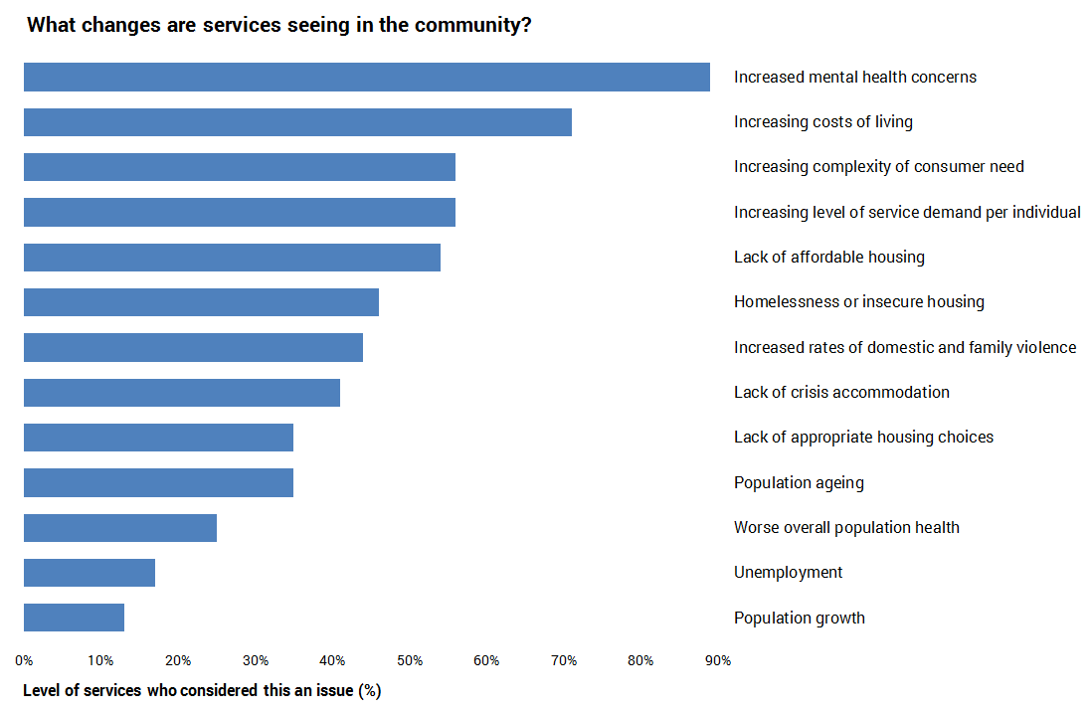

Changing population health and demographics: (select all that apply)

|  |  |  |
| --- | --- | --- |
| Answer | % | Count |
| Increased mental health concerns | 89% | 56 |
| Increasing costs of living | 71% | 45 |
| Increasing level of service demand per individual | 56% | 35 |
| Increasing complexity of consumer need | 56% | 35 |
| Lack of affordable housing | 54% | 34 |
| Homelessness or insecure housing | 46% | 29 |
| Increased rates of domestic and family violence | 44% | 28 |
| Lack of crisis accommodation | 41% | 26 |
| Population ageing | 35% | 22 |
| Lack of appropriate housing choices (e.g. for older persons to downsize into) | 35% | 22 |
| Worse overall population health | 25% | 16 |
| Unemployment | 17% | 11 |
| Population growth | 13% | 8 |
| Total | 100% | 63 |

## Changing patterns of service use and demand

### Changing patterns of service use

Services were also asked about factors which were leading to changes in service use and provision. Services felt that better knowledge and promotion of services was contributing to increased service use (54%), as was the new increased availability of online and telehealth supports (44%). Nearly 30% of services felt that there is now reduced stigma in access services. One-quarter of services felt that user concern about being exposed to infection was still affecting service use.

### Factors affecting future service demand

Some of the factors which services have already seen changing within the community – e.g., increasing living costs, increased chronic health issues – were expected to continue to affect service demand into the future. The most pressing expected issues were costs of living continuing to increase (79%), and the level of chronic health issues continuing to increase (60%). Climate change was seen as a major factor in future demand for services, with 51% of services expecting an increasing number of disasters to affect the need for services and support, and 51% expecting increasing health impacts from extreme weather events.

Other issues were expected to impact service demand included:

* Loss of essential services to the region.
* Lack of intervention programs.
* Diminishing stock of affordable rentals.
* Vaping and increased drug use.
* Lack of general practitioners willing to work in the area for regular and consistent hours for five or more years.
* Increase in residents with mental health issues.
* Increasing need for mental health services for both parents and children, with high levels of anxiety/social developmental delay amongst children of primary school age.
* Increasing disability diagnoses.

Factors affecting future service demand

|  |  |  |
| --- | --- | --- |
| Answer | % | Count |
| Increasing costs of living | 79% | 50 |
| Increasing level of chronic health issues | 60% | 38 |
| Increasing number of disasters (e.g., storms, floods, bushfires, heatwaves) impacting need for services and support | 51% | 32 |
| Increasing health impacts of extreme weather events (e.g., heat stroke, cardiovascular events) | 51% | 32 |
| Population ageing | 49% | 31 |
| Increasing food insecurity | 40% | 25 |
| Other (please specify) | 13% | 8 |
| Total | 100% | 63 |

### Inability to service demand

Roughly two-thirds of services (63%) had experienced demand which they could not service; 12% were not sure. Unmet demand was mainly dealt with through referring to other services (69%), prioritising service access for those most in need (55%), keeping a waiting list (45%), and/or referring to services in neighbouring Council areas (43%). One-third of services had had to decline requests for service.

Other ways or responding to unmet demand included reducing the paediatric age range for service provision, undertaking ongoing advocacy within the organisation and with external stakeholders, and using an after-hours GP services. One service noted the lack of specialist LGBTIQA+ supports and services in the region.

Only one service said that it had not experienced unmet demand.

### Factors affecting services’ ability to meet community demand

Lack of funding was by far the main factor affecting services ability to meet demand (60% of services). Lack of staff and volunteers was also a major issue, including lack of staff time (42%), lack of skilled staff (36%), challenges in retaining staff (29%) and not enough volunteers (27%). One service noted that ageing volunteers was an issue for their service.

General resourcing was also a major issue (40%) along with lack of infrastructure (36%). Not knowing where to refer people to was an issue for eight services; lack of accessible communication was only an issue for two services, and lack of confidence in supporting LGBTIQA+ clients was an issue for one service. One service highlighted as issues the complexity of presenting conditions, combined with no suitable place to refer clients to other than acute outpatients at hospitals.

### Future challenges

Lack of funding (75%), increased service demand (66%) and staff shortages (57%) were expected to be the main service challenges over the next five years. Climate change was also expected to have a major impacts, including its impacts on community wellbeing (38%), service access (28%) and infrastructure (22%). Volunteer shortages (32%) and lack of appropriate infrastructure to house services (28%) were also expected to be a challenge. Fourteen percent of services thought that lack of capacity to response quickly to emergencies would be an issue; one service identified the need to prevent issues rather than respond to them.

### Reduced demand after COVID-19

Very few services identified reduced demand after COVID-19. The only areas of reduced demand (each identified by one services) were:

* Mental health.
* Social support.
* Mental health services – service believed that this could be due to a number of competing public and private services and significant staff turnover in these teams.
* Reductions in demand for face-to-face group work and other community-focused models of primary prevention.
* General health checks have been reduced, just starting to improve.
* Social group attendance.
* Temporary reduction during lockdowns.

### Programs which have ceased in the past 12 months

Services were asked if there were any programs that they had had to cease providing in the past 12 months. Thirteen services identified the following areas where they had ceased or reduced program offerings:

* Extra social opportunities for clients.
* Social support programs.
* Paediatric physiotherapy.
* Employment support services
* Food and resources.
* Some June 2021 storm recovery activity.
* Mental health.
* Support to young people through the Lilydale Youth Hub due to its closure.
* Community visitors scheme.
* Adult speech therapy.
* Lilydale youth hub was defunded. No funded youth services available.
* Due to the lack of space, service was unable to roll out a number of programs, or to expand in line with demand.
* Psychology.

Services were asked if for other comments regarding service provision, gaps and demand. The main themes for service comments related to: housing, including funding (4 services), lack of services (3), disability housing (3 services), access to swimming pools (3), mental health and youth/student wellbeing (3), and staff recruitment (2). The full list of comments is listed in *Appendix 3.*

### Technology

Most services (76%) were using technology to fully or partly deliver services. This included online service provision such as Zoom (80% of services using technology),and apps (24%). Other ways of incorporating technology included: websites and portals (e.g., Yarra Ranges jobs portal), telephone, social media, specific software programs (e.g., GP management software), and assisting those who lacked technological literacy.

### Innovation

Services were using a range of innovations to cope with changing service demands, particularly collaboration with other (services), seeking alternative funding (47%), re-training staff (39%), technology (38%) and outreach (36%). Other innovations included telehealth (27%), scenario planning for future changes (22%), working to establish service hubs (19%) and pop-up services (17%). Specific innovations listed in comments included:

* student readiness and support for future health professional capacity;
* employing a Practice Nurse;
* remote appointments by phone or Microsoft Teams;
* education and advocacy; and
* creative ideas.

## Other comments

Services were asked if they had anything else that they would like to share. The main theme of comments was the need for additional funding or continued Council support. One service commented that, following on from the pandemic, the Yarra Ranges population *“appear very stressed [with an increase in] incivility and micro-aggressions from the community towards services”.*

The full list of comments is listed in *Appendix 3.*

# Demographics

## 2021 Census highlights

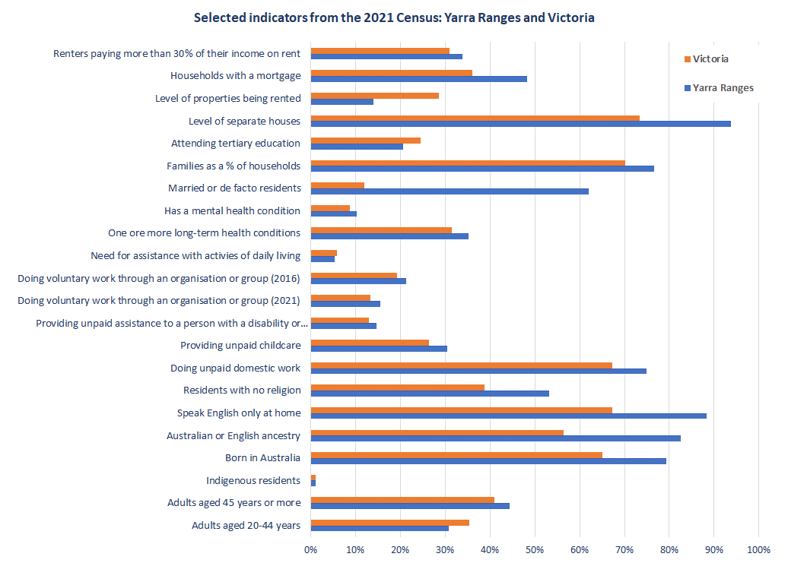

The August 2021 Census counted 156,068 residents in Yarra Ranges. Loss of access to new arrivals over the past few years means that this number is substantially less than could have been expected with normal population movement. The Census shows the key characteristics of Yarra Ranges residents, identifies differences between local areas, and provides information for the first time on long-term health conditions. The Census reveals inequalities, and provides crucial information for planning services such as health and education. It also shows what population changes have happened over the past five years. Small area data maps and analysis of trends will be released on Council’s ID Consulting page by the end of August 2022; data on industry and employment will be released by the ABS in October 2022.

Key sources of Census data are here: <https://profile.id.com.au/yarra-ranges> (band <https://www.abs.gov.au/census/find-census-data/quickstats/2021/LGA27450>

Australians have been described as “decidedly irreligious”, with a growing multicultural population, more people being willing to identify as indigenous, and millennials becoming the dominant age group. The 2021 Census marked the 50th anniversary of indigenous people being full included in the Census. However, they are still under-represented, with the ABS estimated in a 17% undercount.

In Yarra Ranges, most residents have Australian or English ancestry, speak English only, and do not have a religion - Yarra Ranges has the second-highest level of residents with no religion within metropolitan Melbourne. However, it has a substantial level of indigenous residents in Upper Yarra Valley and Healesville–Yarra Glen; and a large cluster of refugees from Myanmar in Mooroolbark and Kilsyth. Despite being small in numbers, these groups have specific cultural and service needs to be considered in Council’s service provision.

Yarra Ranges residents have a low level of involvement with tertiary education, and many young adult males who leave school before finishing Year 11. Historically, young people in Yarra Ranges have been highly successful in finding post-school employment or vocational training opportunities, and the October Census data release will identify whether this trend is continuing.

Yarra Ranges has a high level of family households, and the main family type is couples with children. Families and households have relatively high median incomes, with more detailed income data due late 2022. The level of non-dependent 15-24 year olds who lived with their parents rose slightly between 2016 and 2021. Yarra Ranges has a very high level of residents with unpaid caring or volunteering roles, but the level of volunteers has dropped by nearly 30% since 2016.

This Census was the first to ask about long term health conditions in the Australian population, and it turns out a lot of us have them – one-third of Australians reported a long-term health condition. Yarra Ranges has an above average level of residents with long-term health conditions and ranks seventh-highest within Melbourne for people experiencing mental health conditions. Indigenous residents, women and young people are disproportionately affected by long-term health conditions. Teenagers and adults aged less than 45 females, those on very low incomes, and those with a disability were most likely to experience a mental health condition. Living alone or in a one-parent family is associated with poorer mental health in Yarra Ranges.

Housing in Yarra Ranges is focused on separate housing, and has a low level of dwellings being rented, which is an issue for those wishing to form a new household in Yarra Ranges; it also has an above average level of renting households which are spending a high proportion of income on rent. Yarra Ranges has a very high level of households with a mortgage, many of whom may be vulnerable to the impacts of rising interest rates.

## Key population characteristics

The August 2021 Census counted 156,068 residents in Yarra Ranges. Key findings from a preliminary analysis of the first-release Census data include:

* The number of residents identifying as Aboriginal and/or Torres Strait Islander (ATSI) rose by 26% between 2016 and 2021. Upper Yarra Valley and Yarra Valley have the highest levels of indigenous residents.
* Resident age profiles vary markedly across Yarra Ranges, with Healesville-Yarra Glen and the Yarra Valley having higher proportions of older residents; the Urban Area having a higher level of children under 10 and younger parents; the Hills having a higher level of older children and teenagers, and middle aged or retired residents; and Yarra Valley having a high level of teenagers and adults aged 50 plus. The main age group where Yarra Ranges lost residents was young adults aged 18-24 (a loss of 472 residents since 2016); there was also a slight decline (84 persons) in the number of 50-59 year olds.
* Yarra Ranges residents come from a predominantly Australian or British background, with a much higher level of Australian-born residents than the Victorian average; Yarra Ranges has the seventh-highest level of Australian-born residents, within Victoria. Due to past humanitarian migration, Yarra Ranges has a relatively high level of residents from Myanmar, at 0.8% compared to 0.2% across Victoria. Yarra Ranges has the fourth-highest number of residents from Myanmar, compared to other Victorian municipalities. Mount Evelyn has the highest level of residents with Australian or English ancestry, who speak English only at home and who have no religion.
* The number of new arrivals dropped dramatically in both 2020 and 2021, from the mid-400s down to 163 in 2020 and 71 in 2021. Given that pre-COVID, Yarra Ranges consistently had several hundred overseas arrivals per year, the low numbers in 2020 and 2021 translate to about 700 less Yarra Ranges residents than could have otherwise been expected.
* Yarra Ranges has a very high level of residents with no religion, at 53.2% of residents compared to 38.8% across Victoria, and this level has risen substantially since 2016. Yarra Ranges has the second-highest level of residents with no religion within metropolitan Melbourne. Amongst those practicing a religion, the main religion was Christianity, at 37.8% of residents. Upwey-Tecoma has the highest level of residents with no religion (61.6%).
* Yarra Ranges residents are much less likely to attend tertiary education, particularly university. Yarra Ranges also has a very high level of young male adults who left school early and have not completed Year 11. Upper Yarra Valley has the lowest level of residents attending tertiary education (3.4%) and Upwey-Tecoma has the highest (24.3%) – this indicator in one which shows very high variation across Yarra Ranges.
* Yarra Ranges has above average family and household incomes. However, 14.5% of households have incomes of less than $650 per week. This level is highest in Upper Yarra Valley (34.1%) and Yarra Valley (20.2%). Note that the level has dropped since 2016, when 17.1% of households had incomes of less than $650 per week – this may be partly due to JobKeeper and JobSeeker allowances during lockdowns.
* Yarra Ranges has a relatively high level of residents doing unpaid domestic work, providing unpaid childcare, providing unpaid assistance to a person with a disability or health condition, and doing voluntary work (over the past twelve months). Yarra Ranges has the sixth-highest level of persons providing assistance with unpaid childcare across metropolitan Melbourne, highlighting the impact of the pandemic in terms of increased childcare responsibilities for both working and non-working parents. Mount Evelyn had the highest level of residents who were providing unpaid childcare. Mount Dandenong-Olinda has the highest level of residents doing unpaid domestic work, providing unpaid assistance to a person with a disability, and volunteering. It also had the lowest decline in volunteering between 2016 and 2021, along with Belgrave-Selby. Upper Yarra Valley had the largest drop in its level of volunteers, which fell by 57% - from 18.5% to 8% of adults.
* Whilst Yarra Ranges continues to have a high level of volunteering relative to Victoria, the level of volunteers has dropped dramatically, from 21.3% in 2016 to 15.5% in 2021. Volunteers are essential to a wide range of community sports, activities and services, and this 27% drop in the level of volunteers is a very concerning shift. Women were more likely than men to be carers or volunteers.
* More than one in three residents (35.2%) have one or more long-term health conditions, compared to 31.4% across Victoria. The most common health conditions are mental health, arthritis, asthma, diabetes and heart disease. Yarra Ranges has a comparatively high level of residents with mental health conditions, arthritis or asthma. Healesville-Yarra Glen has the highest level of residents with one or more long-term health conditions.
* Within Yarra Ranges, indigenous residents, women and young people are disproportionately affected by several long-term health conditions. Indigenous residents are much more likely to have long-term mental health conditions, asthma, diabetes or kidney disease. Females are much more likely than males to have a long-term health condition, at 38.1% compared to 32.3% of males. They have a higher prevalence of mental health conditions, arthritis and asthma. Males have a higher level of heart disease and diabetes. Teenagers and adults aged less than 45 were the age groups most likely to experience a mental health condition.
* Yarra Ranges ranked seventh-highest for the level of residents with mental health conditions, within metropolitan Melbourne. Within Yarra Ranges, Yarra Valley and Belgrave-Selby have the highest levels of residents with a mental health condition. The prevalence of mental health conditions was also highest amongst 15-44 year olds, females, those on very low incomes, and those with a disability requiring assistance with daily activities. Protective factors for mental health included being born in Australia, being married or in a de-facto relationship, or being in a couple with children household. Risk factors included heading a one parent family, or being in a lone person household.
* In 2021, 5.4% of Yarra Ranges residents (8,430 persons) reported a need for assistance with activities of daily living, with a slightly higher level of disability amongst females, which would be due to there being more frail aged females. The level of residents with a disability was by far highest amongst the frail aged: 49.9% of those aged 85 plus have a disability, along with 18.2% of 75-84 year olds, highlighting the need for supports and service access to enable this age group to retain as much of their independence as possible. Children aged 5-14 also have a relatively high level of disability (5.2%).
* Yarra Ranges has an above average level of residents who are married or part of a de facto couple, and the level is particularly high in Mount Dandenong-Olinda and Wandin-Seville.
* Yarra Ranges has a relatively high level of family households; and an above average level of single parent households which are headed by male parents. The level of non-dependent 15-24 year olds who lived with their parents rose slightly between 2016 and 2021, from 34.2% to 36.3%. Upper Yarra Valley has the highest level of one parent families and lone person households. Wandin-Seville and Belgrave-Selby have the highest levels of family households and couples with children.
* Overall, Yarra Ranges has a high level of occupancy amongst private dwellings, which could indicate a lower level of holiday homes, unoccupied investment properties and Airbnbs. However, the level of unoccupied private dwellings varies hugely across Yarra Ranges, and is highest in Upper Yarra Valley, Yarra Valley and Mount Dandenong-Olinda. In Upper Yarra Valley, 31% of private dwellings are unoccupied; this would not be due to the pandemic, as the level was about the same in 2016.
* Yarra Ranges has a very high level of separate houses, and a corresponding low level of medium or high density dwellings. This lack of medium to high density housing is linked to a low level of rental dwellings. Lack of rental properties – particularly affordable rentals - is a continuing issue for Yarra Ranges residents, making it difficult for people to form a new household in the same area. Yarra Ranges has one of the lowest levels in Melbourne of both rental properties and social housing. Within Yarra Ranges, Mooroolbark and Kilsyth have the highest level of properties which are being rented (20%). Mount Dandenong-Olinda, Wandin-Seville and Belgrave-Selby have the highest levels of separate houses (99%).
* Yarra Ranges has a very high level of households with a mortgage (48.2% compared to 36.1%). This group accounts for 49% of occupied private dwellings and is potentially vulnerable to continued interest rate rises. Yarra Ranges already has an above average level of renter households in housing stress – more than one-third of renter households have high rent payments, compared to 30.9% across Victoria.[2] The level of renters in rental stress was by far the highest in Yarra Valley (40%) and Monbulk-Silvan (39%). The level of home owners in mortgage stress was highest in Upper Yarra Valley; and Upper Yarra Valley also has the highest level of households with a mortgage, along with Mount Evelyn and Belgrave-Selby.

Selected indicators from the 2021 Census: Yarra Ranges and Victoria (part 1)

|  |  |  |  |  |  |  |  |
| --- | --- | --- | --- | --- | --- | --- | --- |
| Census 2021 indicators | Yarra Ranges | Yarra Valley | Upper Yarra Valley | Healesville-Yarra Glen | Lilydale-Coldstream | Moorool-bark | Kilsyth |
| Indigenous residents | 1.1% | 1.3% | 3.4% | 2.7% | 1.3% | 0.9% | 1.3% |
| Born in Australia | 79.4% | 80.0% | 73.5% | 80.5% | 79.9% | 75.7% | 76.0% |
| Speak English only at home | 88.3% | 89.9% | 78.2% | 91.1% | 89.0% | 81.7% | 83.7% |
| Providing unpaid assistance to a person with a disability or health condition | 14.7% | 14.6% | 13.4% | 14.3% | 14.6% | 14.2% | 14.1% |
| Doing voluntary work through an organisation or group (2021) | 15.5% | 14.4% | 8.0% | 15.8% | 14.3% | 13.1% | 12.1% |
| Doing voluntary work through an organisation or group (2016) | 21.3% | 20.5% | 18.5% | 22.0% | 19.7% | 19.1% | 17.0% |
| Decrease in level of volunteers, 2016-2021 | 27% | 30% | 56.8% | 28% | 27% | 31% | 29% |
| One or more long-term health conditions* | 35.2% | 35.8% | n/a | 37.2% | 36.6% | 34.4% | 36.9% |
| Has a mental health condition | 10.3% | 11.4% | 10.5% | 10.2% | 10.5% | 10.3% | 10.8% |
| Lone person households | 21.3% | 26.7% | 35.4% | 24.2% | 24.1% | 19.3% | 27.4% |
| Owners paying more than 30% of their income on mortgages | 14.0% | 16.6% | 25.5% | 15.1% | 14.0% | 13.5% | 16.1% |
| Renters paying more than 30% of their income on rent | 33.9% | 40.2% | 0.0% | 33.5% | 35.8% | 32.2% | 34.3% |
| Household income less than $650 per week | 14.5% | 20.2% | 34.1% | 17.2% | 15.7% | 12.7% | 17.0% |
| Median weekly household income | $1,881 | $1,439 | $900 | $1,594 | $1,784 | $1,992 | $1,654 |

*\* Upper Yarra Valley has a very high level of residents who did not state whether they have any health conditions.*

Source: Australian Bureau of Statistics (2022). *Yarra Ranges 2021 Census All Persons QuickStats.* Retrieved from: <https://www.abs.gov.au/census/find-census-data/quickstats/2021/LGA27450>

Selected indicators from the 2021 Census: Yarra Ranges and Victoria (part 2)

|  |  |  |  |  |  |  |  |  |
| --- | --- | --- | --- | --- | --- | --- | --- | --- |
| Census 2021 indicators | Mount Evelyn | Mon-trose | Mt Dande-nong Olinda | Monbulk-Silvan | Wandin-Seville | Upwey-Tecoma | Belgrave-Selby | VIC |
| Indigenous residents | 1.0% | 0.6% | 0.8% | 0.5% | 1.0% | 0.4% | 0.5% | 1.0% |
| Born in Australia | 85.6% | 82.9% | 78.4% | 80.8% | 84.9% | 80.6% | 79.7% | 65.0% |
| Speak English only at home | 93.9% | 92.2% | 89.8% | 90.2% | 92.4% | 91.3% | 90.0% | 67.2% |
| Providing unpaid assistance to a person with a disability or health condition | 16.0% | 14.5% | 16.1% | 15.0% | 15.0% | 14.9% | 15.1% | 12.9% |
| Doing voluntary work through an organisation or group (2021) | 16.2% | 14.6% | 22.0% | 18.6% | 16.4% | 18.4% | 19.7% | 13.3% |
| Doing voluntary work through an organisation or group (2016) | 22.7% | 20.3% | 27.8% | 24.8% | 21.8% | 23.6% | 25.0% | 19.2% |
| Decrease in level of volunteers 2016-2021 | 29% | 28% | 20.9% | 25% | 25% | 22% | 21.2% | 31% |
| One or more long-term health conditions | 34.8% | 35.2% | 35.6% | 33.5% | 34.0% | 34.7% | 34.5% | 31.4% |
| Has a mental health condition | 10.2% | 9.8% | 9.8% | 9.3% | 9.0% | 10.9% | 11.3% | 8.8% |
| Lone person households | 18.1% | 19.2% | 20.2% | 19.6% | 15.7% | 19.3% | 16.2% | 25.9% |
| Owners paying more than 30% of their income on mortgages | 12.8% | 9.9% | 15.2% | 15.6% | 14.3% | 11.3% | 11.9% | 15.5% |
| Renters paying more than 30% of their income on rent | 32.1% | 32.0% | 34.3% | 39.3% | 31.9% | 31.1% | 30.8% | 30.9% |
| Household income less than $650 per week | 11.9% | 13.8% | 12.8% | 14.0% | 11.4% | 11.6% | 11.2% | 16.4% |
| Median weekly household income | $2,045 | $2,094 | $2,102 | $1,872 | $2,066 | $2,148 | $2,253 | $1,759 |

Source: Australian Bureau of Statistics (2022). *Yarra Ranges 2021 Census All Persons QuickStats.* Retrieved from: <https://www.abs.gov.au/census/find-census-data/quickstats/2021/LGA27450>

# Service datasets

## Health services

Health services include general practitioners (GPs); mental health; community health and allied health (e.g., physiotherapy, dentists); and acute health (e.g., hospitals).

### General factors affecting health workforce shortages

Workforce shortages have exacerbated service access issues over the past four years. However, the number of registered health professionals in Australia has risen by 18% since the COVID-19 pandemic, including doctors, nurses and psychologists. Thus the issue is not an absolute lack of numbers. It is more about the type, location and participation patterns of the health workforce. Factors contributing towards shortages in many areas of Australia include:

* Workers are not necessarily based in the areas of highest need, causing localized shortages. There aren’t enough workers in the areas that need them the most, especially rural and remote areas. There are also variations based on type of worker – the Outer East has a low level of health professionals across all service types, but has a particularly low level of psychiatrists.
* More workers are working part-time, so growth in numbers does not necessarily mean growth in effective full-time workers.
* The skills of workers such as nurses are under-utilised due to regulations; and too much time is spent in administrative task, especially for General Practitioners (GPs).
* The burden of disease is changing, due to population ageing and a growing level of chronic disease. This means that the health workforce needs to keep growing at a faster rate than population growth.
* Other factors include staff burnout; and the ongoing effects of the pandemic, including backlogs, delayed care, mental health problems and long-COVID.[3]

Workforce variations include:

**GPs**: Inner Eastern Melbourne has 2.39 GPs per 1,000 residents, whilst Outer Melbourne has 1.43 per 1,000, roughly 60% of the level in the inner east.

**Psychiatrists:** The discrepancy for psychiatrists is particularly high. Inner Eastern Melbourne has 0.3 psychiatrists per 1,000 residents, whilst Outer Melbourne has 0.08 per 1,000, the second lowest level in metropolitan Melbourne and only about one-quarter of the rate available in the inner east.

**Clinical psychologists:** Inner Eastern Melbourne has 1.38 clinical psychologists per 1,000 residents, whilst Outer Melbourne 0.72 per 1,000, roughly half the level.

The lack of GPs affects patient capacity to get a referral to a mental health professional. And once people obtain a referral, the low level of psychologists and psychiatrists creates a major gap in service access, compounding the already high levels of mental health issues in outer metropolitan areas.

### Shortages of medical practitioners

#### Distribution Priority Areas for GPs services

Distribution Priority Areas (DPAs) compare available general practitioner (GP) services to GP service benchmarks. The data was last updated on21 July 2022. All parts of the Yarra Valley are classified as DPAs for GPs. The Urban Area and the Hills are classified as having an adequate number of GPs for their population.

#### Districts of Workforce Shortage

Districts of Workforce Shortage (DWS) assess the number of non-GP medical specialists compared to the population of an area[4]. The data was last updated on21 July 2022. Yarra Ranges had a workforce shortage for each type of medical specialist, in every area of the municipality:

* Anaesthetics – all areas of Yarra Ranges had a workforce shortage.
* Diagnostic radiology – all areas of Yarra Ranges.
* Obstetrics and gynocaelogy – all areas of Yarra Ranges.
* Medical oncology – all areas of Yarra Ranges.
* Cardiology – all areas of Yarra Ranges.
* General surgery – all areas of Yarra Ranges.
* Ophthalmology – all areas of Yarra Ranges.
* Psychiatry – all areas of Yarra Ranges.

Access was worst for anaesthetics, obstetrics and gynocaelogy, ophthalmology, and psychiatry – no services were available anywhere in outer eastern Melbourne. Diagnostic radiology and medical oncology had somewhat closer availability, as they were available in Croydon in the outer east; similarly, cardiology and general surgery were available in Bayswater in the outer east.

### GP costs and numbers

GP data is available grouped by federal electorate. Yarra Ranges is in the Casey electorate, and Casey’s boundaries align with those of Yarra Ranges. Casey has 37 GP clinics, 36 of which responded to the Cleanbill GP survey. The survey found that 34 clinics (94.4%) were willing to take on new patients. This is better than the Victorian average of 88.9%. However, only four clinics bulk bill, giving Casey an extremely low bulk billing rate of 11.8%, compared to 34.6% for Victoria. The average out of pocket cost is $35.28, below the Victorian average of $40.10.

GP bulk-billing rates: Casey and Victoria, 2023

|  |  |  |
| --- | --- | --- |
| Indicator | Casey electorate | Victoria |
| Total clinics | 37 | 1,553 |
| Quoted clinics | 36 | n/a |
| Available clinics | 34 | n/a |
| Bulk billing clinics | 4 | n/a |
| Average cost (standard consultation) | $75.03 | n/a |
| Availability rate | 94.4% | 88.9% |
| Bulk billing rate | 11.8% | 34.6% |
| Average out-of-pocket cost (standard consultation) | $35.28 | $40.10 |

Source: Cleanbill (2023). *Health of the nation report.* <https://cleanbill.com.au/wp-content/uploads/2023/04/Cleanbill-Health-of-the-Nation-Report-April-2023-1.pdf>

### Service issues for GPs

An Eastern Metropolitan Primary Health Network (EMPHN) survey of GPs, conducted in April and May 2023, found the following service issues:

* **Workforce retention:** GPs are working less hours on average, which would add to GP shortage issues; nearly one in five intend to retire from general practice within three years; less than 50% rate their work enjoyment highly, compared to 63% pre-COVID.
* **Technology**: Both GPs and patients have issues with internet connections and technology, which can cause issues for video telehealth services; phone consultations are less problematic.
* **Service integration:** Two-thirds of GPs did not have positive experiences with their main local hospital; delays in hospital discharge were the most complained-about issue.
* **Mental health:** All categories of patients had severe access difficulties for mental health services, with the worst result being 59%; mental health support was fragmented with limited awareness of mental health service hubs; many GP practices were resorting to providing or referring to private mental health practitioners.
* **Aged care:** GPs found it challenging to deliver health care to patients in aged care facilities.
* **Cultural awareness/safety:** About half of practices had an informal approach to implementing a cultural awareness/cultural safety policies.

EMPHN GP survey findings by theme, 2023

|  |  |
| --- | --- |
| ****Theme**** | Findings |
| ****Practitioner workforce/demographics**** | - Part-time employment in general practice is becoming increasingly common, especially amongst female GPs. 37% of survey respondents are working less than 30 hours per week. - 18% of GPs surveyed intend to retire from general practice within three years.  - GPs are the least likely (49%) to rate their enjoyment of work highly, a decline compared to 2019 results (when 63% of GPs expressed a high/very high level of work enjoyment.) |
| ****Digital enhancement**** | - Approximately 1 in 4 practices have data analysis tools in place that are under-utilised – this is a valuable contact and service opportunity. - Telehealth consultations via telephone only are more likely to be problem-free. - Internet connectivity and technical barriers (both patient and GP) are common and can reduce video telehealth consultation success rates. |
| ****Cultural Awareness and Cultural Safety**** | - Although most practices have a cultural awareness / cultural safety policy in place, the implementation of this is likely to be informally managed in around half of practices. |
| ****Aged and Palliative Care**** | - GPs continue to face challenges in delivering care to their aged care facility patients. |
| ****Mental Health (MH)**** | - Access to mental health support services varies by patient category, with between 30% to 59% of responses indicating that severe access difficulties are being experienced. - Sources of mental health support for patients are fragmented, with very limited visibility of centralised hubs in use.- Private mental health services were mentioned most frequently (41% of comments) – many via employed/on-site private psychologists/counsellors/mental health nurses.- Around 1 in 4 (24%) responses indicated that a mental health service solution seemed “too hard.” |
| ****Local health system integration**** | - Only 1 in 3 provide a positive overall rating for their most used hospital. - Discharge summary delay is the most mentioned complaint by GPs. |

Source: EMPHN (2023).  *Digging deeper into the EMPHN GP Needs and Engagement Survey, April-May 2023.* <https://www.emphn.org.au/news-events/news/digging-deeper-into-the-emphn-gp-needs-and-engagement-survey>

### Primary health needs in the community

The Translating Research Outcomes into the Primary Health Interface (TROPHI) project aims to provide research that provides practice-based evidence to improve primary health care and patient outcomes in the outer Eastern Melbourne region of Victoria, focused on Knox, Maroondah and Yarra Ranges. The project aims to help patients to have better health outcomes by having relevant research communicated to GPs. TROPHI held a community forum in August 2023, to identify regional needs. Attendees included GPs, public health providers, practice managers, representatives from local councils and academic GPs. The forum examined both service needs and service-based solutions. A stakeholder forum will be conducted late in 2023. The August forum found:

* A community preference for locally-based services means that service need to be delivered locally, or provide via satellite/outreach services.
* A lack of residential aged care in the Yarra Valley. Also, deficiencies were identified in the delivery of aged care and amenities for elderly populations.For example, both lack of transport to physical services, and no coverage for or understanding of how to access on-line services (particularly for the elderly population), continue to be a challenge in the rural areas of the Outer East.
* There needs to be specific tailoring of care targeting at women’s health.
* There were needs in terms of gaining support from non-GP specialists for care delivery in primary care, including support for better referral processes**.**
* There needs to be better access to adolescent mental health services - particularly CALD – to develop appropriate tailoring of services to needs.
* GPs needed more peer-to-peer support, in order to minimise burnout and reduce loneliness.[5]

### NEPHU population health planning

The North Eastern Public Health Unit (NEPHU) has been developing a Population Health Catchment Plan, to identify priorities for place-based primary and secondary prevention activity – focusing on preventable chronic disease and modifiable risk factors. NEPHU has also needed to identify two population health priorities for targeted collective effort. To achieve these aims, NEPHU has been undertaking collaborative multi-sector stakeholder population health planning. Phase 4 of the planning process consisted of a multisector stakeholder workshop, to generate recommendations for the two shared priorities for collective impact work.

All focus groups involved in the service consultation identified partnerships as a key theme. This included sharing resources, learnings and information. Advocacy and service access were the second most identified key overall themes (under six out of seven priority area workshops),especially collective advocacy regarding funding and legislative change. Service access was also a key theme, identified in five out of the seven workshops. Other key themes included focusing on priority populations, and community engagement.

Themes for shared effort and action, by health priority area

|  |  |  |  |  |  |  |
| --- | --- | --- | --- | --- | --- | --- |
| Increasing active living | Increasing healthy eating | Reducing injury in the community | Reducing harmful drug and alcohol use | Improving sexual and reproductive health | Reducing tobacco-related harm | Reducing preventable chronic disease |
| 1. Advocacy and funding | 1. Advocacy | 1. Needs and opportunity identification | 1. Advocacy | 1. Social determinants and priority populations focus | 1. Priority populations | 1. Accessible services and referral pathways |
| 2. Infrastructure and environment | 2. Environments, infrastructure and food systems | 2. Priority population focus | 2. Accessible services | 2. Secondary prevention and service access | 2. Partnerships | 2. Advocacy |
| 3. Evaluation | 3. Partnerships and networks | 3. Partnerships and information sharing | 3. Targeted approaches, primary prevention and community engagement | 3. Partnerships | 3. Building the evidence-base for vaping | 3. Partnerships and sharing resources |
| 4. Accessible and equitable systems and services | 4. Evaluation | 4. Advocacy | 4. Partnerships |  | 4. Accessible services and referral pathways | 4. Settings-based approach |
| 5. Partnerships and shared learning | 5. Community engagement and education | 5. Community engagement |  |  | 5. Advocacy and legislation |  |
|  |  | 6. Accessibility of services |  |  |  |  |

Source: NEPHU (February 2023). *NEPHU Population Health Catchment Planning Workshop Findings Report (Stage 1, Phase 4)*. <https://thewellresource.org.au/uploads/Population-Health-Catchment-Planning-Workshop-_Findings-Report.pdf>

### Changes in use of GP, allied health and specialist health care

For Medicare-subsidised GP, allied health and specialist health care, the last full year of data pre-COVID is for 2018/19. The latest data is for 2021/22; the first six months of this financial year still involved substantial lockdowns. So comparing 2018/19 and 2021/22 shows what changes occurred in service demand during COVID, but not whether service usage has returned to normal patterns since lockdown. Note that all comparisons in this section are of 2021/22 compared to 2018/19.

**What types of care were people using less of?**

#### Allied health

Residents aged 45-64 were using less allied health services overall. The number of patients did not change significantly (down 1.4%) but the number of total services used dropped by 6.6%, leading to a 5.3% drop in services per 100 residents. This shows that patients were using less services per person. Other age groups had relatively static total allied health service usage.

Allied health physical health care was also being used less. The number of patients dropped by 5.2%, services dropped by 6.5% and the rate of service use dropped by 5%.  
Other allied health fell hugely, with patient numbers falling by 51% and service numbers falling by 50%.

#### Chronic disease, preventative care and service provision

Use of the asthma cycle of care practice incentives program (PIP) dropped hugely during COVID, with the number of patients and services dropping by 37.5%, and the rate of service use halving. Similarly, use of the diabetes cycle of care PIP dropped substantially during COVID, with the number of patients and services dropping by about 15%, and the rate of service use dropping by 14%. Overall, the number of patients and services for PIPs fell by 13%. Use of GP chronic disease management plans fell in terms of patient numbers (down 6%), service numbers (down 8%) and the overall service rate (down 6.5%).

#### GPs

Long GP appointments fell by 6% and service use per patient fell substantially – the number of services fell by 16% and the service rate fell by 15%. Prolonged GP services also fell significantly - the general level of prolonged appointments fell by 6% in terms of patient numbers and 11% for service numbers. The number of patients for ‘GP Prolonged – Imminent danger of death’ fell by 63%, and service use per 100 residents fell by 73%. There were substantial restrictions on GP use for patients with COVID-like symptoms, so this may have redirected respiratory patients to emergency departments.

GP enhanced primary care appointments fell by 6.5% for patient numbers and by 8% for service numbers.

The number of patients for urgent GP after-hours care fell by 6%, with a 13% drop in services and a 12% drop in the service rate. This may have been replaced by use of emergency departments; these data will be checked when available.

Telehealth fell by 100%, presumably due to changes in funding for telehealth.

#### Physical care

There was a substantial drop in use of chiropractic services – the number of patients dropped by 9.5% and the number of services dropped by 11.5%, leading to a 10% drop in the service rate. There was a similar pattern in use of exercise physiology, with patient numbers dropping by 11%. Service use per person rose, so the number of services decreased by a lower 6% level and the service rate dropped by 4%. GP acupuncture also fell, with a 3% drop in patient numbers and a 6% drop in services; the service rate fell by 5%. Osteopathy experienced a 3% fall in patient numbers and a 4% fall in the rate of service use. Physiotherapy experienced a 5% fall in both patient numbers and the rate of service use.

#### Mental health

GP mental health appointments dropped, with an 8% drop in patients and a 10.5% drop in service numbers. A GP referral is needed to use clinical psychology, so lower GP mental health service use would flow on to lower use of clinical psychology.

The number of clinical psychology patients dropped by 6%, but existing patients used a higher level of services, so there was little change in the number of services or the service rate. The number of patients for other psychologists fell by 7%.

Allied health mental health services were being used less in 2021/22, despite the growing prevalence of mental health issues during COVID. The number of patients dropped by 6.6% and the number of services dropped by 4.7%; services per 100 people dropped by 3.2%. Other allied mental health had a 3% fall in patient numbers and an 8% fall in service numbers, meaning that patients were using less services per person.

#### Indigenous health care

There was a large fall in use of Nursing and Aboriginal Health Workers during COVID. The number of patients fell by 3% and the rate of service use fell by 6%. The decline was similar amongst both males and females. The drop in patient numbers was highest amongst 0-24 year olds and 45-64 year olds; service use per patient had the largest decline amongst 45-64 year olds. There was less change amongst those aged 25-44, and a decline in service use per person amongst those aged 65 plus.

The number of patients for practice nurses/Aboriginal health workers fell by 8% and service use per patient fell, leading to an 8% fall in the rate of service use.

#### Other

Other Non-referred Medical Practitioner attendances fell by 32% in terms of patient numbers and 45% in terms of service rate, meaning that there was less service use per patient compared to pre-COVID.

**What types of care were people using more of?**

#### Specialist health care

Audiology rose considerably, with an 18% rise in the number of patients and a 27% rise in the number of services; the rate of services per 100 people rose by one-third.

The number of dietetics patients rose by 5% and the number of services rose by 13%. This means that there was higher service use per patient. Leading to a 14% rise in the rate of service use.

#### Preventative care

Cervical smear PIPs rose by 8% in terms of number of patients/services, and 10% in terms of service rate.

#### GPs and nurses

GP attendances rose across all age groups, particularly 0-24 year olds, with an 11% increase in patient numbers; and a 24% increase in the rate of services compared to 15% across the total population. The number of male patients rose by 10%, compared to a 5% rose amongst females.

Other GP services with a substantial increase in patient and service numbers include: multidisciplinary case conferences, with a substantial rise in service use per patient; pregnancy support counselling, with a 9% rise in patient numbers; and short GP appointments, with a very large 58% rise in patient numbers.

The number of patients of GP nurse practitioners rose by 7%.

#### Mental health

Use of GP focused psychological strategies and family group therapy rose substantially, with a 16% increase in patients and very high 69% increase in service use, showing a large jump in service use per patient. This led to a 67% increase in the rate of services per 100***.***

There was a large jump in psychiatric patients and services – the number of patients rose by 15% and service use per patient increased, with a 32% rise in the service rate.

#### Other

Early intervention services for children jumped, with a 16% increase in patients and services, and 33% rise in the service rate. This may be due to the developmental impacts of COVID lockdowns.

Use of occupational therapy had a very large rise, with a 54% increase in patient numbers and a 64% increase in the rate of service provision. The number of speech pathology patients rose by 12%. Total specialist attendances rose amongst 0-24 year olds and 25-44 year olds, with a 3% rise in patient numbers. Medication management review also had a large rise, with a 19% jump in patient numbers.

There was a large rise in midwifery patients – possibly due to concerns about accessing hospital-based services. The number of patients rose by 18% and the number of services rose by 32%.

**Questions**

The questions raised by this data include what was driving increased service demand, and whether increases were due to an increased level of health issues. E.g., was there an actual increase in hearing issues? Did cervical smears increase because it was a relatively accessible form of screening? – BreastScreen services were closed for part of the lockdowns. With increases in GP services, did that mean an increase in use of services which actually were accessible via GPs?

Services which experienced minimal change in patient numbers or level of service use included:

* Allied health attendances (all ages apart from 45-64).
* Optometry. This one would have been expected to fall due to limited availability post-COVID. It may rise in 2022/23 due to declining eye health during lockdown.
* Diagnostic imaging (all ages).
* Diabetes education
* GP use for health assessments, standard length appointments, or non-urgent after hours care.
* Podiatry
* Total specialist attendances amongst persons aged 45 years or more, all persons, and males and females.
* Medication management reviews (residential).

Medicare-subsidised GP, allied health and specialist health care: Yarra Ranges, 2018/19 to 2021/22

|  |  |  |  |  |  |  |  |  |  |
| --- | --- | --- | --- | --- | --- | --- | --- | --- | --- |
| Type of provider/care | No. of patients | | No. of services | | Services per 100 people | | % change, 2018-19 to 2021-22 | | |
|  | **2018-19** | **2021-22** | **2018-19** | **2021-22** | **2018-19** | **2021-22** | **No. of patients** | **No. of services** | **Services per 100 people** |
| Allied Health attendances (total) |  |  |  |  |  |  |  |  |  |
| 0-24 | 12,198 | 10,388 | 34,607 | 31,356 | 69.29 | 65.43 | -2.9% | -4.5% | -1.4% |
| 25-44 | 12,182 | 12,209 | 34,864 | 39,805 | 86.46 | 99.31 | 1.4% | -1.2% | 0.9% |
| 45-64 | 19,565 | 18,727 | 50,275 | 47,418 | 119.23 | 113.95 | -1.4% | -6.6% | -5.3% |
| 65+ | 16,565 | 17,775 | 53,936 | 55,713 | 216.66 | 206.44 | 4.3% | 3.0% | 0.9% |
| All persons | 60,510 | 59,099 | 173,683 | 174,291 | 110.39 | 111.3 | 0.6% | -2.1% | -0.5% |
| Female | 35,457 | 34,893 | 105,501 | 110,317 | 133.07 | 139.99 | 0.1% | -1.5% | 0.1% |
| Male | 25,054 | 24,206 | 68,181 | 63,974 | 87.36 | 82.23 | 1.2% | -3.1% | -1.6% |
| Allied Health subtotal - Mental Health Care | 11,807 | 10,121 | 55,522 | 58,190 | 35.29 | 37.16 | -6.6% | -4.7% | -3.2% |
| Allied Health subtotal - Optometry | 44,526 | 43,774 | 60,323 | 56,992 | 38.34 | 36.39 | 2.8% | 1.9% | 3.5% |
| Allied Health subtotal - Other | 9,706 | 10,206 | 29,752 | 30,399 | 18.91 | 19.41 | -0.6% | 0.2% | 1.7% |
| Allied Health subtotal - Physical Health Care | 8,674 | 8,921 | 28,086 | 28,708 | 17.85 | 18.33 | -5.2% | -6.5% | -5.0% |
| Asthma Cycle of Care PIP | 575 | 35 | 575 | 35 | 0.37 | 0.02 | -37.5% | -37.5% | -50.0% |
| Audiology |  | 92 |  | 183 |  | 0.12 | 17.9% | 27.1% | 33.3% |
| Cervical Smear PIP | 453 | 170 | 453 | 170 | 0.29 | 0.11 | 7.6% | 7.6% | 10.0% |
| Chiropractic Services | 851 | 948 | 2,825 | 3,100 | 1.80 | 1.98 | -9.5% | -11.5% | -10.0% |
| Clinical Psychologist | 4,064 | 3,337 | 18,106 | 19,558 | 11.51 | 12.49 | -6.0% | -1.2% | 0.4% |
| Diabetes Education | 1,106 | 700 | 2,053 | 1,083 | 1.30 | 0.69 | 2.8% | 0.4% | 1.5% |
| Diabetes Mellitus Annual Cycle of Care PIP | 1,468 | 677 | 1,469 | 679 | 0.93 | 0.43 | -15.2% | -14.9% | -14.0% |
| Diagnostic Imaging (total) |  |  |  |  |  |  |  |  |  |
| 0-24 | 12,998 | 12,009 | 23,474 | 21,736 | 47.00 | 45.36 | 2.1% | -0.9% | 2.3% |
| 25-44 | 15,568 | 15,777 | 37,367 | 38,349 | 92.67 | 95.68 | 1.8% | 0.0% | 2.2% |
| 45-64 | 19,393 | 18,758 | 51,847 | 51,662 | 122.95 | 124.15 | 0.5% | -0.3% | 1.1% |
| 65+ | 15,509 | 16,564 | 52,056 | 55,618 | 209.10 | 206.09 | 3.7% | 4.0% | 1.8% |
| All persons | 63,469 | 63,108 | 164,744 | 167,364 | 104.71 | 106.87 | 2.0% | 1.1% | 2.7% |
| Female | 36,484 | 36,297 | 101,446 | 102,312 | 127.96 | 129.83 | 1.9% | 0.9% | 2.5% |
| Male | 26,985 | 26,811 | 63,299 | 65,052 | 81.10 | 83.62 | 2.0% | 1.5% | 3.0% |
| Dietetics | 1,300 | 1,109 | 2,131 | 2,149 | 1.35 | 1.37 | 5.3% | 13.0% | 14.2% |
| Early Intervention Services for Children | 117 | 57 | 117 | 57 | 0.07 | 0.04 | 16.3% | 16.3% | 33.3% |
| Exercise Physiology | 1,153 | 670 | 2,709 | 1,624 | 1.72 | 1.04 | -11.1% | -5.8% | -3.7% |
| GP Acupuncture | 416 | 317 | 2,205 | 1,753 | 1.40 | 1.12 | -3.1% | -6.4% | -5.1% |
| GP After-hours (non-urgent) | 36,127 | 23,624 | 69,913 | 43,634 | 44.44 | 27.86 | -0.6% | -1.4% | 0.1% |
| GP After-hours (urgent) | 2,658 | 1,383 | 4,328 | 2,121 | 2.75 | 1.35 | -6.1% | -12.6% | -11.8% |
| GP attendances (total) |  |  |  |  |  |  |  |  |  |
| 0-24 | 42,703 | 43,116 | 222,478 | 237,159 | 445.47 | 494.9 | 11.2% | 20.2% | 24.1% |
| 25-44 | 36,581 | 38,810 | 235,879 | 298,990 | 584.96 | 745.98 | 9.3% | 18.5% | 21.1% |
| 45-64 | 38,938 | 39,866 | 270,154 | 336,623 | 640.66 | 808.96 | 4.1% | 9.8% | 11.4% |
| 65+ | 25,354 | 28,302 | 290,275 | 383,860 | 1,166.00 | 1422.39 | 4.2% | 7.9% | 5.6% |
| All persons | 143,576 | 150,094 | 1,018,786 | 1,256,632 | 647.55 | 802.45 | 7.4% | 13.0% | 14.8% |
| Female | 74,902 | 76,843 | 592,657 | 727,302 | 747.54 | 922.91 | 5.0% | 11.1% | 12.9% |
| Male | 68,675 | 73,251 | 426,129 | 529,330 | 545.98 | 680.42 | 10.1% | 15.7% | 17.5% |
| GP Chronic Disease Management Plan | 23,023 | 23,947 | 55,758 | 59,325 | 35.44 | 37.88 | -5.8% | -8.0% | -6.5% |
| GP Focused Psychological Strategies and Family Group Therapy | 102 | 57 | 198 | 154 | 0.13 | 0.1 | 16.3% | 69.2% | 66.7% |
| GP Health Assessment | 4,266 | 4,215 | 4,324 | 4,266 | 2.75 | 2.72 | -0.2% | 0.1% | 1.5% |
| GP Long (Level C) | 61,931 | 57,452 | 137,237 | 116,267 | 87.23 | 74.24 | -6.0% | -15.9% | -14.6% |
| GP Mental Health | 18,523 | 17,520 | 31,848 | 30,202 | 20.24 | 19.29 | -7.8% | -10.5% | -9.1% |
| GP Multidisciplinary Case Conference | 223 | 166 | 449 | 371 | 0.29 | 0.24 | 2.5% | 32.5% | 33.3% |
| GP Pregnancy Support Counselling | 91 | 106 | 113 | 134 | 0.07 | 0.09 | 9.3% | 8.1% | 12.5% |
| GP Prolonged - Imminent danger of death | 114 | 52 | 124 | 56 | 0.08 | 0.04 | -63.1% | -76.6% | -73.3% |
| GP Prolonged (Level D) | 7,763 | 7,416 | 12,267 | 11,044 | 7.80 | 7.05 | -5.7% | -11.3% | -10.0% |
| GP Short (Level A) | 13,190 | 34,223 | 18,063 | 50,974 | 11.48 | 32.55 | 58.4% | 61.0% | 63.5% |
| GP Standard (Level B) | 133,734 | 133,652 | 642,297 | 721,051 | 408.25 | 460.44 | 1.7% | -0.6% | 1.0% |
| GP subtotal - After-hours | 37,232 | 24,263 | 74,242 | 45,755 | 47.19 | 29.22 | -0.7% | -2.0% | -0.4% |
| GP subtotal - Enhanced Primary Care | 39,327 | 38,943 | 93,331 | 94,768 | 59.32 | 60.52 | -6.5% | -8.3% | -6.9% |
| GP subtotal - Other | 140,650 | 139,355 | 848,727 | 925,651 | 539.46 | 591.09 | 2.0% | -0.7% | 0.8% |
| GP subtotal - PIP | 2,466 | 881 | 2,497 | 884 | 1.59 | 0.56 | -12.7% | -12.6% | -12.5% |
| GP Telehealth (patient-end support) | 26 | - | 29 | - | 0.02 | 0 | n/a | n/a | n /a |
| Medication Management Review (domiciliary) | 411 | 409 | 412 | 410 | 0.26 | 0.26 | 19.2% | 19.5% | 18.2% |
| Medication Management Review (residential) | 524 | 440 | 530 | 441 | 0.34 | 0.28 | -0.2% | -0.7% | 0.0% |
| Midwifery | 85 | 154 | 666 | 896 | 0.42 | 0.57 | 17.6% | 32.3% | 32.6% |
| Nurse Practitioners | 609 | 830 | 813 | 1,521 | 0.52 | 0.97 | 6.8% | -2.9% | -1.0% |
| Nursing and Aboriginal Health Workers (total) |  |  |  |  |  |  |  |  |  |
| 0-24 | 709 | 655 | 957 | 915 | 1.92 | 1.91 | -7.9% | -5.7% | -2.6% |
| 25-44 | 1,233 | 1,480 | 2,154 | 2,852 | 5.34 | 7.12 | -4.8% | -4.7% | -2.6% |
| 45-64 | 2,876 | 3,064 | 3,941 | 4,495 | 9.35 | 10.8 | -7.9% | -12.6% | -11.3% |
| 65+ | 4,679 | 6,015 | 7,898 | 9,885 | 31.72 | 36.63 | 0.8% | -6.1% | -8.1% |
| All persons | 9,496 | 11,214 | 14,950 | 18,147 | 9.50 | 11.59 | -3.0% | -7.6% | -6.1% |
| Female | 5,567 | 6,613 | 8,998 | 10,813 | 11.35 | 13.72 | -3.5% | -7.9% | -6.5% |
| Male | 3,929 | 4,601 | 5,952 | 7,334 | 7.63 | 9.43 | -2.3% | -7.0% | -5.6% |
| Occupational Therapy | 184 | 229 | 566 | 570 | 0.36 | 0.36 | 53.7% | 64.7% | 63.6% |
| Osteopathy | 1,649 | 1,922 | 5,133 | 5,971 | 3.26 | 3.81 | -2.9% | -5.4% | -4.0% |
| Other Allied Health |  | 525 |  | 904 |  | 0.58 | -51.3% | -49.7% | -48.7% |
| Other Allied Mental Health | 1,229 | 993 | 5,224 | 5,133 | 3.32 | 3.28 | -2.6% | -8.3% | -6.8% |
| Other Non-referred Medical Practitioner attendances | 17,984 | 6,577 | 36,194 | 12,046 | 23.01 | 7.69 | -32.2% | -45.5% | -44.7% |
| Other Psychologist | 7,088 | 6,229 | 32,192 | 33,499 | 20.46 | 21.39 | -7.2% | -6.0% | -4.6% |
| Physiotherapy | 5,667 | 5,891 | 17,419 | 18,013 | 11.07 | 11.5 | -4.6% | -5.9% | -4.5% |
| Podiatry | 7,574 | 8,212 | 23,572 | 24,877 | 14.98 | 15.89 | 1.5% | 2.0% | 3.6% |
| Practice Nurse/Aboriginal Health Worker | 8,833 | 10,284 | 13,471 | 15,730 | 8.56 | 10.04 | -4.0% | -9.5% | -8.1% |
| Psychiatry | 2,392 | 2,843 | 11,069 | 12,907 | 7.04 | 8.24 | 15.1% | 29.7% | 31.6% |
| Specialist attendances (total) |  |  |  |  |  |  |  |  |  |
| 0-24 | 9,402 | 10,096 | 22,085 | 25,661 | 44.22 | 53.55 | 3.1% | 1.3% | 4.6% |
| 25-44 | 9,989 | 11,063 | 26,494 | 33,196 | 65.70 | 82.83 | 3.2% | 2.6% | 4.9% |
| 45-64 | 15,589 | 15,422 | 47,260 | 50,755 | 112.08 | 121.97 | 0.4% | -2.1% | -0.7% |
| 65+ | 15,876 | 17,584 | 61,220 | 73,572 | 245.91 | 272.62 | 4.7% | 4.9% | 2.7% |
| All persons | 50,856 | 54,166 | 157,059 | 183,184 | 99.83 | 116.98 | 2.8% | 2.0% | 3.6% |
| Female | 28,085 | 29,816 | 88,204 | 104,069 | 111.25 | 132.06 | 2.0% | 2.3% | 3.9% |
| Male | 22,771 | 24,350 | 68,855 | 79,116 | 88.22 | 101.7 | 3.9% | 1.6% | 3.1% |
| Speech Pathology | 308 | 208 | 1,203 | 635 | 0.76 | 0.41 | 11.8% | -6.3% | -4.7% |

Source: Australian Institute of Health and Welfare. Medicare-subsidised GP, allied health and specialist health care across local areas: 2021–22. <https://www.aihw.gov.au/reports/primary-health-care/medicare-subsidised-gp-allied-health-and-specialis/report-editions>; Australian Institute of Health and Welfare. Medicare-subsidised GP, allied health and specialist health care across local areas: 2021–22 - Technical notes for 2021-22. <https://www.aihw.gov.au/reports/primary-health-care/medicare-subsidised-gp-allied-health-and-specialis/contents/technical-notes>; Australian Institute of Health and Welfare. Medicare-subsidised GP, allied health and specialist health care across local areas: 2013–14 to 2018–19 <https://www.aihw.gov.au/reports/primary-health-care/medicare-subsidised-health-local-areas-2019/data>; Australian Institute of Health and Welfare. Medicare-subsidised GP, allied health and specialist health care across local areas: 2019–20 to 2020–21. <https://www.aihw.gov.au/reports/primary-health-care/medicare-subsidised-health-local-areas-2021-22/data>

### Community health services

In 2021/22, Inspiro had:

* 16 schools and preschools involved in their program;
* 255 community consultations;
* 1,503 students reached;
* 597 visits to the Yarra Ranges Food Connections website; and
* 55 educators training.

Overall, 6,301 clients accessed their services, and there were 20,254 face-to-face appointments plus 6,219 telehealth appointments.[6] These included 4,783 mental health and alcohol and drug appointments.

In 2022/23, Inspiro had:

* 16 schools and 50 preschools involved in their program;
* 16,531 allied health appointments
* 1,281 children screened under Smiles4Miles.
* 255 community consultations;
* 1,503 students reached;
* 597 visits to the Yarra Ranges Food Connections website; and
* 55 educators training.

Overall, 7,740 clients accessed their services, and there were 34,777 face-to-face appointments plus 5,091 telehealth appointments.[7] These included 4,783 mental health and alcohol and drug appointments.

Yarra Valley Health also offers community health services, but as it is part of Eastern Health, data for just the Yarra Ranges part of its service catchment are not available.

### Community dental services

Yarra Ranges has one community dental clinic[8], based at the Inspiro community health centre in Lilydale. In 2021/22, Inspiro saw 3,599 dental clients across 8,887 appointments. One-quarter of these were new clients. Note that the first half of this year would have been affected by COVID lockdowns. 1,230 clients had emergency appointments in 2021/22. 1,045 children were involved in the Smiles for Miles program.[9]

In 2022/23, Inspiro saw 4,459 dental clients across 11,666 appointments. This was a 24% increase in the number of clients compared to 2021/22. 1,344 clients had emergency appointments in 2022/23. Whilst this may be partly due to a rebound in numbers from 2021/22 – a year affected by COVID - 35% were new clients. As well as the likely need for dental services post-lockdown, cost of living may also have led patients to look for more affordable alternatives. Much of this dental usage was for emergencies, with 30% of clients having an emergency appointment.

Children aged less than 10 accounted for 65% of new dental clients and 29% of all dental clients in 2022/23. All children aged 0–12 years are eligible for public dental care in Victoria, which would contribute to these figures.

In 2021/22, the level of dental use which was for emergencies was similar across all age groups aged 20 plus, but in 2022/23, use of emergency dental services was noticeably higher amongst persons aged 40 plus.

Community dental clients by age: Inspiro community dental services, 2022/23

|  |  |  |  |  |  |  |  |  |
| --- | --- | --- | --- | --- | --- | --- | --- | --- |
| Age group | All dental | Emergency dental | New clients dental | Total | All dental | Emergency dental | New clients dental | Most likely to have visits which were emergencies |
| 0 to 04 | 857 | 14 | 753 | 1624 | 19% | 1% | 48% | 1% |
| 05 to 09 | 544 | 65 | 265 | 874 | 12% | 5% | 17% | 7% |
| 10 to 14 | 237 | 35 | 26 | 298 | 5% | 3% | 2% | 12% |
| 15 to 19 | 137 | 45 | 16 | 198 | 3% | 3% | 1% | 23% |
| 20 to 24 | 102 | 38 | 24 | 164 | 2% | 3% | 2% | 23% |
| 25 to 29 | 127 | 49 | 32 | 208 | 3% | 4% | 2% | 24% |
| 30 to 34 | 120 | 54 | 34 | 208 | 3% | 4% | 2% | 26% |
| 35 to 39 | 138 | 55 | 30 | 223 | 3% | 4% | 2% | 25% |
| 40 to 44 | 143 | 65 | 27 | 235 | 3% | 5% | 2% | 28% |
| 45 to 49 | 182 | 76 | 23 | 281 | 4% | 6% | 1% | 27% |
| 50 to 54 | 196 | 92 | 39 | 327 | 4% | 7% | 2% | 28% |
| 55 to 59 | 195 | 80 | 32 | 307 | 4% | 6% | 2% | 26% |
| 60 to 64 | 213 | 115 | 35 | 363 | 5% | 9% | 2% | 32% |
| 65 to 69 | 232 | 115 | 46 | 393 | 5% | 9% | 3% | 29% |
| 70 to 74 | 309 | 133 | 62 | 504 | 7% | 10% | 4% | 26% |
| 75 to 79 | 338 | 130 | 70 | 538 | 8% | 10% | 4% | 24% |
| 80 to 84 | 251 | 112 | 44 | 407 | 6% | 8% | 3% | 28% |
| 85 & over | 137 | 70 | 14 | 221 | 3% | 5% | 1% | 32% |
| Total | 4,458 | 1343 | 1572 | 7373 | 100% | 100% | 100% | 18% |

## 

## Mental health services

### Availability of psychiatrists and GPs

Lack of access to GPs and local mental health specialists are a major barrier for seeking appropriate mental health care.  The federal government's Health Workforce Locator classifies all areas of the Yarra Ranges LGA as a District of Workforce Shortage for psychiatrists (as of July 2022). Pre-COVID-19 data are not available, but this indicator can be used to track future changes in the availability of psychiatrists.[10]  The outer eastern area of Yarra Ranges, from Seville outwards, is also classified as a Distribution Priority Area for GPs.

### Unpublished GP and hospital data

The Eastern Melbourne Primary Health Network (EMPHN) collects a range of My Health data from general practices, and has access to hospital data. The Yarra Ranges LGA has 46 GPs – 85% are registered with My Health, meaning that 15% are not covered in the EMPHN data analysis. Data in this section are sourced the November 2021 EMPHN LGA Profile - Yarra Ranges V1.1; and are averages of 2019/20 and 2020/21, unless otherwise stated. Updated data are expected to be available when the latest version of the EMPHN Needs Assessment Report is released.

Preliminary data from the profile show that the Yarra Ranges LGA has the third-highest prevalence of mental health issues in general practice, within the EMPHN catchment - 5.8% of residents had visited their GP for mental health concerns, compared to 5.12% across the EMPHN. The EMPHN data reveal significant variation in mental health service use across Yarra Ranges:

* The areas with the highest levels of general practitioner (GP) visits for mental health issues include The Patch, Monbulk, Wesburn, Yarra Junction and Seville.
* The areas with high mental health-related emergency department presentations and hospital admissions include Kilsyth, Mooroolbark, Olinda and Sherbrooke.
* Yarra Ranges has a high level of emergency department presentations for mental health (33 per 1,000 residents), but a lower than expected rate of people presenting to general practice for mental health concerns.

### Medicare-subsidised mental health-specific services

In 2020/21, there was no increase in Yarra Ranges in the total number of mental health care patients. In fact, there were drops in the number of patients attending clinical psychologists (a 12.4% drop), other psychologists (a 5.2% drop), and other allied health providers (a 6.3% drop). There was a minimal rise in GP patients (1.6%) and a substantial rise in the number of people seeing psychiatrists (11%).

The service data imply that for those residents already linked into services, service usage per person jumped, with the number of services increasing by:

* 22.2% for other allied health providers;
* 13.5% for psychiatrists;
* 13.2% for other psychologists;
* 10.2% for clinical psychologists;
* 4.2% for GPs; and
* an average of 10.2% across all provider types.

The year 2021/22 covered roughly five months of lockdown and seven months out of lockdown. Whilst the data for this year cannot be considered ‘post-pandemic’ data, they show a fall in patient numbers and services provided, across all mental health services. However, it cannot be known whether this is due to reducing service demand in the second year of lockdown, or difficulties in accessing services. Once data for 2022/23 are released, it can be confirmed whether the 2021/22 data was the beginning of a return to demand at pre-pandemic levels.

Medicare-subsidised mental health-specific services and people receiving Medicare-subsidised mental health-specific services, by SA3 area and provider: Yarra Ranges, 2017/88 to 2020/21

|  |  |  |  |  |  |  |  |  |
| --- | --- | --- | --- | --- | --- | --- | --- | --- |
| Provider type | 2017/ 18 | 2018/ 19 | 2019/ 20 | 2020/ 21 | 2021/22 | % change 2019/20-2020/21 | | % change 2020/21-2021/22 |
|  |  |  |  |  |  | **Yarra Ranges** | **Victoria** | **Yarra Ranges** |
| Number of patients: |  |  |  |  |  |  |  |  |
| Psychiatrists | 2,457 | 2,495 | 2,576 | 2,859 | 2,843 | 11.0% | 6.6% | -0.6% |
| General practitioners | 18,483 | 18,662 | 18,845 | 19,149 | 17,520 | 1.6% | 5.9% | -8.5% |
| Clinical psychologists | 3,793 | 4,053 | 4,020 | 3,523 | 3,337 | -12.4% | -1.8% | -5.3% |
| Other psychologists | 7,357 | 7,137 | 7,117 | 6,744 | 6,229 | -5.2% | -0.2% | -7.6% |
| Other allied mental  health | 1,221 | 1,241 | 1,134 | 1,063 | 993 | -6.3% | 6.6% | -6.6% |
| All providers | 33,311 | 33,588 | 33,692 | 33,338 | 30,922 | 0.0% | 3.4% | -7.2% |
| Mental Health Care subtotal |  |  |  |  | 10,121 |  |  |  |
| Number of services: |  |  |  |  |  |  |  |  |
| Psychiatrists | 15,327 | 15,582 | 16,418 | 18,629 | 12,907 | 13.5% | 8.2% | -30.7% |
| General practitioners | 33,451 | 32,528 | 33,027 | 34,402 | 30,202 | 4.2% | 9.9% | -12.2% |
| Clinical psychologists | 16,437 | 18,067 | 17,837 | 19,658 | 19,558 | 10.2% | 24.8% | -0.5% |
| Other psychologists | 32,615 | 32,383 | 31,458 | 35,601 | 33,499 | 13.2% | 20.7% | -5.9% |
| Other allied mental health | 5,313 | 5,252 | 4,758 | 5,813 | 5,133 | 22.2% | 28.9% | -11.7% |
| All providers | 103,143 | 103,812 | 103,498 | 114,103 | 101,299 | 10.% | 16.1% | -11.2% |
| Mental Health Care subtotal |  |  |  |  | 58,190 |  |  |  |

*Note: Data are for the Yarra Ranges SA3.*

Source: Australian Institute of Health and Welfare. (2022). *Mental health services in Australia: Medicare-subsidised mental health-specific services.* <https://www.aihw.gov.au/mental-health/topic-areas/medicare-subsisded-services>; Australian Institute of Health and Welfare. (2022). Medicare-subsidised GP, allied health and specialist health care across local areas: 2021–22 - Medicare-subsidised services, by Statistical Area Level 3 (SA3): 2021–22 https://www.aihw.gov.au/reports/primary-health-care/medicare-subsidised-gp-allied-health-and-specialis/data

## Ambulance services

In 2022/23, 50% of Code 1 events were responded to in 15 minutes or less, compared to 62% across Victoria. The response level has dropped by 35% since 2018/19; across Victoria, the response level has dropped by a lower 25%.

The drop in the level of incidents responded to quickly is a Victoria-wide phenomenon, but the drop has been much worse in Yarra Ranges. Yarra Ranges already had the third-lowest level of timely responses (after Nillumbik and Cardinia), and continued to have the third-lowest level in 2022/23. The state-wide target is that 85% of Code 1 emergencies are responded to in 15 minutes or less. Overall, response times have been trending down since COVID.

Average response times have more than doubled in Yarra Ranges, rising by 54% from just under 12 minutes to just over 18 minutes. Victoria-wide there was a 43% rise in average response times, from 11 minutes to 16 minutes.

Response times have been affected by record demand for ambulance services. There was a 20% rise in time-critical Code 1 emergencies over the past four years; across Victoria, there was a larger 32% rise.

Thus Yarra Ranges has experienced less growth in demand than the whole of Victoria, yet has experienced a bigger drop in the level of Code 1 emergencies which are responded to quickly.

**Code 1 First Response Performance: Yarra Ranges & Victoria, 2018/19 to 2022/23**

|  |  |  |  |  |  |  |
| --- | --- | --- | --- | --- | --- | --- |
| Local Government Area | 2022/23 | 2021/22 | 2020/21 | 2019/20 | 2018/19 | % change, 2018/19 to 2022/23 |
| % Responses <= 15 Minutes |  |  |  |  |  |  |
| Yarra Ranges (S) | 50.4% | 59.7% | 69.2% | 76.1% | **77.9%** | -35.3% |
| Total Victoria | 62.8% | 67.5% | 77.2% | 82.3% | 83.9% | -25.2% |
| Average Response Times Minutes |  |  |  |  |  |  |
| Yarra Ranges (S) | 18:21 | 16:08 | 13:48 | 12:17 | 11:56 | 53.77% |
| Total Victoria | 15:57 | 15:02 | 12:48 | 11:34 | 11:10 | 42.84% |
| Total Number of First Responses |  |  |  |  |  |  |
| Yarra Ranges (S) | 8,096 | 7,871 | 7,254 | 6,921 | 6,722 | 20.44% |
| Total Victoria | 384,752 | 363,018 | 313,424 | 301,255 | 291,220 | 32.12% |

*Code 1 patients are those who require urgent paramedic and hospital care, and these patients receive a lights and sirens response.*

Source: Ambulance Victoria (2023). *Annual Reports, 2018/19, 2019/20, 2020/21, 2021/22, 2022/23*. <https://www.ambulance.vic.gov.au/about-us/our-performance/>

Source: Ambulance Victoria (2023). *Ambulance Victoria’s Performance, 2022/23 Quarter 4.*

<https://www.ambulance.vic.gov.au/wp-content/uploads/2023/08/2022-23-Q4-Ambulance-Response-Quarter-4-FY2022-23.pdf>

## Specialist Homelessness Services

The Australian Institute of Health and Welfare (AIHW) obtains data from specialist homelessness service (SHS) agencies on clients using their services. Clients may be homeless or at risk of homelessness, or children presenting with a parent or guardian. The rate of clients is highest in Kilsyth, Lilydale-Coldstream, Upper Yarra Valley and Yarra Valley. Compared to the whole of metropolitan Melbourne, SHS data for 2019/20 shows that clients in Yarra Ranges were much more likely to be children, more likely to be female, more likely to be seeking assistance due to issues with interpersonal relationships, more likely to be singe parents with children, and more likely to be indigenous. Yarra Ranges also had a high level of clients who had experienced family and domestic violence, at 66% compared to 41% across Greater Melbourne.

SHS clients in Yarra Ranges were much likely to have unmet needs for services and assistance met than clients across Greater Melbourne.The gap in wholly unmet needs – services neither provided nor referred - between Yarra Ranges and Greater Melbourne was highest for accommodation provision, family services, disability services, immigration/cultural services and other specialist services. Females were more likely than males to have unmet need for disability services, whilst males were more likely to have unmet need for drug and alcohol services.

### Clients by local area

The Australian Institute of Health and Welfare (AIHW) obtains data from specialist homelessness service (SHS) agencies on clients using their services. Clients may be homeless or at risk of homelessness, or children presenting with a parent or guardian. The level of homelessness, based on counts of clients using Specialist Homelessness Services, has declined over the past six years. In 2014/15, these services had 2,726 clients from Yarra Ranges, falling to 2,485 in 2020/21. The average rate of clients in Yarra Ranges was 15.6 per 1,000 residents. The rate of clients was highest in the Yarra Valley and the Urban Area, despite the lack of services based in the Yarra Valley meaning that clients generally have a substantial amount of travel in order to access homelessness services:

* Kilsyth (23.1 per 1,000);
* Lilydale – Coldstream (22.1 per 1,000);
* Upper Yarra Valley (20.6 per 1,000); and
* Yarra Valley (20.4 per 1,000).

The rate was lowest in Mount Dandenong – Olinda (7.5 per 1,000) and Montrose (9.6 per 1,000). The only areas to experience an increase over the past two years were Belgrave-Selby (2.7% growth) and Upwey-Tecoma (1.1% growth).

Specialist Homelessness Service Clients: Yarra Ranges small areas, 2018/19-2021/22

|  |  |  |  |  |  |  |  |  |  |
| --- | --- | --- | --- | --- | --- | --- | --- | --- | --- |
| SA2 | 2018/19 | | 2019/20 | | 2020/21 | | 2021/22 | | % change, past year |
|  | **Number** | **Rate** | **Number** | **Rate** | **Number** | **Rate** | **Number** | **Rate** |
| Belgrave-Selby | 76 | 7.3 | 92 | 8.9 | 104 | 10.0 | 108 | 10.4 | 3.8% |
| Chirnside Park | 151 | 12.9 | 163 | 14.0 | 151 | 12.9 | 112 | 9.6 | -25.8% |
| Healesville-Yarra Glen | 269 | 18.4 | 307 | 21.0 | 244 | 16.7 | 218 | 14.9 | -10.7% |
| Kilsyth | 283 | 28.6 | 259 | 26.1 | 229 | 23.1 | 203 | 20.5 | -11.4% |
| Lilydale-Coldstream | 461 | 23.2 | 436 | 21.9 | 440 | 22.1 | 408 | 20.5 | -7.3% |
| Monbulk-Silvan | 67 | 11.4 | 46 | 7.8 | 68 | 11.6 | 57 | 9.7 | -16.2% |
| Montrose | 102 | 14.4 | 71 | 10.0 | 68 | 9.6 | 60 | 8.5 | -11.8% |
| Mooroolbark | 456 | 18.8 | 438 | 18.1 | 443 | 18.3 | 390 | 16.1 | -12.0% |
| Mount Dandenong- Olinda | 72 | 7.1 | 80 | 7.9 | 76 | 7.5 | 61 | 6.0 | -19.7% |
| Mount Evelyn | 117 | 11.4 | 139 | 13.6 | 100 | 9.8 | 71 | 7.0 | -29.0% |
| Upwey-Tecoma | 87 | 8.7 | 83 | 8.3 | 98 | 9.8 | 96 | 9.6 | -2.0% |
| Wandin-Seville | 119 | 14.7 | 108 | 13.3 | 116 | 14.3 | 69 | 8.5 | -40.5% |
| Yarra Valley | 371 | 22.1 | 358 | 21.3 | 346 | 20.6 | 310 | 18.5 | -10.4% |
| Upper Yarra Valley | 5 | 25.5 | 5 | 25.5 | 4 | 20.4 | 8 | 40.8 | 100.0% |
| Total | 2,636 | 16.6 | 2,585 | 16.2 | 2,487 | 15.6 | 2171 | 13.6 | -12.7% |

Source: Australian Institute of Health and Welfare (2021). *Data cube: SHSC geographical location of client −* SA2*.* Retrieved from: <https://www.aihw.gov.au/reports-data/health-welfare-services/homelessness-services/data>

Specialist Homelessness Service Clients: Yarra Ranges planning areas, 2020/21-2021/22

|  |  |  |  |  |  |
| --- | --- | --- | --- | --- | --- |
| Planning area | 2020/21 | | 2021/22 | | % change, past year |
|  | Number | Rate | Number | Rate |  |
| Hills | 346 | 9.5 | 322 | 8.8 | -6.9% |
| Urban Area | 1,431 | 17.2 | 1,244 | 15.0 | -13.1% |
| Valley | 462 | 18.5 | 379 | 15.2 | -18.0% |
| Upper Yarra Valley | 4 | 20.4 | 8 | 40.8 | 100.0% |
| Total Yarra Ranges | 2,487 | 15.6 | 2,171 | 13.6 | -12.7% |

Source: Australian Institute of Health and Welfare (2021). *Data cube: SHSC geographical location of client − SA2.* Retrieved from: <https://www.aihw.gov.au/reports-data/health-welfare-services/homelessness-services/data>

### Client characteristics

Customised data for 2019/20 shows that SHS clients in Yarra Ranges were:

* Much more likely to be children aged 0-17, at 39% of clients compared to 26% across Greater Melbourne. Twenty-one percent were aged 0-9 (compared to 16%), 11% were aged 10-14 (compared to 6%), and 7% were aged 15-17 (compared to 4%).
* More likely to be female – females make up 62% of clients in Yarra Ranges, compared to 59% across Greater Melbourne; males make up the remaining 38%.
* More likely to be seeking assistance due to issues with interpersonal relationships –47% of clients were seeking assistance for this reason, compared to 34% across Greater Melbourne. The differential was higher for both males and females.
* More likely to be single parents with children, with this group accounting for 40% of total clients, compared to 32% across Greater Melbourne. Male sole parents accounted for 12% of clients (compared to 10% for Greater Melbourne); females accounted for 28% of clients (compared to 23% for Greater Melbourne). This aligns with the high level of clients who were children.
* More likely to be a member of ‘other’ families, at 13% of the total compared to 10.2% across Greater Melbourne. Other families are groups of relatives which are not parents with children (e.g. sibling groups, children with grandparents or aunts/uncles).
* More likely to be indigenous, with indigenous clients accounting for 7% of the total, compared to 5% for Greater Melbourne.

Yarra Ranges also had a high level of clients who had experienced family and domestic violence, at 66% compared to 41% across Greater Melbourne. Male clients were more likely to have experienced family and domestic violence than females.

The homeless status of clients in Yarra Ranges was more likely to be at risk, with 70% of clients at risk compared to 61% across Greater Melbourne, due to a high level of at risk females. At risk females accounted for 46% of clients in Yarra Ranges compared to 38% for Greater Melbourne. Clients were less likely to actually be homeless (25% compared to 33%).

SHS clients in Yarra Ranges were much likely to have unmet needs for services and assistance met than clients across Greater Melbourne. Across all specific types of service and assistance, Yarra Ranges residents were much less likely to have their identified need met:

* Accommodation provision – 57% of clients had a need identified but the service was not provided or referred, compared to 37% experiencing unmet needs across Greater Melbourne.
* Disability – 48% had a need identified but the service was not provided or referred, compared to 37%.
* Drug/alcohol – 46% had a need identified but the service was not provided or referred, compared to 37%; 20% were referred only, compared to 13% across Greater Melbourne.
* Mental health – 39% had a need identified but the service was not provided or referred, compared to 36%; 23% were referred only, compared to 16% across Greater Melbourne.
* Family – 36% had a need identified but the service was not provided or referred, compared to 18%.
* Assistance to sustain housing tenure – 20% had a need identified but the service was not provided or referred, compared to 15%.
* Legal/financial services – 17% had a need identified but the service was not provided or referred, compared to 6%; 50% were referred only, compared to 28% across Greater Melbourne.
* Immigration/cultural services – 17% had a need identified but the service was not provided or referred, compared to 6%; 17% were referred only, compared to 10% across Greater Melbourne.
* Other specialist services – 26% had a need identified, but the service was not provided or referred, compared to 15%. Females were more likely than males to have unmet needs for disability services, and males were more likely than females to have unmet need for drug and alcohol services.
* The level of unmet need for general services was similar between Yarra Ranges and Greater Melbourne, at 3% compared to 1%; the level was also similar for mental health services, at 39% compared to 36%.

The gap in wholly unmet needs – services neither provided nor referred - between Yarra Ranges and Greater Melbourne was highest for:

* accommodation provision - 21% higher;
* family services – 18% higher;
* disability services – 11% higher;
* immigration/cultural services – 11% higher; and
* other specialist services - 11% higher.

Looking at services which were referred but not provided, there was a large gap between Yarra Ranges and Greater Melbourne for legal/financial services (23% gap), mental health services (7% gap), drug/alcohol services (7% gap) and immigration/cultural services (7% gap).

Males and females were similarly affected by unmet need, except for disability services, where 57% of females experienced unmet need, compared to 30% of males (numbers were similar between the groups); and drug and alcohol services, where 56% of males experienced unmet need, compared to 41% of females.

In 2021/22, Yarra Ranges had 2,175 SHS clients. Between 2019/20 and 2021/22, Yarra Ranges experienced at 16% drop in the number of clients 22. This included a 29% drop in clients with disability, a 25% drop in clients with drug/alcohol issues, a 23% drop in indigenous clients and a 20% drop in clients with a current mental health issue. There was a lower 11% drop in clients across Greater Melbourne.

Clients were most likely to be female (64% of clients); seeking assistance due to interpersonal relationships, need for accommodation, or financial reasons; at risk of homelessness rather than actually being homeless; and/or be a lone person or a single parent.

Compared to Greater Melbourne, in 2021/22, Yarra Ranges had the following differences in SHS clients:

* A higher proportion of Yarra Ranges SHS clients were children aged 0-14 (29% compared to 20% for Greater Melbourne).
* A slightly lower proportion of clients were male and a slightly higher proportion of clients were female.
* A lower proportion of clients were seeking assistance due to financial reasons (19% compared to 22%), a need for accommodation (23% compared to 29%), or for 'other' reasons (5% compared to 11%). A much higher proportion were seeking assistance with interpersonal relationships (53% compared to 35%), and the difference was much higher for females.
* A lower proportion were seeking assistance due to being homeless (23% compared to 33%) and a higher proportion were at risk of being homeless (71% compared to 59%), with females much more likely than males to be at risk of being homeless.
* Yarra Ranges clients were less likely to be living alone (10% compared to 17%); and more likely to be female in a couple with children (10% compared to 6%).
* The main client groups were clients with a current mental health issue (25% - 18% female and 7.5% males). Indigenous clients accounted for 6% of clients, clients with drug/alcohol issues accounted for 5% of clients, and clients with disability accounted for 2% of clients. The number who had experienced family and domestic violence was too small for publication.
* Yarra Ranges male clients were less likely to have a current mental health issue (7.5% compared to 11.5%). Overall, 25% of Yarra Ranges clients had a current mental health issue.

Supported Housing Service clients by client demographics and situation: Yarra Ranges and Greater Melbourne, 2019/20

|  |  |  |  |  |  |  |  |
| --- | --- | --- | --- | --- | --- | --- | --- |
| Client demographics/ situation | Sex | | Yarra Ranges number of total clients | Yarra Ranges % of total clients | Greater Melbourne number of total clients | Greater Melbourne % of total clients | Variation between Yarra Ranges & Greater Melbourne |
| Age/gender |  | |  |  |  |  |  |
| Total Children 0-14 | All | | 1,001 | 39% | 16,584 | 26% | 13% |
| Total Males | Males | | 985 | 38% | 26,570 | 41% | -3% |
| Total Females | Females | | 1,602 | 62% | 37,913 | 59% | 3% |
| Total Clients | All | | 2,587 | 100% | 64,483 | 100% | 0% |
| Main reason for seeking assistance | | |  |  |  |  |  |
| Financial | Males | | 279 | 11% | 7,023 | 11% | 0% |
|  | Females | | 393 | 15% | 8,847 | 14% | 1% |
|  | All | | 672 | 26% | 15,870 | 25% | 1% |
| Accommodation | Males | | 282 | 11% | 9,457 | 15% | -4% |
|  | Females | | 313 | 12% | 9,717 | 15% | -3% |
|  | All | | 595 | 23% | 19,174 | 30% | -7% |
| Interpersonal relationships | Males | | 363 | 14% | 5,743 | 9% | 5% |
|  | Females | | 840 | 32% | 15,994 | 25% | 8% |
|  | All | | 1,203 | 47% | 21,737 | 34% | 13% |
| Health | Males | | 14 | 1% | 851 | 1% | -1% |
|  | Females | | 14 | 1% | 730 | 1% | -1% |
|  | All | | 28 | 1% | 1,581 | 2% | -1% |
| Other | Males | | 46 | 2% | 3,350 | 5% | -3% |
|  | Females | | 42 | 2% | 2,453 | 4% | -2% |
|  | All | | 88 | 3% | 5,803 | 9% | -6% |
| Not stated | Males | | 1 | 0% | 146 | 0% | 0% |
|  | Females | | 0 | 0% | 172 | 0% | 0% |
|  | All | | 1 | 0% | 318 | 0% | 0% |
| Homeless status at first presentation | | |  |  |  |  |  |
| Homeless | Males | | 316 | 12% | 10,868 | 17% | -5% |
|  | Females | | 337 | 13% | 10,279 | 16% | -3% |
|  | All | | 653 | 25% | 21,147 | 33% | -8% |
| At risk | Males | | 629 | 24% | 14,659 | 23% | 2% |
|  | Females | | 1,180 | 46% | 24,477 | 38% | 8% |
|  | All | | 1,809 | 70% | 17,106 | 61% | 9% |
| Not stated | Males | | 40 | 2% | 1,043 | 2% | 0% |
|  | Females | | 85 | 3% | 3,157 | 5% | -2% |
|  | All | | 125 | 5% | 4,200 | 5% | 0% |
| Living arrangement at first presentation | |  |  |  |  |  |  |
| Lone person | | Males | 239 | 9% | 10,564 | 16% | -7% |
|  | | Females | 256 | 10% | 8,141 | 13% | -3% |
| One parent with child/ren | | Males | 318 | 12% | 6,288 | 10% | 3% |
|  | | Females | 716 | 28% | 14,650 | 23% | 5% |
| Couple with child/ren | | Males | 163 | 6% | 3,622 | 6% | 1% |
|  | | Females | 195 | 8% | 4,823 | 7% | 0% |
| Couple without child/ren | | Males | 49 | 2% | 993 | 2% | 0% |
|  | | Females | 80 | 3% | 1,513 | 2% | 1% |
| Other family | | Males | 122 | 5% | 2,698 | 4% | 1% |
|  | | Females | 214 | 8% | 3,886 | 6% | 2% |
| Group | | Males | 43 | 2% | 1,601 | 2% | -1% |
|  | | Females | 53 | 2% | 1,944 | 3% | -1% |
| Not stated | | Males | 51 | 2% | 804 | 1% | 1% |
|  | | Females | 88 | 3% | 2,956 | 5% | -1% |
| Client groups | |  |  |  |  |  |  |
| Indigenous clients | | Males | 73 | 3% | 1,453 | 2% | 1% |
|  | | Females | 99 | 4% | 2,135 | 3% | 1% |
| Clients who have experienced family and domestic violence | | Males | n.p. | n/a | 6,952 | 11% | n/a |
|  | | Females | n.p. | n/a | 19,690 | 31% | n/a |
| Clients with disability | | Males | 20 | 1% | 862 | 1% | -1% |
|  | | Females | 28 | 1% | 831 | 1% | 0% |
| Clients with a current mental health issue | | Males | 214 | 8% | 7,890 | 12% | -4% |
|  | | Females | 472 | 18% | 11,957 | 19% | 0% |
| Clients with problematic drug/alcohol issues | | Males | 53 | 2% | 3,125 | 5% | -3% |
|  | | Females | 87 | 3% | 2,548 | 4% | -1% |
|  | |  |  |  |  |  |  |
| Total clients | | Total | 2,587 | 100% | 64,483 | 100% | 0% |

### Unmet needs for services and assistance

SHS clients in Yarra Ranges were much likely to have unmet needs for services and assistance met than clients across Greater Melbourne. Across all specific types of service and assistance, Yarra Ranges residents were much less likely to have their identified need met:

* Accommodation provision – 57% of clients had a need identified but the service was not provided or referred, compared to 37% experiencing unmet needs across Greater Melbourne.
* Disability – 48% had a need identified but the service was not provided or referred, compared to 37%.
* Drug/alcohol – 46% had a need identified but the service was not provided or referred, compared to 37%; 20% were referred only, compared to 13% across Greater Melbourne.
* Mental health – 39% had a need identified but the service was not provided or referred, compared to 36%; 23% were referred only, compared to 16% across Greater Melbourne.
* Family – 36% had a need identified but the service was not provided or referred, compared to 18%.
* Assistance to sustain housing tenure – 20% had a need identified but the service was not provided or referred, compared to 15%.
* Legal/financial services – 17% had a need identified but the service was not provided or referred, compared to 6%; 50% were referred only, compared to 28% across Greater Melbourne.
* Immigration/cultural services – 17% had a need identified but the service was not provided or referred, compared to 6%; 17% were referred only, compared to 10% across Greater Melbourne.
* Other specialist services – 26% had a need identified, but the service was not provided or referred, compared to 15%. Females were more likely than males to have unmet needs for disability services, and males were more likely than females to have unmet need for drug and alcohol services.
* The level of unmet need for general services was similar between Yarra Ranges and Greater Melbourne, at 3% compared to 1%; the level was also similar for mental health services, at 39% compared to 36%.

The gap in wholly unmet needs – services neither provided nor referred - between Yarra Ranges and Greater Melbourne was highest for:

* accommodation provision - 21% higher;
* family services – 18% higher;
* disability services – 11% higher;
* immigration/cultural services – 11% higher; and
* other specialist services - 11% higher.

Looking at services which were referred but not provided, there was a large gap between Yarra Ranges and Greater Melbourne for legal/financial services (23% gap), mental health services (7% gap), drug/alcohol services (7% gap) and immigration/cultural services (7% gap).

Males and females were similarly affected by unmet need, except for disability services, where 57% of females experienced unmet need, compared to 30% of males (numbers were similar between the groups); and drug and alcohol services, where 56% of males experienced unmet need, compared to 41% of females.

***Supported Housing Service clients by need for services and assistance, and service provision status: Yarra Ranges and Greater Melbourne, 2019/20***

|  |  |  |  |  |  |  |
| --- | --- | --- | --- | --- | --- | --- |
| Type of service/assistance needed |  | Yarra Ranges | | Greater Melbourne | | Difference between Yarra Ranges & Greater Melbourne |
| **Status of service provision** | **No. of clients** | **Share of clients** | **No. of clients** | **Share of clients** |
| Accommodation provision | Need identified | 1,332 |  | 34,050 |  |  |
| Provided | 472 | 35% | 17,413 | 51% | -16% |
| Referred only | 96 | 7% | 4,110 | 12% | -5% |
| Not provided or referred | 764 | 57% | 12,527 | 37% | 21% |
| Assistance to sustain housing tenure | Need identified | 898 |  | 23,542 |  |  |
| Provided | 661 | 74% | 19,136 | 81% | -8% |
| Referred only | 54 | 6% | 918 | 4% | 2% |
| Not provided or referred | 183 | 20% | 3,488 | 15% | 6% |
| Mental health | Need identified | 159 |  | 5,610 |  |  |
| Provided | 61 | 38% | 2,674 | 48% | -9% |
| Referred only | 36 | 23% | 904 | 16% | 7% |
| Not provided or referred | 62 | 39% | 2,032 | 36% | 3% |
| Family | Need identified | 231 |  | 5,191 |  |  |
| Provided | 98 | 42% | 3,374 | 65% | -23% |
| Referred only | 49 | 21% | 870 | 17% | 4% |
| Not provided or referred | 84 | 36% | 947 | 18% | 18% |
| Disability | Need identified | 31 |  | 802 |  |  |
| Provided | 14 | 45% | 357 | 45% | 1% |
| Referred only | 2 | 6% | 145 | 18% | -12% |
| Not provided or referred | 15 | 48% | 300 | 37% | 11% |
| Drug/alcohol | Need identified | 50 |  | 1,770 |  |  |
| Provided | 17 | 34% | 890 | 50% | -16% |
| Referred only | 10 | 20% | 233 | 13% | 7% |
| Not provided or referred | 23 | 46% | 647 | 37% | 9% |
| Legal/financial services | Need identified | 167 |  | 3,754 |  |  |
| Provided | 17 | 10% | 1,621 | 43% | -33% |
| Referred only | 84 | 50% | 1,033 | 28% | 23% |
| Not provided or referred | 66 | 40% | 1,100 | 29% | 10% |
| Immigration/ cultural services | Need identified | 70 |  | 3,800 |  |  |
| Provided | 46 | 66% | 3,168 | 83% | -18% |
| Referred only | 12 | 17% | 388 | 10% | 7% |
| Not provided or referred | 12 | 17% | 244 | 6% | 11% |
| Other specialist services | Need identified | 375 |  | 10,584 |  |  |
| Provided | 200 | 53% | 7,013 | 66% | -13% |
| Referred only | 78 | 21% | 1,977 | 19% | 2% |
| Not provided or referred | 97 | 26% | 1,594 | 15% | 11% |

|  |  |  |  |  |  |  |
| --- | --- | --- | --- | --- | --- | --- |
| General services | Need identified | 2,238 |  | 59,166 |  |  |
| Provided | 2,156 | 96% | 58,030 | 98% | -2% |
| Referred only | 11 | 0% | 428 | 1% | 0% |
| Not provided or referred | 71 | 3% | 708 | 1% | 2% |

## Alcohol services

Service usage related to alcohol varied a lot by service type. Ambulance attendance for intoxication rose in the first year of the pandemic and then decreased in the second year. Online counselling rose during the first year and dropped in the second year. Phone counselling dropped in the first year and then rose in the second year.

Counselling may be seen partly as a preventative measure which people can choose to use or not use. Treatment is more indicative of the level of alcohol issues in the community – and the treatment data shows that after years of going down, the rate of treatment for alcohol issues more than doubled in 2020/21, then rose by a further 23% in 2021/22. Hospital admissions related to alcohol spiked up in 2020/21, then dropped in 2021/22 but have not returned to pre-pandemic levels.

### Ambulance attendances

Ambulance attendances for alcohol intoxication steadily increased between 2014/15 and 2018/19, from a rate of 193 per 100,000 to 374 per 100,00. There was a slight drop to 346 per 100,000 in 2019/20 – the fourth quarter of this year was affected by lockdowns in Victoria. This was followed by a slight increase in 2020/21 (to 363 per 100,000), then a sharp drop in 2021/22, to 261 per 100,000. Both 2020/21 and 2021/22 were highly affected by lockdowns. Thus it is difficult to pick a clear pattern, but the overall trend was upwards pre-pandemic, then downwards during lockdowns. 2022/23 will be the first financial year post-lockdowns; when data for this year is released, this should indicate whether lower than pandemic era attendance rates have been sustained.

Alcohol only (intoxication) ambulance attendances per 100,000 residents: Yarra Ranges, 2011/12 to 2021/22

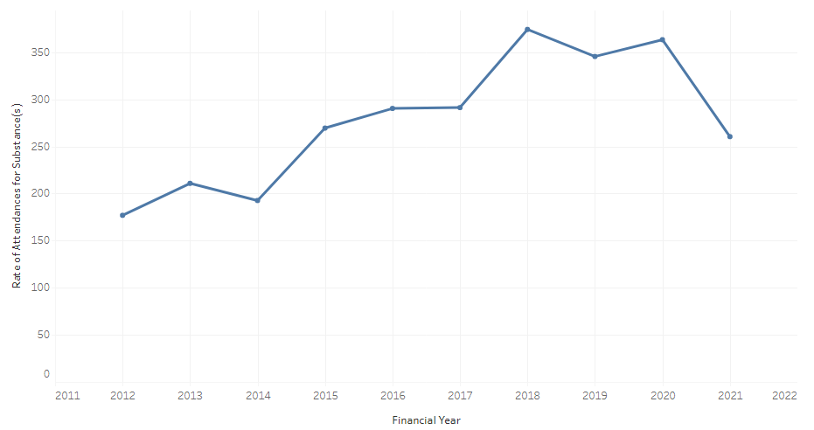

Source: Turning Point (December 2022). *Ambulance attendances.*  <https://aodstats.org.au/explore-data/ambulance-attendances/>

### DirectLine phone counselling

The level of alcohol related telephone counselling sessions and referrals has been dropping in Yarra Ranges since 2018, including a drop in the 2020 calendar year. There was an increase in 2021, with the rate moving from 71 per 100,000 to 81. Whilst more growth in 2020 and 2021 may have been expected during lockdowns, need for counselling maybe have been partly met by increased online counselling from 2020 onwards.

Alcohol-related telephone counselling and referral services per 100,000 residents: Yarra Ranges, 2012 to 2021

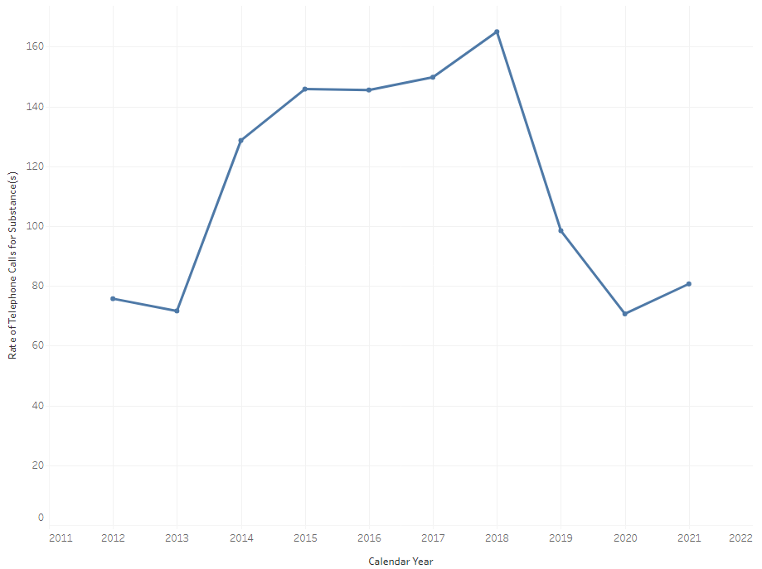

Source: Turning Point (November 2022). *DirectLIne.*  <https://aodstats.org.au/explore-data/directline/>

### Counselling online

Data on online counselling is available by calendar year rather than financial year. Online counselling was limited pre-pandemic, but had started to be used minimally in 2013. Between 2019 and 2020, the rate of online alcohol counselling rose by 21% to 17 sessions per 100,000; the rate then more than halved in 2021, to eight sessions per 100,0000. The number of sessions experienced a 23% rise followed by a 56% fall, to 12 sessions. All usage was amongst 20-44 year olds, particularly 25-34 year olds; numbers were split evenly between males and females in 2020 and 2021. Total numbers in 2021 had fallen bellow the 2019 pre-pandemic levels.

Alcohol-related online treatment sessions per 100,000 residents – Counselling Online: Yarra Ranges, 2013 to 2021

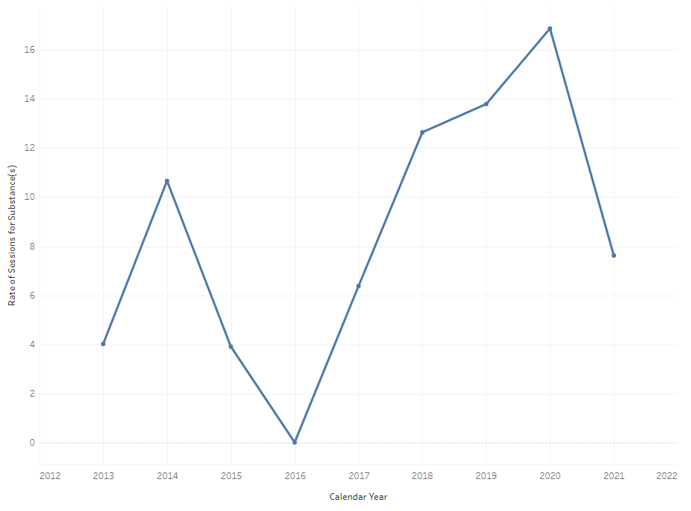

Source: Turning Point (November 2022). *Counselling online.*  <https://aodstats.org.au/explore-data/counselling-online/>

Alcohol-related online treatment sessions per 100,000 residents – Counselling Online: Yarra Ranges, 2013 to 2021

|  |  |  |  |  |  |  |  |  |  |
| --- | --- | --- | --- | --- | --- | --- | --- | --- | --- |
|  | 2013 | 2014 | 2015 | 2016 | 2017 | 2018 | 2019 | 2020 | 2021 |
| Number of counselling  online sessions for alcohol |  |  |  |  |  |  |  |  |  |
| 0-19yrs | 0 | 0 | 0 | 0 | 0 | 0 | 0 | 0 | 0 |
| 20-24yrs | 0 | 6 | 0 | 0 | 0 | 5 | 0 | 5 | 0 |
| 25-34yrs | 0 | 0 | 0 | 0 | 0 | 7 | 11 | 8 | 6 |
| 35-44yrs | 0 | 5 | 0 | 0 | 0 | 0 | 0 | 5 | 0 |
| 45-54yrs | 0 | 0 | 0 | 0 | 0 | 0 | 0 | 0 | 0 |
| 55-64yrs | 0 | 0 | 0 | 0 | 0 | 0 | 0 | 0 | 0 |
| 65+yrs | 0 | 0 | 0 | 0 | 0 | 0 | 0 | 0 | 0 |
| Female | 6 | 8 | 0 | 0 | 0 | 12 | 14 | 14 | 7 |
| Male | 0 | 8 | 0 | 0 | 0 | 8 | 8 | 13 | 5 |
| Total | 6 | 16 | 6 | 0 | 10 | 20 | 22 | 27 | 12 |
| Rate of counselling online sessions for alcohol (per 100,000) |  |  |  |  |  |  |  |  |  |
| 0-19yrs | 0 | 0 | 0 | 0 | 0 | 0 | 0 | 0 | 0 |
| 20-24yrs | 0 | 61 | 0 | 0 | 0 | 50 | 0 | 51 | 0 |
| 25-34yrs | 0 | 0 | 0 | 0 | 0 | 35 | 54 | 39 | 31 |
| 35-44yrs | 0 | 24 | 0 | 0 | 0 | 0 | 0 | 24 | 0 |
| 45-54yrs | 0 | 0 | 0 | 0 | 0 | 0 | 0 | 0 | 0 |
| 55-64yrs | 0 | 0 | 0 | 0 | 0 | 0 | 0 | 0 | 0 |
| 65+yrs |  |  | 0 | 0 | 0 | 0 | 0 | 0 | 0 |
| Female | 8 | 11 | 0 | 0 | 0 | 15 | 17 | 17 | 9 |
| Male | 0 | 11 | 0 | 0 | 0 | 10 | 10 | 16 | 6 |
| Total | 4 | 11 | 4 | 0 | 6 | 13 | 14 | 17 | 8 |

Source: Turning Point (November 2022). *Counselling online.*  <https://aodstats.org.au/explore-data/counselling-online/>

### Treatment episodes

From 2016/17 to 2019/20, the rate of treatment for alcohol issues trended steadily downwards. The level then spiked upwards, more than doubling to 130 per 100,000 in 2020/21. The rate rose by 23% in 2021/22, reaching a rate of 160 per 100,000.

Alcohol-related episodes of care, per 100,000 residents: Yarra Ranges, 2012/13 to 2021/22

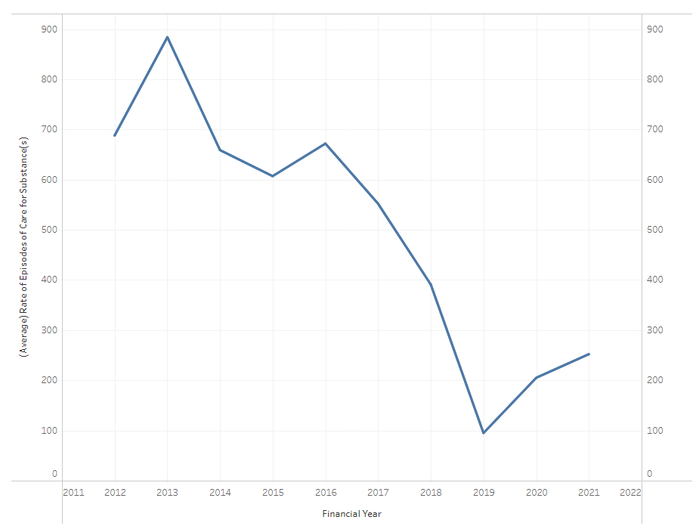

Source: Turning Point (November 2022). *Treatment episodes.*  <https://aodstats.org.au/explore-data/treatment-episodes/>

## Other service types

### Legal services

The Eastern Community Legal Centre (ECLC, Yarra Ranges branch) is based in Healesville and is the only community legal service in Yarra Ranges. In 2021/22, it had 2,023 clients across Eastern Melbourne; most of these were new clients and they were most likely to be aged 25-49 (60%). The main reasons for seeking legal help were family violence (55%), family law (21%) and other civil disputes (11%). Most clients had low or no income (71%), and 55% were experiencing financial disadvantage. Two-thirds were experiencing family violence, and 22% had a disability or mental illness.

ECLC has been involved in supporting Yarra Ranges residents affected by the June 2021 storm; as of June 2022, it had assisted more than 90 clients with storm-related legal help.[11]

There is also a Victorian Legal Aid service based in Ringwood. In 2021/22, it had between 751 and 1,500 clients from Yarra Ranges.[12]

Eastern Community Legal Centre client statistics, 2021/22

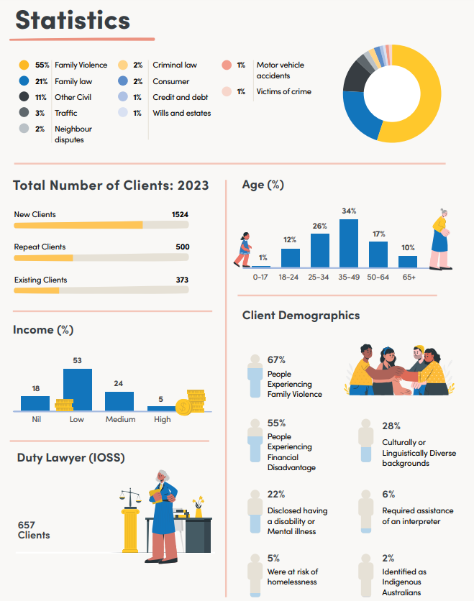

### Eating disorder services

Yarra Ranges currently does not have any dedicated eating disorder services. EACH is considering starting an eating disorders clinic at EACH in Ferntree Gully and Ringwood East, in early 2024. Broader mental health services such as Headspace and adult mental health services can also assist with eating disorders.

### Problem gambling support services

EACH provides Gamblers Help services via outreach in Healesville and Yarra Junction.[13] No data are available on local client numbers.

### Social support services

Social support services covering Yarra Ranges include:

* Anglicare Victoria.
* Inspiro.
* Australian Red Cross.
* Vantage Point Community.
* The Mustard Seed.

There are also three phone-based social support services (Outer East Phone Chat, Friends for Good Friendline, Bridges Phone a Friend); and Victoria Police has a community safety register.

### Emergency support services

There are six main emergency support services in Yarra Ranges, as listed in the table below. Utilities also have financial assistance available to those having difficulties paying their bills.

Emergency support services in Yarra Ranges

|  |  |  |
| --- | --- | --- |
| Organisation | Service | Areas serviced |
| HICCI | Financial assistance.  May have access to firewood. | Healesville area |
| LinC Yarra Valley | Financial assistance.  May have access to firewood. | Upper Yarra area |
| The Salvation Army (Mooroolbark) | Food (non-perishable).  Material support. | Mooroolbark and surrounds |
| CIS Yarra Ranges | Food vouchers and financial assistance. Information and referral service for enquiries including housing, health, family support and mental health. | Yarra Ranges residents: information and advice.  Emergency relief provided to Urban Area and Hills |
| Dandenong Ranges Emergency Relief Service | Emergency relief including financial assistance, food, clothing vouchers, travel assistance and more.  May have access to firewood. | Dandenong Ranges |
| The Mustard Tree | Op shop, Cafe and Food Bank.  May have access to firewood. |  |

### Family violence support services

In 2020/21, Eastern Domestic Violence Service (EDVOS) received more than 13,500 referrals and requests for service from family violence victim survivors, across a wide range of referral sources. 8,324 victim survivors - mostly women and children - engaged with EDVOS for a comprehensive service response which included assessment, planning and support. Twenty-two percent % of clients lived in Yarra Ranges.[14]

### Aged care services

The target populations for residential aged care are all people aged 65 years and over, and indigenous people aged 50–64. Yarra Ranges has large gaps in residential aged care services, with no services at all in the Hills and a large shortfall in the Urban Area. The goal for service provision is currently 78 places per 1,000 people aged 70 plus. This service ratio will be temporarily reduced to 60.1 places per 1,000, over three years starting from 2024-25.[15]

The Urban Area has a shortfall of 302 places, the Hills has a shortfall of 279 places and the Valley has a shortfall of 64 places.The Hills has no residential age care; nor do Wandin-Seville, Upper Yarra Valley or Mount Evelyn.Montrose, Kilsyth, Healesville-Yarra Glen and Chirnside Park have a higher level of supply than the Yarra Ranges average, whilst Lilydale-Coldstream and Mooroolbark have an undersupply. The level of places in the Yarra Valley is above the Yarra Ranges average, although below the current national benchmark.

Residential care places: Yarra Ranges small areas, June 2023

|  |  |  |  |  |
| --- | --- | --- | --- | --- |
| SA2 Name | Residents aged 70+ | Residential care places | Residential care places per 1,000 aged 70+ | Shortfall in places based on benchmark |
| Yarra Valley | 2,116 | 142 | 67 | 23 |
| Montrose | 984 | 277 | 282 | -200 |
| Kilsyth | 1,525 | 220 | 144 | -101 |
| Healesville - Yarra Glen | 2,264 | 250 | 110 | -73 |
| Lilydale - Coldstream | 2,608 | 95 | 36 | 108 |
| Mooroolbark | 2,484 | 75 | 30 | 119 |
| Chirnside Park | 1447 | 144 | 100 | -31 |
| Wandin - Seville | 807 | 0 | 0 | 63 |
| Upper Yarra Valley | 19 | 0 | 0 | 1.5 |
| Mount Dandenong - Olinda | 1,227 | 0 | 0 | 96 |
| Monbulk - Silvan | 713 | 0 | 0 | 56 |
| Mount Evelyn | 962 | 0 | 0 | 75 |
| Belgrave - Selby | 879 | 0 | 0 | 69 |
| Upwey - Tecoma | 755 | 0 | 0 | 59 |
| Total Yarra Ranges | 18,975 | 1,203 | 63 | 277 |
| Current national benchmark |  |  | 78 |  |

Source: Australian Institute of Health and Welfare (2023). *Victoria service list, 30 June 2023.* <https://www.gen-agedcaredata.gov.au/Resources/Access-data/2023/September/Aged-care-service-list-30-June-2023>; <https://www.abs.gov.au/census/find-census-data/quickstats/2021/211051280>

Residential aged care service list: Yarra Ranges, 30 June 2023

|  |  |  |  |  |
| --- | --- | --- | --- | --- |
| Service Name | Physical Suburb | Residential Places | Organisation Type | SA2 Name |
| AdventCare Yarra Ranges | Warburton | 42 | Religious | Yarra Valley |
| Mercy Place Boronia | Montrose | 43 | Charitable | Montrose |
| Walmsley Aged Care | Kilsyth | 120 | Private Incorporated Body | Kilsyth |
| MiCare Overbeek Lodge | Kilsyth | 55 | Community Based | Kilsyth |
| Monda Lodge Hostel | Healesville | 30 | State Government | Healesville - Yarra Glen |
| MiCare Margriet Manor | Kilsyth | 45 | Community Based | Kilsyth |
| Kirkbrae Kilsyth Nursing Home | Kilsyth | 110 | Religious | Montrose |
| Lilydale Aged Care | Lilydale | 95 | Charitable | Lilydale - Coldstream |
| Mercy Place Montrose | Montrose | 124 | Charitable | Montrose |
| Estia Health Yarra Valley | Yarra Junction | 100 | Private Incorporated Body | Yarra Valley |
| Holmwood Aged Care | Healesville | 100 | Private Incorporated Body | Healesville - Yarra Glen |
| BlueCross Baradine | Mooroolbark | 75 | Private Incorporated Body | Mooroolbark |
| Aurrum Healesville | Healesville | 120 | Private Incorporated Body | Healesville - Yarra Glen |
| Chirnside Views | Chirnside Park | 144 | Private Incorporated Body | Chirnside Park |

Source: Australian Institute of Health and Welfare (2023). *Victoria service list, 30 June 2023.* <https://www.gen-agedcaredata.gov.au/Resources/Access-data/2023/September/Aged-care-service-list-30-June-2023>; <https://www.abs.gov.au/census/find-census-data/quickstats/2021/211051280>

# Conclusion

The Human Services Needs Analysis has collected a range of information about service needs and demand for services. This information includes challenges for the community in accessing the services that they need, major barriers to service access, challenges for services in meeting community needs, areas of unmet need, service gaps, and changes in demand since the onset of the pandemic.

The next steps for the project will be to share these insights more broadly, to use this work to inform upcoming strategic and advocacy work, and to work with service providers to develop appropriate responses.

**The PDF version of the Executive Summary, copies of this report, and information about related work, can be found here:** [**https://www.yarraranges.vic.gov.au/Community/Health-and-Wellbeing/Human-Services-Needs-Analysis**](https://www.yarraranges.vic.gov.au/Community/Health-and-Wellbeing/Human-Services-Needs-Analysis)

# Appendix 1: Additional demographics

## People and population

The 2021 Census counted 156,068 residents in Yarra Ranges, compared to 149,537 in 2016 (a 4.4% increase). This figure will be adjusted to calculate the estimated resident population, to allow for residents who are absent from their homes on Census night.

The population was split roughly 50:50 between males (49.5%) and females (50.5%). The median age of residents is 40 years. Yarra Ranges has a below average level of adults aged 20-44 (30.8% compared to 35.4%), and an above average level of persons aged 45 plus (44.4% compared to 41%); its level of children and teenagers is similar to the Victorian average. The largest age groups in Yarra Ranges are 45-49 year olds and 50-54 year olds (in terms of population share). The age group that has changed the most since 2016 is 70-74 year olds, increasing by 1,716 people, followed by 75-79 year olds (1,485 persons), 35-39 year olds (1,275 persons) and 30-34 year olds (1,245 persons). The number of residents aged 0-14 has increased, along with 30-39 year olds, 50-54 year olds, and persons aged 60 years or more. In terms of service age groups, the main age group where Yarra Ranges lost residents was young adults aged 18-24 (a loss of 472 residents since 2016); there was also a slight decline (84 persons) in the number of 50-59 year olds.

Compared to Yarra Ranges, Healesville-Yarra Glen has an above average proportion of older residents aged 55 years or more, and a below average level of 0-54 year olds.The Hills has a higher level of 5-19 year olds, and 40-74 year olds. The Urban Area has a higher level of 0-9 year olds and 20-39 year olds. Yarra Valley has an above average level of 10-19 year olds, 25-29 year olds and 50-69 year olds**.**

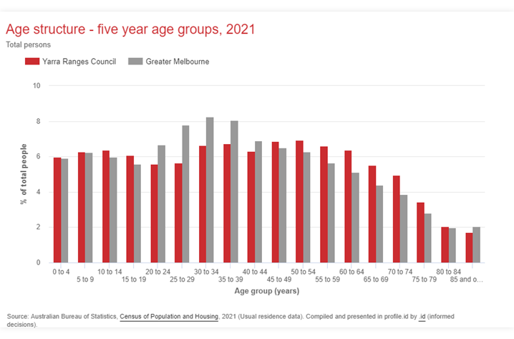

In 2021, Yarra Ranges had 1,713 residents who identified as ATSI (1.1% of the population). Whilst this number is still considered to be an understatement, it is up from 1,359 in 2016 (a 26% rise), indicating that more residents now feel more comfortable with identifying as indigenous in the Census records. Yarra Ranges residents are more likely to state their indigenous status – only 3.4% did not state it, compared to 4.5% for Victoria. The indigenous population has a much younger age profile, with 79% aged less than 50, compared to 62% of the non-indigenous population. Upper Yarra Valley (3.4%) and Healesville-Yarra Glen (2.7%) have the highest levels of indigenous residents; Upwey-Tecoma (0.4%) has the lowest.

Yarra Ranges has an above average level of residents who are married or part of a de facto couple. Nearly half of residents aged 15 years or more are married, compared to 46.8% across Victoria; 12.8% are in de facto marriages, compared to 11.2% across Victoria. Mount Dandenong-Olinda and Wandin-Seville have the highest levels of married or de facto residents (66%), and Upper Yarra Valley has the lowest (49%).

## Cultural diversity

Most residents were born in Australia (79.4% compared to 65%); this is the seventh-highest level in Victoria. Also, most residents speak English only at home (88.3% compared to 67.2%). Across Victoria, nearly one-third of households use a non-English language, compared to 10% in Yarra Ranges. The main languages other than English are Mandarin (0.8%), Italian (0.7%), Chin Haka (0.7%), German (0.4%) and Dutch (0.3%).

The number of new arrivals dropped dramatically in both 2020 and 2021. Yarra Ranges had 461 arrivals from overseas in 2018, 459 in 2019, 163 in 2020 and 71 in 2021. Given that pre-COVID, Yarra Ranges consistently had several hundred overseas arrivals per year, the low numbers in 2020 and 2021 translate to about 700 less Yarra Ranges residents than could have otherwise been expected. The lack of arrivals on temporary working visas would also have impacted agricultural businesses in Yarra Ranges (however, the drop in persons on working visas is not quantified via the Census). Most of those who did arrive over the past two years came from China, the United Kingdom, India or New Zealand.

## Income

Yarra Ranges has above average family and household incomes. Median weekly family incomes are $2,203 compared to $2,136 for Victoria; median household incomes are $1,881 compared to $1,759 for Victoria. Note that medians are not the same as averages, and represent the mid-point between the highest and lowest incomes. Median weekly household incomes were highest in Belgrave-Selby ($2,253), and lowest in Yarra Valley and Upper Yarra Valley ($1,439 and $900 respectively). In 2021, 14.5% of Yarra Ranges households had incomes of less than $650 per week; and this level is highest in Upper Yarra Valley (34.1%) and Yarra Valley (20.2%). However, the level of low income households has dropped since 2016, when 17.1% of Yarra Ranges households had incomes of less than $650 per week.

## Unpaid work and care

Yarra Ranges has a very high level of residents doing voluntary work or providing unpaid care:

* 14.7% of residents provided unpaid assistance to a person with a disability or health condition, or who needed assistance due to old age. Women were more likely to be providing such assistance, at 17.6% of women compared to 11.7% of men. Those aged 45-64 are the age cohort most likely to be providing assistance (19.6% of 45-54 year olds, and 23.1% of 55-64 year olds). Retirees aged 65 years or more also have a high level of caring responsibilities, at 17.1% of 65-74 year olds, 12.5% of 75-84 year olds and 7.5% of those aged 85 years or more. In most cases this would be due to caring for a partner with disability or health conditions. Mount Dandenong-Olinda and Mount Evelyn have the highest levels of residents who provide unpaid assistance (16%), and Upper Yarra Valley has the lowest (13.4%).
* 15.5% did voluntary work through an organisation or group (during the past 12 months), compared to 13.3% across Victoria. Mount Dandenong-Olinda has the highest level of residents who volunteer (22%) and Upper Yarra Valley has the lowest (8%).

Whilst Yarra Ranges continues to have a high level of volunteering relative to Victoria, the level of volunteers appears to have dropped dramatically during the pandemic, from 21.3% in 2016 to 15.5% in 2021; Victoria experienced a similar drop, from 19.2% to 13.3%. The volunteering data refers to volunteering over the past 12 months, indicating that many people ceased volunteering during lockdowns and then did not return to it afterwards. Volunteers are essential to a wide range of community sports, activities and services, and a 27% drop in the level of volunteers is a very concerning shift. The drop in the level of volunteers was highest in Upper Yarra Valley, where the level of residents who volunteers more than halved; and lowest in Mount Dandenong-Olinda and Belgrave-Selby (21%).

## Health

### Long-term health conditions

More than one-in-three residents (35.2%) have one or more long-term health conditions, compared to 31.4% of Victorian residents. Fifty-eight percent of residents reported no long-term health conditions, compared to 61% across Victoria. The most prevalent health conditions are mental health, arthritis, asthma, diabetes and heart disease. The conditions for which Yarra Ranges has an above average percentage are:

* mental health conditions, including depression or anxiety (10.3% compared to 8.8%);
* arthritis (9.4% compared to 8%);
* asthma (9.6% compared to 8.4%);
* other long-term health conditions (8.9% compared to 8%); and
* cancer (3.2% compared to 2.8%).

Yarra Ranges ranked seventh-highest for the level of residents with mental health conditions, within metropolitan Melbourne. Yarra Ranges has a below average level of residents with diabetes (4.3% compared to 4.7%); it was similar to the state average for dementia (0.6%), heart disease (3.9%), kidney disease (0.8%), lung conditions (1.7%) and stroke (0.9%). The wording of the question was had the person “been told by a doctor or nurse that they have any of these long-term health conditions?” (with the option to choose from a list and/or tick a box for “any other long-term conditions”).

For mental health, national data indicates that the figure of 10.3% is probably a large under-estimate. This is because the results rely on doctor/nurse diagnosis, and will miss people who did not seek assistance from a health service. The National Study of Mental Health and Wellbeing[16] found that 53% of those experiencing a mental disorder in the past twelve months had not sought help from a service. It also found that more than one in five people (21%) had experienced a mental disorder in the past 12 months. Two in five people (40%) aged 16-24 years had experienced a mental disorder in the past 12 months, roughly double the population average.

Compared to metropolitan Melbourne, Yarra Ranges was well above average for the level of residents with arthritis, mental health conditions and asthma. It was also above average for cancer, heart disease, long conditions, stroke, and other long-term health conditions.

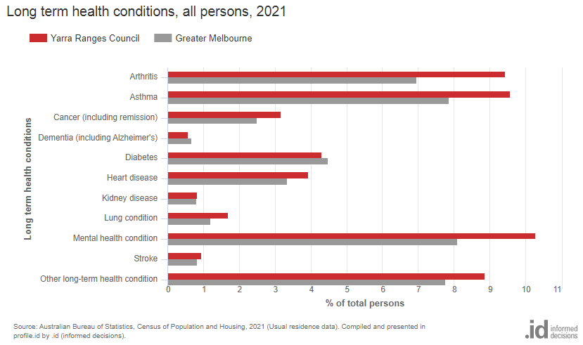

### Mental health conditions

For mental health, teenagers and adults aged 15-64 were most likely to have a mental health condition. The level of residents with a mental health condition was highest amongst 25-34 year olds (14.7% of this age group), 35-44 year olds (14.1%), 15-24 year olds (13.3%) and 45-54 year olds (12.4%). It was below the population average amongst those aged less than 15, and those aged 65 years or more. The reported prevalence was lowest amongst under-15 year olds (3%) and persons aged 75-84 (7%); note that many mental health conditions first become apparent during the early teenage years, which would be part of the reason for low prevalence amongst under-15 year olds. Yarra Valley and Belgrave-Selby have the highest levels of residents with a mental health condition (11%), and Wandin-Seville has the lowest level (9%). Wandin-Seville also has low levels of lone person households and one-parent families, both of which are associated with having a mental health condition.

More than half of residents with a mental health condition (51%) are on very low annual incomes of less than $33,800, compared to 39% of all residents. Persons with a mental health condition are more than three times as likely to need assistance with daily activities - 16% of those with a mental health condition, compared to 5.4% of the total population.

Protective factors for mental health (contributing to a lower prevalence) included being born in Australia, being married or in a de-facto relationship, or being in a couple with children household. Risk factors included heading a one parent family, or being in a lone person household.

Mental health conditions by age: Yarra Ranges, 2021

|  |  |  |
| --- | --- | --- |
| Age group (years) | Rate of mental health conditions per 1,000 | % with a mental health condition |
| 0-14 | 29 | 2.9% |
| 15-24 | 133 | 13.3% |
| 25-34 | 147 | 14.7% |
| 35-44 | 141 | 14.1% |
| 45-54 | 124 | 12.4% |
| 55-64 | 111 | 11.1% |
| 65-74 | 83 | 8.3% |
| 75-84 | 68 | 6.8% |
| 85 years | 96 | 9.6% |
| Total | 103 | 10.3% |

Source: Australian Bureau of Statistics (2022). *Yarra Ranges 2021 Census All Persons QuickStats.* Retrieved from: <https://www.abs.gov.au/census/find-census-data/quickstats/2021/LGA27450>

### Disability

The number of residents with a disability has increased by 22% between 2016 and 2021, from 6,985 to 8,430 (1,535 additional residents with a disability). The percentage increased by 17%, from 4.6% to 5.4%. This is slightly below the Victorian average of 5.9%.

## Housing

As of August 2021, Yarra Ranges had a below average level of dwellings in mortgage stress, with 14% of households with mortgages having repayments which are more than 30% of household income (compared to 15.5% across Victoria). Yarra Ranges has an above average level of renter households in housing stress, with rent payments more than 30% of household income: 33.9% of renter households have high rent payments, compared to 30.9% across Victoria. Yarra Ranges has very little social housing. Only 1% of occupied private dwellings were being rented from a state or territory housing authority, or from a community housing provider. Rental stress is highest in Yarra Valley (40.2%) and Monbulk-Silvan (39.3%). Median weekly rents are lowest in Upper Yarra Valley ($260) and Yarra Valley ($315).

## Transport

Yarra Ranges continues to have a high level of motor vehicle ownership - 96.3% of households own at least one vehicle, compared to 91.1% across Victoria; 69% of households own two or more vehicles (compared to 55.3%). This high level of vehicle ownership reflects the geographically spread-out nature of Yarra Ranges, combined with poor public transport access in many parts of the shire, and long travel distances to services and facilities from the outer parts of the municipality.

# Appendix 2: Strategic alignment

The aims of the Human Services Needs Analysis align with strategic objectives and major initiatives from the Yarra Ranges Council Plan.

## Council Plan

Yarra Ranges Council is committed to supporting services which meet community needs, with the *Council Plan 2021–2025* outlining five strategic objectives, including:

* **Connected and Healthy Communities** - Communities are safe, resilient, healthy, inclusive and socially well connected. Quality services are accessible to everyone.

The HSNA project aligns with this strategic objective through its focus on assessing and improving access to services.

* **Quality Infrastructure and Livable Places** - Quality facilities and infrastructure meet current and future needs. Places are well planned and are hubs of activity that foster wellbeing, creativity and innovation.

The project aligns with this strategic objective through its focus on assessing and helping services to respond to service current and forecast community needs. Data from the service needs analysis will be used to inform the planning and provision of facilities and infrastructure.

* **High Performing Organisation** - An innovative, responsive organisation that listens and delivers quality, value for money services to our community.

The project aligns with this strategic objective through its support for delivery of quality community services. It will also support evidence-based decision making, which is another identified component of having a high performing organisation.

The Council Plan also identified several major initiatives, including a Mental Health Major Initiative Project. This project aims to improve mental health outcomes for the community, strengthen social connections, and advocate for equitable and accessible mental health services across the municipality. The HSNA will support this initiative by providing evidence to support advocacy for equitable and accessible mental health services.

## Municipal Recovery Plan

The *Council Plan 2021–2025* outlined Council’s commitment to municipal recovery from the pandemic and the 2021 storm event. The Municipal Recovery Plan identified lack of local services as a key issue for outlying Yarra Ranges communities, and identified access to mental and physical health services as a major impact of the pandemic. The Plan’s recovery objectives included ensuring that “community members have access to the support, services, and resources they need to address impacts; prevent the escalation of needs; and [to prevent] long- term negative impacts on health and wellbeing”. The project will support the Plan’s objectives by assessing and advocating for better access to services, and advocating to address community needs.

# Appendix 3: Survey respondents

External survey respondents

|  |  |
| --- | --- |
| What is the name of your organisation? |  |
| ADRA Redwood Community Centre | Inspiro Lilydale (2 responses) |
| Anchor Community Care Limited | Inspiro Belgrave |
| Anglican Parish of Mount Dandenong | Knoxbrooke Inc |
| Anglicare Vic | Koha Community Cafe Inc. |
| Belgravia Leisure | Migrant Information Centre (Eastern Melbourne) |
| Benwerren | Monbulk Aquatic Centre Belgravia Leisure |
| Bridges Connecting Communities Ltd | Mount Evelyn Counselling |
| Caladenia Dementia Care | Outer East Foodshare Inc |
| Champion, Temple Society Australia | Recovery Options |
| Chirnside Park Family Clinic | Scope |
| CIS Yarra Ranges (2 responses) | Selby Community House |
| Coldstream Family Practice | Taylor Support Services |
| Dandenong Ranges Emergency Relief Service Inc. | The MISFIT Project |
| Dental Studio Mooroolbark | The Philanthropic Collective |
| Discovery Community Care Inc | Uniting |
| Eastern Community Legal Centre (2 responses) | Vantage Point Community |
| Eastern Health (3 responses) | Wesburn Primary School |
| Healesville Hospital & Yarra Valley Health | Women's Health East (2 responses) |
| ECHO Youth and Family Services | Yarra Glen & District Living & Learning Centre |
| Exercise Thought | Yarra Glen Medical Centre |
| Get Well Clinic (2 responses) | Yarra Junction Medical Centre |
| headspace Lilydale | Yarra Ranges Health, Day Oncology |
| Hearsmart Hearing Solutions | Yarra Ranges Kindergarten Inc. |
| Holy Fools Inc |  |

# Appendix 4: Selected survey tables

Do you have anything else you would like to share on provision of services, service gaps or service demand?

|  |
| --- |
| Do you have anything else you would like to share on provision of services, service gaps or service demand? |
| Whilst our service is located in Knox we see a fair number of people from YR yet cannot access yr funding. |
| I'd like to see proper priority housing for vulnerable people. 12 months+ on the top of a "priority housing list" is not what I consider priority housing. In the meantime women and children sleeping in cars, swags and left to fend for themselves in unsafe environments. |
| Supporting access to services earlier and tertiary intervention and connection with local supportive organisations eg: gyms/recreation facilities for clients with chronic disease |
| Closure of Kilsyth Centenary Pool has impacted our business and community health outcomes. |
| MIC worked collaboratively with early childhood services to increase cultural competency in pre-schools with high enrolments of children from refugee backgrounds. This partnership was highly successful and MIC support was no longer required. |
| Facilities for people with disabilities are lacking particularly swimming pools |
| All community services in the region would benefit from increased resourcing and funding. We see climate change and access to climate justice as emerging priority for the region given the significant risk. |
| No |
| I could only speak to the knowledge I have in my service area. Housing or lack thereof is a huge issue in the area and very little assistance or infrastructure in place for long term solutions |
| It is proving difficult to recruit new staff to the Lilydale area. Lack of emergency accommodation means more use of hotels where costs are rising. Lack of Government and affordable housing in the Yarra Ranges. There are no youth refuges in the Yarra Ranges |
| services for youth are offered, seem to rarely be accessed. Need more mental health practitioners on outreach basis. There is Limited public transport for non drivers- and none between Yarra Junction and Healesville where there is a bit more service provision- |
| Big issue is staff attraction |
| Family violence therapeutic services cannot meet demand. Youth wellbeing is very low in Yarra ranges LGA |
| Support in establishing much-needed disability housing would be beneficial for the growth and development of our company. Support could be in the form of grants or any support in establishing housing services. Support for assisting staff to become mental health qualified would be good. |
| It would be good to have more specific LGBTIQA+ specific services to support the community who often remain closeted due to stigma and fear |
| As a non-funded community service, we believe the time has come that Council make provision within its budget to support our running costs. We require 15K per year for a 3 million return. It is unacceptable that we must work to obtain grants to continue a service we could not be run by Council. All of which is operated and run free of charge by community volunteers. |
| Good support from Emergency Services Group at Yarra Ranges Shire |
| As a community house, we are integral to our community, we would welcome funding which covers our increased costs so we can continue to provide valuable community services. |
| I haven't said that home cleaning is just not available to eligible people & I wonder if people are more independent/resourceful post covid & not seeking some supports? |
| need for greater student welfare support of schools |
| We need an indoor hydrotherapy pool within a 5km radius of Lilydale. |
| As a private provider we are kept out of the information loop and viewed with suspicion by many not for profit groups.Working in the NDIS space there should be more face to face networking available to assist in collaboration. for all players |
| We have had an increase of 450 visits last financial year then the year before. People are in more need then ever due to increase in living costs. People need help with short Case management because the waiting list are very long and not everyone is eligible. Here at CIS Yarra Ranges we support locals with casework, advocacy and support that have no where else to go. |
| No |

Do you have anything else you would like to share?

|  |
| --- |
| Do you have anything else you would like to share? |
| The attendances to MAC clearly illustrate the need to expand our facilities to include such things as a Program Pool, Hydro Pool, expansion of Gym, larger Group Fitness Room, Multipurpose room |
| Post covid 19 - The Yarra ranges LGA population appear very stressed. Increase in incivility and micro-aggressions from the community towards services and lack of available resources. |
| We would like to be funded with our own space. |
| Support from grants has enabled us to continue to strengthen our infrastructure to respond to future emergencies, continue to offer exercise programs, and keep our drop in centre open. |
| We run a program for frail aged people called Cafe Club which is not recognised or supported by Council. Even though it is a cost to our business we continue to run it as there is nothing else in this area for this group |
| We are hoping for continued support form the Yarra Ranges Council to keep our service open |

1. In the context of this analysis, human services needs are defined as an**interdisciplinary set of social assistance programs** that include everything from healthcare and counselling services, to food and shelter. These services are offered through government, non-profit agencies and private service providers; and are designed to contribute to the health and welfare of communities, by delivering a broad range of help and support.
2. Note that this indicator is not comparable with 2016 QuickStats, as applicable households included in this calculation have changed.  The previous measure looked at those in housing cost stress as a percentage of all households, rather than as a percentage of rental or mortgage households.
3. Chysantho, N. (2023). *The Age - Australia is registering 5000 new healthcare workers a month. So why is there still a staffing crisis?* <https://www.theage.com.au/politics/federal/australia-is-registering-5000-new-healthcare-workers-a-month-so-why-is-there-still-a-staffing-crisis-20230817-p5dxab.html>
4. Department of Health (2023). *Health Workforce Locator, 21 July 2022 data.* <https://www.health.gov.au/topics/rural-health-workforce/classifications/dpa> <https://www.health.gov.au/resources/apps-and-tools/health-workforce-locator/app>
5. RACGP (2023). TROPHI Community Needs summary August 2023. Unpublished data.
6. <https://inspiro.org.au/wp-content/uploads/2022/10/2021-22-Inspiro-Annual-Report-Digital-Summary.pdf>
7. <https://inspiro.org.au/wp-content/uploads/2022/10/2021-22-Inspiro-Annual-Report-Digital-Summary.pdf>
8. <https://www.dhsv.org.au/__data/assets/pdf_file/0011/187337/Dental-Health-Services-Victoria-Annual-Report-2021-2022-FINAL-021222-small.pdf>
9. <https://inspiro.org.au/wp-content/uploads/2022/10/2021-22-Inspiro-Annual-Report-Digital-Summary.pdf>
10. Department of Health and Aged Care. (2022). *Health workforce locator.* <https://www.health.gov.au/resources/apps-and-tools/health-workforce-locator/app>
11. https://eclc.org.au/wp-content/uploads/ECLC-Annual-Report-2021-22.pdf
12. <https://www.legalaid.vic.gov.au/annual-report#download-the-full-report>
13. <https://www.each.com.au/service/gamblers-help-eastern/>
14. <https://annualreport2021.fvree.org.au/#ServicesSnapshot>
15. <https://www.health.gov.au/our-work/aged-care-reforms/what-were-doing/sustainable-care#:~:text=Temporary%20changes%20to%20the%20residential%20aged%20care%20planning%20ratio,-Improving%20Aged%20Care&text=The%20Government%20will%20temporarily%20reduce,three%20years%20from%202024%2D25>.
16. <https://www.abs.gov.au/statistics/health/mental-health/national-study-mental-health-and-wellbeing/latest-release#:~:text=The%202020%2D21%20National%20Study,Diagnostic%20Interview%20(CIDI%203.0).>