**2015**

Seville Township Group, June 2015

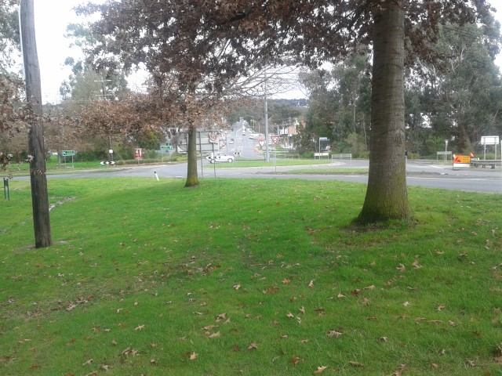

Seville Community Plan 2015-17



**Produced by SEVILLE TOWNSHIP GROUP**

Web: www.sevilletownshipgroup.wordpress.com

Facebook: www.facebook.com/sevilletownshipgroup

Post: PO Box 180 Seville, 3139

Email: sevilletowngroup@gmail.com

Twitter: @sevilletownship

**Seville Township Group**

President: Trilby Dewhurst

Secretary: Colleen Dewhurst

Treasurer: Sue McMurdie

Members: Wayne DeKlijn, Sue McMurdie, Tahnee Dewhurst, Derry Aulich, Rosemary Varty, Nicole Shore, Cynthia Patton, Bev Lindsay.

# Acknowledgements

Thanks to everyone who helped to create this plan:

* Residents, landowners, businesses, sports clubs, students and traders of Seville who participated and volunteered in this process.
* Yarra Ranges Council Community Development Officer Chris Riseley
* Workshop facilitators Kimbra White and Peter Kenyon

# About Seville Township Group

Seville Township Group has been working hard for your community since late 2010. Our aim is to provide connection, community and improvement for Seville and surrounds.

We work on advocacy and initiation of projects. In 2014 these included:

* adding extra rubbish bins to the main street
* meeting with stakeholders, developing plans and successfully receiving grant money for a War Memorial in Seville
* forwarding comments and complaints to Council regarding the Seville Water Play Park
* updating the Water Play Park Facebook page
* liaising with Council regarding streetscape works on Warburton Highway, signage on the Rail Trail, design of the new playspace, and other issues.
* Coordination of the Yarra Valley Spring Festival and blue light discos
* liaising with the developer of the new shopping precinct, particularly regarding parking for the adjacent kindergarten.

# Table of Contents

Acknowledgements 2

About Seville Township Group 2

Seville’s Characteristics 4

Demographics 4

**Social and economic features** 4

**Assets** 5

Planning Context 6

**Upper Yarra Valley & Dandenong Ranges Regional Strategy Plan, 1995** 6

**Seville Community Ideas Report, 2002** 6

**Seville Reserve Master Plan, 2012** 7

Community Planning Activities in Seville, 2013-15 8

**Stall at Springfest, 2013** 8

**Peter Kenyon Workshop, May 2014** 8

**BBQ Behind the IGA, August 2014** 9

**Stall at Springfest 2014** 9

**Sorting Ideas into Categories** 10

**Outdoor Cinema March 2015 – identifying priorities** 10

**Workshop with Kimbra White April 2015 – Identifying Projects** 11

**Consultation with Secondary School Students, Lilydale High School, June 2015** 11

**Release of Draft Community Plan, August 2015** 12

Vision Statement 13

Strategies and Actions 13

Annex 1: Statistical Information 18

Annex 2: Community Ideas and Suggestions in 16 categories (in priority order) 21

# Introduction

The townships of Seville and Seville East are nine kilometres east of Lilydale, along the Warburton Highway. They have a combined population of 3,212 people (2011 census). It is part of the Yarra Valley, which is part of the shire of Yarra Ranges.

Community planning is a process where the members of a community work together to identify a shared vision of the future, and priorities and actions that they can undertake to improve their wellbeing and achieve their goals.

Since 2012, Yarra Ranges Council has been supporting communities in the shire to develop community plans. This document outlines the process followed to develop the Seville Community Plan, and the plan itself.

# Seville’s Characteristics

# Demographics

Seville and Seville East had 3,212 people in 2011. Twenty percent of the population of Seville and Seville East were under 12 years of age in 2011, compared to 15% for Yarra Ranges. This is important to note in planning for events and services for Seville. In Yarra Ranges, the towns with the highest proportion of primary school aged children are in Mount Evelyn and Wandin-Seville.

Nearly half (46%) of Seville households comprise couples with children, compared to 37% for Yarra Ranges as a whole. There is a lower proportion of lone person households than Yarra Ranges. This shows that Seville is a family and children - oriented town, attracted to the wide variety of recreation activities and groups, and the rural lifestyle.

At the other end of the age range, there is a growing number of older people wanting to reside in Seville and surrounding suburbs. The number of residents aged over 65 increased by 17% between 2006 and 2011. The number of people with dementia is forecast to increase as a result.

## **Social and economic features**

Seville is a unique township in that it is has significant, well defined “CBD” and limited housing growth opportunities. This gives Seville an individual feel and a distinct township character.

There is a mix of residential house blocks, hobby farms and large acreage, mainly fruit growers and graziers. About 76% of the land in Seville is used for residential purposes, and open public space accounts for about 18%. In Seville East the proportion of residential land is 57%, with 38% rural land. There is virtually no industrial land use in either town.

A commercial development in the town has recently added a second supermarket to Seville, plus a new medical centre. The town has a primary school, a preschool and a neighbourhood house. Its fire brigade celebrates its 75th anniversary in 2016.

The town has significant open space, with a large recreation reserve which hosts football (men and women, boys and girls), netball, tennis, and cricket clubs, and there is also a pony club. Despite being unsuccessful in stopping its swimming pool from being closed, a water play park was developed which has become very popular with families. A new playground is due to be constructed next to this park in late 2015.

A total of 730 businesses are registered as currently trading in Seville, with a further 200 registered in Seville East. The top three industries of employment are construction, manufacturing and retail trade. The top four occupations are technicians and trades workers, community and personal service workers, labourers and clerical and administrative workers.

## **Assets**

Listed below are the assets and the things that people value about Seville.

* Seville Recreation Reserve and facilities and the variety of sports clubs.
* Water play park
* Rural aspect
* Agribusiness
* 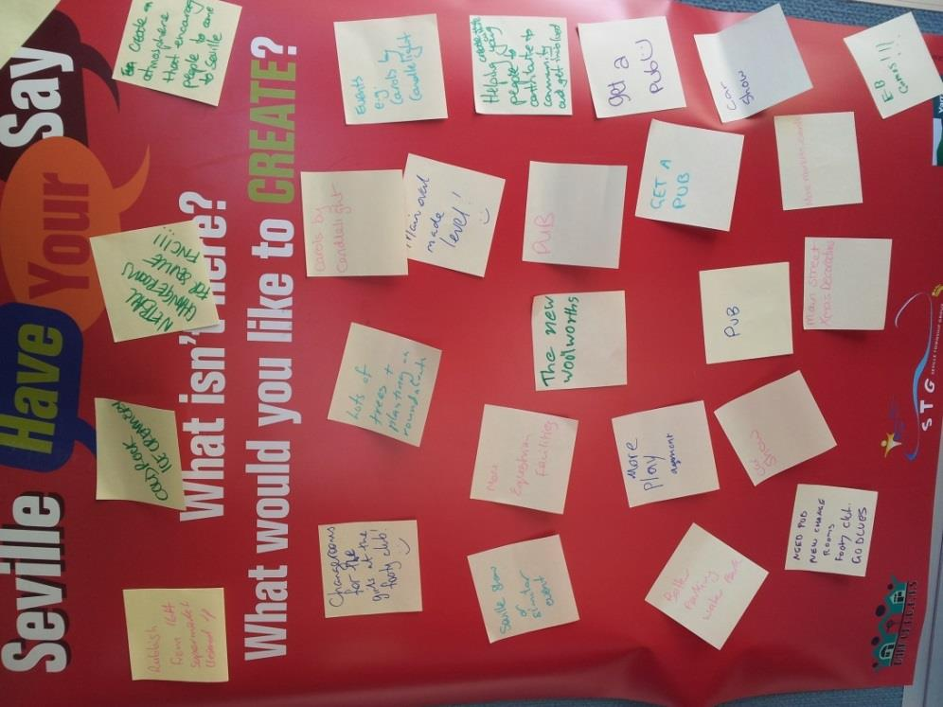Connection to history
* Active community and strong community spirit
* Family connections within the town
* Central location in the Yarra Valley
* Connection to the environment, the bush and Warburton Rail Trail
* New shops and local businesses
* The CFA
* Public transport and easy access to the suburbs
* Local community events

# Planning Context

This section includes extracts from regional and local plans that have an impact on Seville.

## **Upper Yarra Valley & Dandenong Ranges Regional Strategy Plan, 1995**

Seville is classified as a Smaller Rural Settlement Centre (Green Wedge Area). These areas are valued for their scenic rural character, including the open informal arrangement of buildings, the views to the surrounds and a low scale and unfinished feel.

Threats to the character of these centres include:

* poor amenity for pedestrians with large areas of road reserve with no traffic calming measures
* excessive signage
* urban and suburban styles of building design and streetscape treatments (e.g. bulky or heavily massed or detailed buildings; landscaping that is too formal or small scale).

Seville also includes areas classified as Rural Landscape 2. Main agricultural activities are grazing, mixed farming, part time farming and in some areas, fruit and berry production.

This landscape has been extensively subdivided. The lots are larger, with the most common size being about 16 hectares.

The primary purpose of the Rural Landscape 2 Policy Areasis to provide for a range of farming uses and activities (including part time farming) compatible with land suitability, capability and subdivision patterns, to protect and maintain the remaining native vegetation, wildlife, water quality and to maintain and enhance landscape value and character.

## **Seville Community Ideas Report, 2002**

A Seville Community Ideas Report was produced by the Shire of Yarra Ranges in 2002, based on one two-day community workshop which involved about 50 community members. This report outlined the Seville community’s priorities, some of which have come to fruition:

* Provide for the functional requirements of the town centre, including public toilets, seating, weather protection and improved footpaths (partly completed)
* Increased tree planting to improve the streetscape and give character to the town centre (completed)
* Improve the safety and efficiency of access at the Bell Street and Link Road intersections at the Warburton Highway (completed)
* Improvement of pedestrian and cycling paths within the town, with a focus on the main connections between community and commercial facilities and open space areas (partly completed)
* Stormwater and vegetation management strategies for the town and surrounding rural area (partly completed)
* Sort through land ownership and management arrangement along the creek corridor to gain approval for creek trail (not completed)
* Seville could improve its business and tourism activities through a business development and marketing plan (not completed)
* Clear guidelines should be set to ensure quality outcomes for strategically important areas of the town (partly completed).

## **Seville Reserve Master Plan, 2012**

The Seville Reserve is a large 40 acre reserve which is used for a wide variety of sport and recreation, and is a major asset in the town.

Yarra Ranges Council developed a master plan for the reserve, in consultation with community leaders and reserve user groups, in 2012. The plan sets out priorities for the development of the reserve as follows:

High Priority (within 3 years):

* Pavilion development, including improving and expanding change facilities; provide for both male and female umpires; multi-use community social area that can accommodate up to 250 people.
* Upgrade oval 2 (south) with irrigation and drainage, warm season grasses and replacement perimeter fencing
* Install removable bollards on roadway to the north and west of pavilion, to make pedestrian access safer at peak times.
* Pony club to remove structures and reinstate vegetation in creek corridor.

Medium priority (within five years):

* Incorporate a public toilet into the main pavilion
* Develop a regional playground with BBQ and picnic facilities
* Install training lights on oval 2 and upgrade lights on oval 1.
* Develop a levelled open grass area for informal sports training and community use for events and passive recreation
* Redevelop the 6 tennis courts and make two courts usable for netball, with lighting and fencing.
* A pedestrian bridge over the creek connecting the car park on the west side of the creek to the water play park on the east side.

Low priority (within ten years):

* Upgrade public toilet and consider its relocation to be closer to proposed village green and netball courts
* Upgrade oval 1 with irrigation and drainage and warm season grasses.
* Circuit walking path from a connection with the Warburton Trail, along the creek corridor and around oval 2
* Consider fitness stations along the walking path
* Formalise car parking along the access road and Monbulk-Seville Road.

Many of the projects listed have not yet been completed by the Council.

# Community Planning Activities in Seville, 2013-15

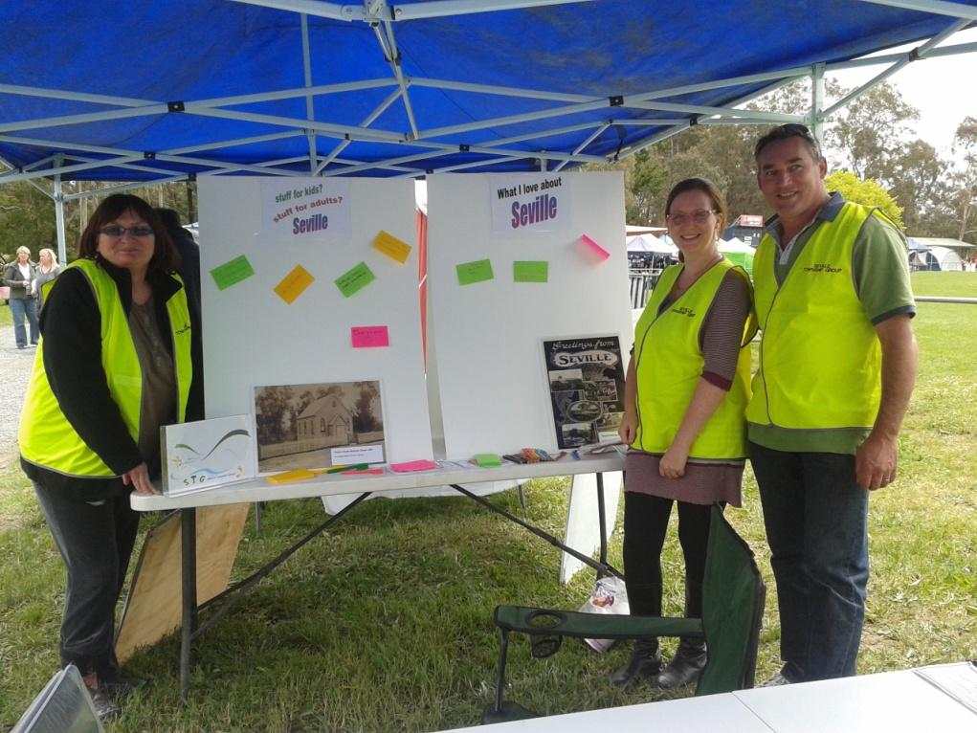In total, about 250 people actively participated in the community planning process in Seville, by attending events and by providing suggestions at various events or via email, Facebook or phone calls. The various events that were held are described below.

## **Stall at Springfest, 2013**

A Have your Say stall was set up at the Yarra Valley SpringFest in late 2013. This successful festival is organised each year by Seville Township Group in conjunction with a large number of local organisations. People were asked what they liked about Seville, and what ideas they had to make it an even better place. The stall also provided the public with a chance to comment on the proposed design of the new playground which is to be installed between the water play park and the oval.

(Pictured: Sue, Trilby and Wayne from Seville Township Group).

## **Peter Kenyon Workshop, May 2014**

In May 2014, Peter Kenyon, an expert in asset-based community development, visited Yarra Ranges and conducted a series of workshops in 6 different townships. Wild Cattle Creek Estate hosted a workshop which was attended by 30 people from Seville and neighbour township Wandin. Peter inspired the group with stories of successful community initiatives in New Zealand and across Australia.

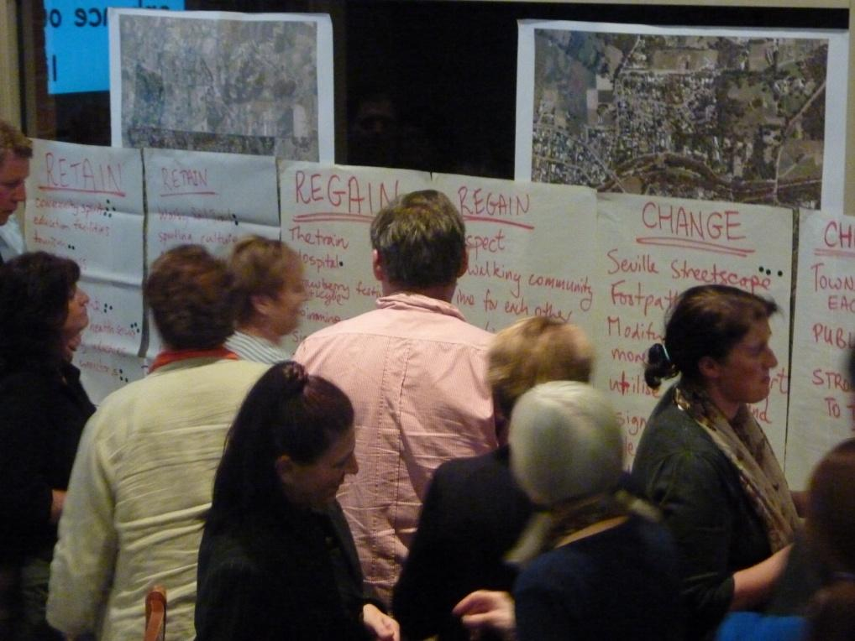He asked the attendees to discuss in small groups these questions:

What does Seville/Wandin have that you want to keep (retain)?

What did Seville/Wandin have that you want to get back (regain)?

What things need to change in Seville/Wandin to make it a better place?

What isn’t here? What would you like to create in Seville/Wandin?

This exercise generated hundreds of ideas and suggestions. The attendees then were given six sticky dots each to vote on their top priorities.

The most popular suggestions were:

* creating a better connected and organised community
* creating an attractive main street
* providing information for visitor about our heritage
* improved recreation facilities and clubs
* more events
* retain our rural aspect
* more activities for young people

(Pictured: workshop attendees use sticky dots to nominate their top priorities).

## **BBQ Behind the IGA, August 2014**

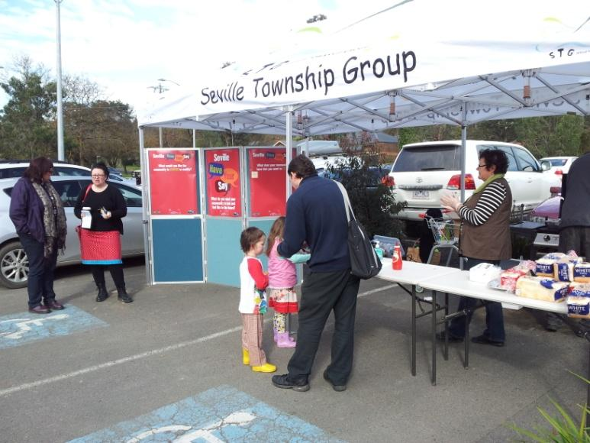

On a Saturday morning in August 2014, Seville Township Group set up another Have your Say stand with a free sausage sizzle and colourful posters which attracted interested from about 20? passers-by. The posters asked the same four questions that were used at the workshop. More ideas and suggestions were collected.

## **Stall at Springfest 2014**

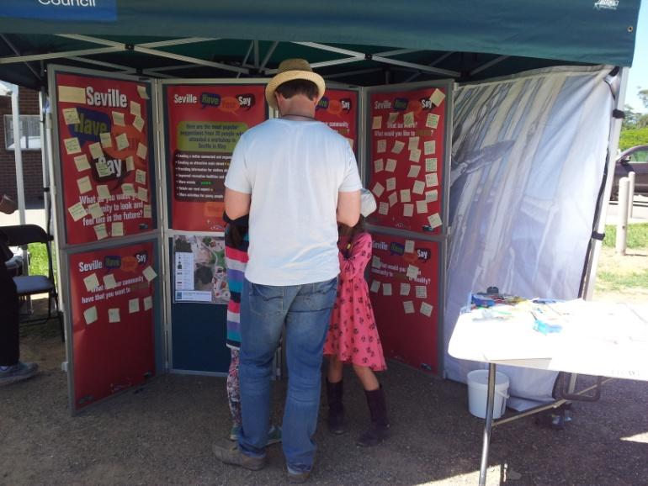Once again, a Have Your Say stall was set up at Springfest, and dozens of ideas were collected.

## **Sorting Ideas into Categories**

One night in April 2014, Seville Township Group members sorted all of the ideas and suggestions received so far, and put them into 16 categories. See Annex 2 for details.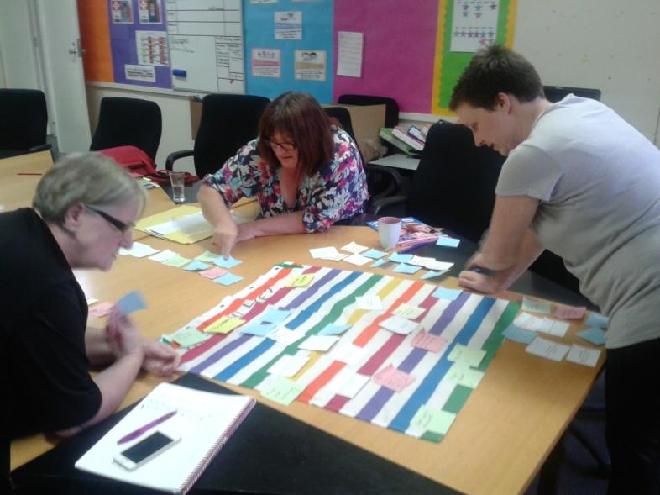

(Pictured: Colleen, Sue and Trilby sorting ideas into categories).

## **Outdoor Cinema March 2015 – identifying priorities**

In March, in conjunction with Yarra Ranges Council, an outdoor movie night was held at the Recreation Reserve. An animated film was shown to attract families. The purpose of the movie night was to ask the audience to vote for their top priorities from the 16 listed.

Volunteers moved through the crowd before the movie started, and distributed voting forms, and attendees could also vote by putting sticky dots on 16 posters. More comments and suggestions were collected. About 80 people voted.

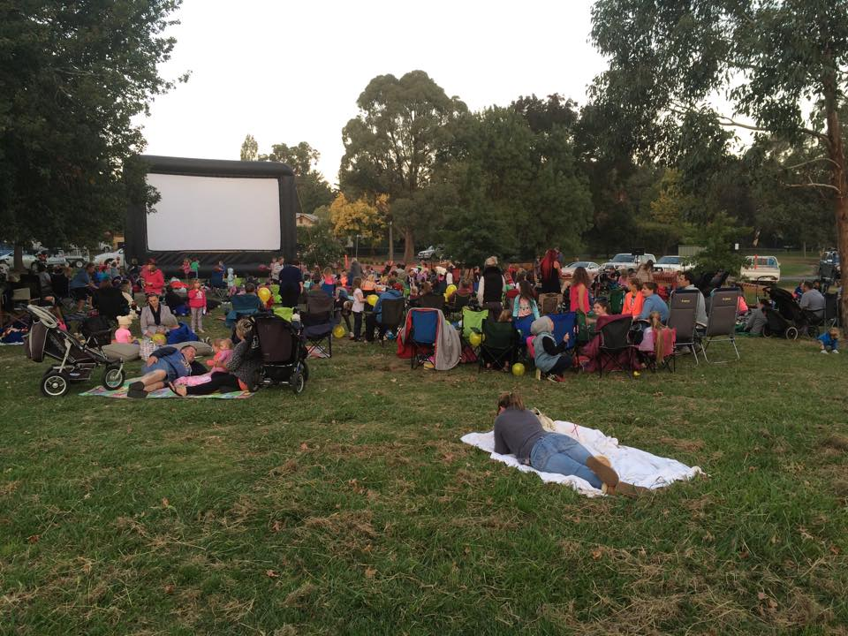Seville Primary School and Seville Community House had food stalls and raised funds for their own projects.

About 200 people attended the night, and the feedback about the event was very positive.

## **Workshop with Kimbra White April 2015 – Identifying Projects**

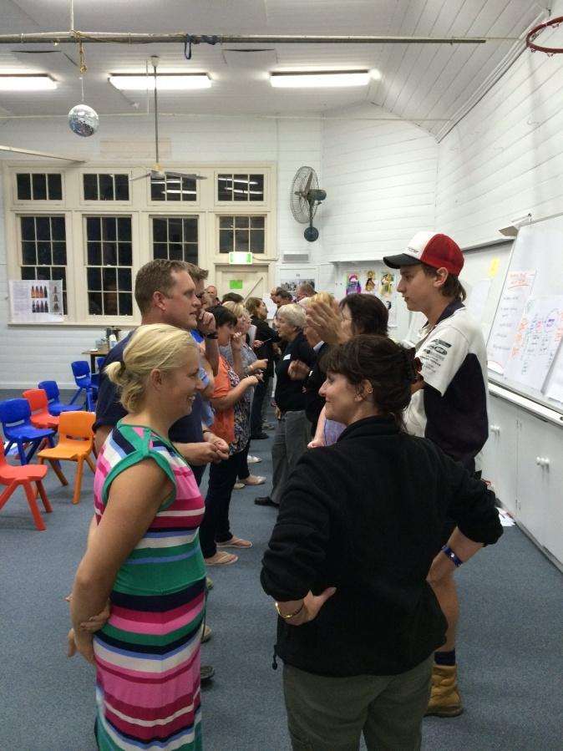Thirty members of the community came to this workshop which was facilitated by Kimbra White, and hosted by Seville Primary School. Once again, the school put on a great sausage sizzle.

The group focussed on the top ten priorities as voted on at the outdoor cinema night, and in small groups, discussed project ideas that will address these priorities. These projects are included in the next section.

Approximately 12 of the attendees were residents of Hickman Place, who were concerned about the future of Hickman Place Reserve. Seville Township Group continues to provide advice to residents on this issue.

Finally, the group was asked to write down five words that describe the Seville of the future. These were discussed in groups and then collated, and then narrowed down to half a dozen words. Then, a few sentences were created using these words. One sentence was chosen, which is the vision statement for this community plan (see below).

(Pictured: workshop attendees get to know each other at the start of the night).

## **Consultation with Secondary School Students, Lilydale High School, June 2015**

Because young people had attended the April workshop in small numbers, it was decided that more ideas were needed to assist Seville Township Group to plan appropriate activities into the future. Organising activities for young people was one of the top ten priorities identified through this process.

Sue from STG, and Chris and Simon from Yarra Ranges Council, visited Lilydale High School and ran a workshop at lunchtime for 15 students from Seville. Students of all ages attended, and their most popular suggestions are listed below, which tended to be about recreation activities, and this reflects the things that they and many others value about Seville, i.e. the environment, the open spaces and a small close-knit community.

* Access to a swimming pool
* Sports Day where different sports are played
* Sport competitions during school holidays
* Night matches of footy and netball
* Running track
* Gym
* Motorbike trails
* Mountain bike/BMX trails/jumps
* Seating areas for catching up with people

## 

## **Release of Draft Community Plan, August 2015**

This draft plan was completed by Seville Township Group in August 2015 and the community was provided the opportunity to comment via a letterbox and post box drop, Facebook, and email. Six comments were received.

Following a three-week period of community consultation, the plan was finalised and presented to Yarra Ranges Council for acknowledgement on 6 October 2015.

# Vision Statement

*“Seville is an active and connected community with a proud history and wonderful facilities, which cares about its people and its rural environment.”*

# Strategies and Actions

|  |  |  |  |
| --- | --- | --- | --- |
| Action | Next Steps | When | Who |
| ***Build our community spirit, and celebrate and value our pioneer family heritage*** | | | |
| Organise “Treasures from Olde Seville”:  A series of talks and exhibitions over a weekend that showcase our history, culture and family connections | * Find our “local treasures” - source a range of people to talk about their histories of Seville. * Conduct interviews, collate photos, stories and documents. * Take photos of our treasures (people, places). * Source info and help on the best ways to display material. * Determine date, locations, and book venues. * Promote weekend. * Use images and text from the event as content for a book. * Tie in with the “I grew up in Seville” reunion on same weekend. | March 2016 | Seville Township Group  Seville Primary School  Seville Community House  Heritage groups e.g. Mont de Lancey  Historical Societies |
| ANZAC memorial project | * Seek agreement from Council * Apply for grants. * Continue to gather evidence of community support and promote the project through Facebook. * Continue fundraising activities, e.g. in March 2016, a concert is planned featuring Normie Rowe, coupled with a corporate lunch hosted by Tony Smith MP, and a pre-season football match featuring guest AFL players. * Approach authorities regarding the refurbishment of the bus shelter memorial. | 2015-17 | Memorial Project committee  Yarra Ranges Council  Seville Primary School  Funding bodies, e.g. Department of Veterans Affairs  ANZAC Centenary 2014-18  RSL clubs |

|  |  |  |  |  |
| --- | --- | --- | --- | --- |
| Action | Next Steps | | When | Who |
| ***Run more community events*** | | | | |
| “I grew up in Seville” Reunion | | * Set up Facebook page * Set up organising committee * Confirm venue – Reminisque * Liaise with Memorial Project Committee re fundraising during event. * Liaise closely with Seville Primary School who is holding an open day on the same day. | Saturday 5th March 2016 | The Reunion Committee  Seville Township Group  Seville Primary School  Memorial Project committee |
| Hold Yarra Valley Spring Festival in conjunction with 75th anniversary of the Seville CFA | | * Apply for a grant from Council | 2016 | Seville CFA  Seville Township Group  Seville Primary School  Seville Pre-school  Seville Community House  Community groups  Traders |
| Plan and run other events | | * Further discussions, consultation, getting new people interested. * Consider running family-oriented and youth events based on outcomes of ongoing consultations. | 2016-2017 | Seville Township Group  Seville Community House  Community leaders |

|  |  |  |  |
| --- | --- | --- | --- |
| Action | Next Steps | When | Who |
| ***Improve communication between our community groups, clubs and businesses*** | | | |
| Establish the Seville Voice email newsletter, plus paper version for those who prefer it.  To promote the town’s assets and activity. | * Talk to community groups, sports clubs, school, pre-school to see who wants to be involved. * Approach local traders for support through ads or sponsorship * Ask residents (via the newsletter) what they want to hear about, e.g. news, history, what’s on, specials and promotions. | 2016 | Seville Township Group to contact traders, school, pre-school and sports clubs. |

|  |  |  |  |  |  |  |
| --- | --- | --- | --- | --- | --- | --- |
|  | | |  |  |  | |
| Action | | | Next Steps | When | Who | |
| ***Advocate for improved facilities at the Seville Recreation Reserve*** | | | | | | |
| Establish a recreation reserve stakeholder group, to advocate for Council to implement the recommendations of the reserve Master Plan | * Contact sports clubs and other stakeholders of the reserve * Establish group leadership positions and select leaders. Set up group governance. | | 2015 | | Seville Township Group, reserve stakeholders. | |
| Advocate for female change rooms at the pavilion | * Approach clubs to secure their support, and collect ideas and suggestions from reserve users. | | 2015 | | Recreation reserve stakeholders group | |
| * Raise funds for the community contribution | | 2015-16 | | Sports clubs that use the reserve | |
| * Work with Yarra Ranges Council to submit a funding application in state and/or federal funding programs that are available at the time. | | 2016 | | Recreation reserve stakeholder group  Yarra Ranges Council  Sport and Recreation Victoria | |
| Advocate for new toilet block including disability access and nappy changing facilities. | * Gather support from reserve users, including water play park. * Develop a project proposal for Council’s consideration * Discuss with Council’s Facilities Management team. | | 2016-17 | | Recreation reserve stakeholder group  Yarra Ranges Council | |

|  |  |  |  |
| --- | --- | --- | --- |
| Action | Next Steps | When | Who |
| ***Encourage tourists to drop in, shop and stay*** | | | |
| Pop-up market in town centre to showcase local wineries and food producers | * Look at other examples, e.g. Torquay, Yering * Get producers involved. * Explore funding options | 2016 | Yarra Valley Smaller Wineries  Five Oaks Wines  Seville Township Group  Seville Chamber of Commerce  Yarra Valley Tourism  Yarra Ranges Council  Seville Primary School  Seville Pre-school |
| Explore other events such as “the Longest Lunch”, Harvest Lunch | * Advocate to Yarra Valley Tourism for financial and other support for events in Seville | 2016-17 |
| Start a “Stop and Stay, Stop and Shop” campaign | * Planning meeting |

|  |  |  |  |  |  |
| --- | --- | --- | --- | --- | --- |
| Action | | Next Steps | When | Who | |
| ***Improved footpaths and trails, and links between the Warburton Trail and the town*** | | | | | |
| Advocate for more clearly visible and consistent signage and continuous safer paths and better access to the town, leading to an increase in patronage | * Gain support from local businesses. * Work together on signage detail. * Consult with adjacent property owners * Seek Council support/approval | 2015-16 | Seville Chamber of Commerce  Seville Township Group  Yarra Ranges Council |
| Advocate for sealed paths around Seville Primary School, i.e. Railway and Walker Roads, including school crossing on Railway Road. | * Gain community support * Contact property owners on these roads * Contact Council and local councillor * Seek funding. | 2016-17 | Seville Township Group  Seville Primary School  Yarra Ranges Council  Seville Community House |

Annex 1: Statistical Information

|  |  |  |  |
| --- | --- | --- | --- |
|  | **Seville (incl. Seville East) No.** | **Seville (incl. Seville East)**  **%** | **Yarra Ranges Council area**  **%** |
| **Population Summary** |  |  |  |
| Total Population | 3,212 | 100% | 100% |
| Males | 1,634 | 51% | 49% |
| Females | 1,578 | 49% | 51% |
| Australian citizens | 2,976 | 93% | 90% |
| Eligible voters (citizens 18+) | 2,108 | 66% | 67% |
| Indigenous population | 37 | 1% | 1% |
| Australian-born | 2,767 | 86% | 79% |
| Speaks language other than English at home | 98 | 3% | 6% |
| Overseas-born | 345 | 11% | 16% |
| Needs assistance due to age or disability | 73 | 2% | 4% |
| **Age Structure** |  |  |  |
| Babies and pre-schoolers (0 to 4) | 264 | 8% | 6% |
| Primary schoolers (5 to 11) | 376 | 12% | 9% |
| Secondary schoolers (12 to 17) | 290 | 9% | 9% |
| Tertiary education/independence (18 to 24) | 263 | 8% | 9% |
| Young workforce (25 to 34) | 384 | 12% | 11% |
| Parents and homebuilders (35 to 49) | 780 | 24% | 22% |
| Older workers & pre-retirees (50 to 59) | 415 | 13% | 14% |
| Empty nesters and retirees (60 to 69) | 281 | 9% | 11% |
| Seniors (70 to 84) | 146 | 5% | 7% |
| Frail aged (85 and over) | 13 | 0% | 1% |
| Total Population | 3,212 | 100% | 100% |
|  |  |  |  |

|  |  |  |  |
| --- | --- | --- | --- |
|  | **Seville (incl. Seville East) No.** | **Seville (incl. Seville East)**  **%** | **Yarra Ranges Council area**  **%** |
| **Household Types** |  |  |  |
| Couples with children | 502 | 46% | 37% |
| Couples without children | 268 | 25% | 26% |
| One parent families | 105 | 10% | 11% |
| Lone person households | 167 | 15% | 20% |
| Group households | 10 | 1% | 2% |
| Total households (inc. non-classifiable) | 1,086 | 100% | 100% |
| **Religion** |  |  |  |
| Christian religions | 1,746 | 54% | 54% |
| Non Christian religions | 47 | 1% | 2% |
| No Religion | 1,128 | 35% | 34% |
| Not stated | 258 | 8% | 9% |
| Total persons (inc. non-classifiable) | 3,210 | 100% | 100% |
| **Education** |  |  |  |
| Attending preschool or primary school | 436 | 14% | 11% |
| Attending secondary school | 252 | 8% | 7% |
| Attending university or TAFE institution | 156 | 5% | 6% |
| Total persons (including those not attending) | 3,208 | 100% | 100% |

|  |  |  |  |
| --- | --- | --- | --- |
|  | **Seville (incl. Seville East) No.** | **Seville (incl. Seville East)**  **%** | **Yarra Ranges Council area %** |
| **Labour Force** |  |  |  |
| Employed | 1,753 | 72% | 96% |
| Unemployed | 24 | 1% | 4% |
| Total labour force | 1,777 | 73% | 66% |
| Not in the labour force | 602 | 25% | 30% |
| Total persons aged 15+ (incl. Not Stated) | 2,431 | 100% | 100% |
| **Dwelling Summary** |  |  |  |
| Separate houses | 1,137 | 98% | 92% |
| Medium and high density | 29 | 2% | 7% |
| Other dwellings (inc. Caravans, houseboats) | 0 | 0% | 1% |
| Occupied private dwellings | 1,082 | 93% | 92% |
| Unoccupied Dwellings | 83 | 7% | 7% |
| Non private dwellings | 0 | 0% | 0% |
| Total dwellings | 1,165 | 100% | 100% |
| **Housing Tenure** |  |  |  |
| Owned | 292 | 27% | 33% |
| Purchasing | 634 | 59% | 47% |
| Renting | 116 | 11% | 14% |
| Total households (incl. not stated and other) | 1,083 | 100% | 100% |
| **Household Income** |  |  |  |
| Less than $600 (low) | 151 | 14% | 18% |
| $600 to $1,249 (lower middle) | 281 | 26% | 25% |
| $1,250 to $1,999 (upper middle) | 271 | 25% | 21% |
| $2,000 or more (high) | 247 | 23% | 24% |
| Incomes not stated | 119 | 11% | 11% |
| Total households | 1,069 | 100% | 100% |
| **Internet Connection** |  |  |  |
| Broadband connection | 798 | 74% | 73% |
| Dial-up connection | 46 | 4% | 3% |
| Other connection | 28 | 3% | 3% |
| No connection | 150 | 14% | 15% |
| Not stated | 60 | 6% | 5% |
| Total households | 1,082 | 100% | 100% |
|  |  |  |  |
| Source: Australian Bureau of Statistics, Census of Population and Housing 2011.  Compiled and presented in profile.id by .id, the population experts. | | | |
| [http://www.id.com.au](http://www.id.com.au/) |  |  |  |

# Annex 2: Community Ideas and Suggestions in 16 categories (in priority order)

**Create new recreation facilities at the reserve**

(63 ideas, 65 votes)

* Skate park 14
* Better toilets 8
* BBQ area 4
* Fundraisers 4
* Fitness classes 3
* Create female/new change rooms at footy club 3
* Fenced dog park 3
* Basketball area 3
* More equestrian facilities/opportunities/hub 3
* Activities and events for older children 3
* Fitness track, spaces to work out 2
* More shops 2
* BMX track 2
* Level main oval
* Develop the sporting precinct so that it is a hub for the Yarra Valley

**Improve the water play park and the playground**

(55 ideas, 68 votes)

* Indoor pool 23
* Better/cleaner toilets/change room 10
* Shade Sail/zone 6
* More car-parking around water park 4
* 40 kph on Monbulk-Seville Road 2
* Safety fence around water play park 2
* Smoke-free zone 2
* Playground upgrade 8 (including facilities for older kids, climbing rope, wizzy dizzy), like Yarra Glen
* Toddler friendly
* More rubbish bins
* More seating
* More sprinklers
* Extra drinking water fountain

**Have better looking streets and safer traffic**

(57 ideas, 54 votes)

* Seal Station Road (4), Russell Road
* Signage 5
* Lots of trees/shrubs on roundabouts 3
* Right hand turning arrow off Warby Hwy into Link Road 2
* More street lighting 2
* Blossom trees in centre of road 2
* Fix roundabout 2
* Keep village feel 2
* Speed reduction Monbulk Seville Road from 100 to 80 kph, Link Road 60 to 40 kph
* Christmas decorations in the main street
* Unified building frontages on main street
* CCTV in main street, mainly in footy season
* Reduce dust on Paynes Road (hwy end)
* Rubbish from IGA supermarket cleaned up
* Modify the wait time crossing the road at the lights
* Better guttering and more made roads, especially near tourist attractions i.e. wineries
* Less Traffic lights
* Made roads, sewage and water mains
* Fix potholes
* More police

**Run more community events**

(39 ideas, 48 votes)

* Markets e.g. harvest, craft, trash ’n’ treasure 7
* Festivals (e.g. Springfest, Strawberry) 6
* Cinema/kids movie/summertime/annually/weekly 4
* Baking competition 3
* Car show 3
* Carols by Candlelight 2
* Free food and drink at events
* Make sure advertised suppliers turn up
* Street fair
* Family nights
* Monthly Saturday evening events
* Fundraisers
* More sponsorship of events
* Bring back Kylie Minogue
* Reduce amount of alcohol at sports events

**Support local businesses, community groups and educational facilities**

(41 ideas, 19 votes)

* Support the CFA 10
* Support Wandin/Seville Community Bank 9
* Support local farmers 2
* Stronger chamber of commerce
* Keep development concentrated in the valley.
* Promote our community house and school
* Create a Seville brand of agricultural produce
* Signage

**Build our community spirit, and celebrate and valuing our pioneer family heritage**

(55 ideas, 14 votes)

* Keep a sense of community spirit/attitude/helping 14
* Keep history and culture, family connections, heritage 8
* Good to be near family, friends 7
* Good place for families 4
* Regain Respect 4
* Keep our sporting culture 3
* Keep the sense of knowing people/small town 3
* Develop a war memorial 2
* Provide info for visitors about our heritage 2
* Be a place to shop and enjoy
* Central to everything
* I like the fact that there are no pubs
* A Seville.com.au website with history and photos (state library is a great resource)
* Link to tourism developments
* Reach out to have a conversation to inspire others to be involved

**Improved footpaths and trails, and links between the Warby Trail and the town**

(34 ideas, 24 votes)

* Stronger connection to the Warby Trail
* More bike trails
* Bins on Warby Trail
* Drinking water and toilets with signs on Warby Trail
* Bikes for hire/free in town
* Seville East needs access to Warby Trail
* Make Warby Trail more family friendly
* Sealed footpaths around school
* Better/safer access for horse riders and cyclists into Seville/Wandin
* A bridge across the creek further back along Station Street
* Paved paths so bikes are safer to ride on around Seville
* A bridge over the creek from the water park to the back of the shops
* Footpath on Warby Highway, on Woolworths side of the road
* Make footpath on Old Warby Road safe for kids

**Improve communication between our community groups, clubs and businesses**

(41 ideas, 8 votes)

* Collaboration between townships and promoting each other 6
* Collaboration between schools 5
* Encourage community involvement 2
* Local newsletter
* A gathering place
* Keep our radio station YVFM
* Network meeting of all groups and organisations

**Organise more activities for our young people**

(39 ideas, 39 votes)

* Discos/dances/music/alcohol-free 3
* Set up youth groups 2
* Keep the Scouts
* Include sporting activities for youth at festivals
* Involve young people in design of art work
* Amazing race challenge
* Family event once a week
* Free lollies and chocolates!

**Encourage tourists to drop in, visit and stay**

(36 ideas, 22 votes)

* Clear info about town (attractions etc) at entrance 10
* More restaurants, wineries, cafes, galleries, shops 4
* Family friendly pub 4
* Tourist info and heritage centre 3
* More promotion 2
* Support prominent tourism businesses
* Keep Shedfest
* Regain a heritage appearance of buildings
* “Welcome to the real Yarra Valley” slogan
* “Wandin” signs on Warby Highway and Clegg Road
* Lobby Council to relax laws on registering B&Bs.
* Lobby state government to invest infrastructure along Warby Hwy

**Keep Seville rural, and protect our environment**

(27 ideas, 14 votes)

* Keep it as natural as possible

**Encourage a wider variety of new retail businesses**

(18 ideas, 10 votes)

* Create a Pub 6
* Opp Shop 3
* Create Aldi, Officeworks, Big W, EB Games, Cold Rock Ice Creamery
* Regain a fruit and veg shop
* Keep opportunities for our kids to work locally
* Gift shop
* Cafes
* Decent bakery

**Establish community health services and organise specialists to visit**

(14 ideas, 2 votes)

* Regain a hospital (4)
* Specialist doctors (2)
* Community health services (7)
* Services for the elderly.

**Find new uses for under-used public land, e.g. clustering services that are currently in different locations at one central site (a “community hub”)**

(15 ideas, 4 votes)

* Public park and playground, public exercise classes at 7 Hickman Place (4)
* Public toilets (4)
* Utilise empty space e.g. former maternity and child health centre.
* Community garden on land next to feed store.

**Lobby for better public transport**

(8 ideas, 4 votes)

* Bring back the rail service (5)

**We need a wider variety of housing types, including housing for the aged**

(8 ideas, 1 vote)

* Housing for single parent families
* Retirement village – so people can downsize