# Setting up / Managing Subscriptions

You may wish to setup subscriptions alerts to ensure you are notified by email when NQPHN have advertised a tender matching a category you have subscribed to.

## Adding Subscription Alerts

1. Click the Home button on the My Account tab

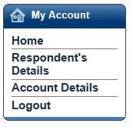

1. Select ‘My RFx Subscriptions’:

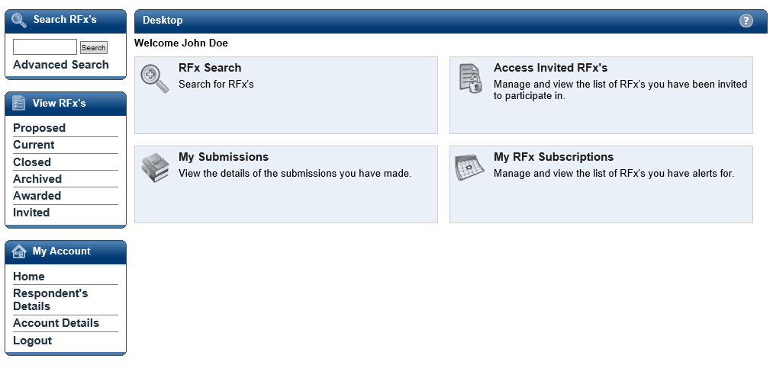

1. Select the link ‘Click here to add a new RFx Subscription’.

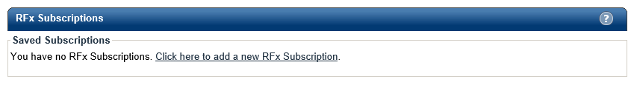

1. The following screen will appear:

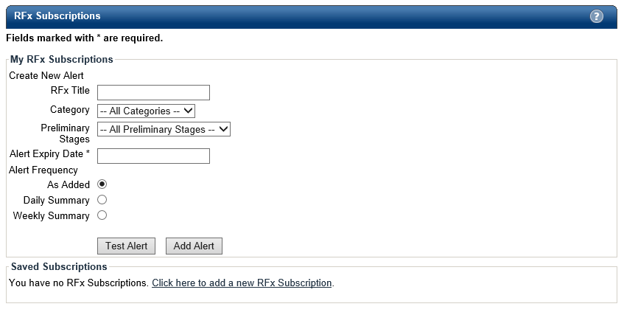

1. Enter the combination of search criteria required for the subscription:
   * RFX Title – enter criteria to perform a title word search. i.e. ‘After Hours’, this will search for all tenders with RFx titles that match the title of ‘After Hours’
   * Select the ‘category’ using the drop-down box
   * In most cases you can leave the ‘Preliminary Stages’ dropdown box set to ‘ALL PRELIMINARY STAGES’. You would use this filter if you wished to only be informed of a particular type of tender i.e. Request for Tender or Expression of Interest
   * Add an ‘Alert Expiry Date’ sometime into the future
   * Choose from either ‘As Added’, ‘Daily Summary’ or ‘Weekly Summary’ for the frequency of the alert to be provided/
2. Select ‘Add Alert’.
3. Your alert will be listed in RFx Subscriptions screen, you can at any time come back and make adjustments to the alert.

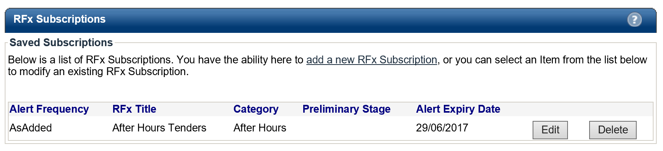

## Modifying Subscription Alerts

1. Click the Home button on the My Account tab:



1. Select ‘My RFx Subscriptions’.



1. To modify information on an Alert, simply click on the ‘Edit’ button next to the alert:



1. Modify the required details and click ‘Update Alert’ to save the changes

## Deleting an Alert

1. Click the Home button on the My Account tab:



1. Select ‘My RFx Subscriptions’.



1. To delete an Alert, simply click on the ‘Delete button next to the alert:

